


Kingsfield First School
Computing Policy
June 2026-Version 2
June 2027
To be reviewed:
October 2026
Agreed and ratified by the Local Advisory Board on:
Headteacher – Mrs C Hodson
Responsible Officer:
Mr C Clulow
Chair of Local Advisory Board:
The Computing Policy has been discussed and adopted by the Local Advisory Board in October 2026

Complementary Policies
Within the CFLP, the Computing, Online Safety, PSHE & Citizenship work in complementary alignment to ensure pupils develop both the knowledge and the judgement required to engage safely in modern digital life.
- Computing equips pupils with the technical skills and knowledge including how to effectively navigate the internet and elements of A.I.
- PSHE & Citizenship provides the ethical framework, enabling pupils to understand the benefits, risks and responsible use of online environments and A.I. including safety, wellbeing and digital citizenship.
- The overlap between the two disciplines is critical, ensuring that pupils can apply their technical understanding safely, responsibly and effectively.
Together, these areas ensure that pupils are not only digitally competent but also digitally responsible, aligning with best practice in safeguarding and online safety education (e.g. DfE Teaching Online Safety in Schools, Education for a Connected World framework).
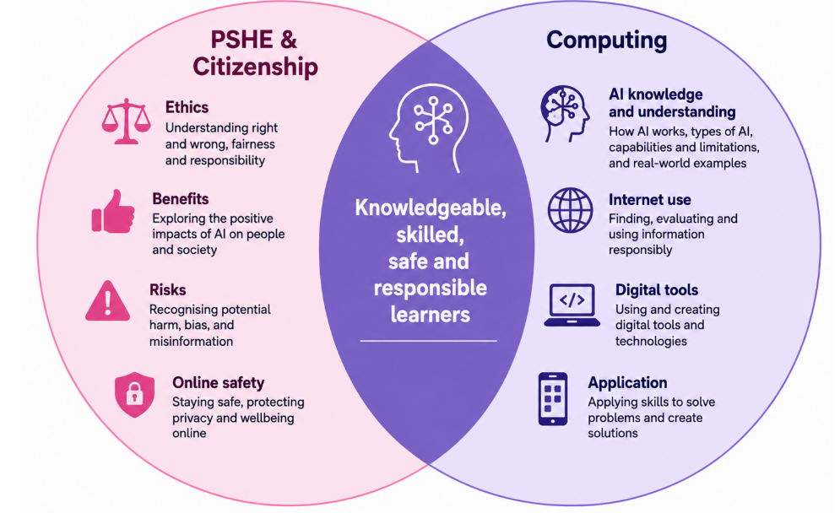

Intent of Computing Policy
Curriculum Intent
The overall intent of our school curriculum is to:
- Recognise individuality: valuing the unique strengths, experiences and contributions of our pupils, staff and wider school community
- Be inclusive: meeting the diverse needs of all learners through adaptive teaching and removing barriers to learning
- Engage and inspire: delivering a knowledge-rich, ambitious and well-sequenced curriculum within meaningful and purposeful contexts
- Promote aspiration: fostering resilience, independence and pride in achievement through appropriate challenge and high expectations
- Develop future citizens: preparing pupils to be responsible, respectful and active members of society who celebrate diversity and understand the importance of democratic values
Our computing curriculum is integral in supporting these aims and contributes significantly to pupils’ personal development and readiness for life in a digital world.
In line with the National Curriculum for Computing, we ensure that all pupils:
- Understand and apply the fundamental principles of computer science, including abstraction, logic, algorithms and data representation
- Analyse problems in computational terms and gain repeated practical experience of writing programs to solve such problems
- Evaluate and apply information technology, including new and emerging technologies, to solve problems effectively
- Become responsible, competent, confident and creative users of digital technology
Kingsfield First School is committed to ensuring that all pupils develop a secure and progressive understanding of computing in order to prepare them for life in an increasingly digital world. We aim to deliver a broad, balanced and ambitious curriculum that:
- Meets the requirements of the National Curriculum for Computing
- Provides engaging, appropriately challenging learning opportunities for all pupils
- Reflects current and emerging technologies and their role in everyday life
- Develops pupils’ digital literacy, computational thinking and creativity
- Equips pupils with the knowledge, skills and confidence to use technology effectively across their learning and beyond
- Ensures pupils understand how to use technology safely, responsibly and respectfully
This policy outlines how we support pupils to succeed in their education and become competent, responsible digital citizens, both in school and when using technology at home.

Implementation

EYFS
In the Early Years Foundation Stage, whilst the explicit ‘Technology’ strand has been removed, it remains important to provide children with a broad, play-based experience of computing across a range of contexts, including outdoor provision. Computing extends beyond computers; it encompasses opportunities to explore real-world applications through role play and imaginative scenarios. Children develop confidence, control and language skills by interacting with both non-digital resources and age-appropriate technology, such as interactive whiteboards and tablets.

KS1 and KS2
Computing is a statutory subject within the National Curriculum and must be taught with a secure and thorough understanding.
As outlined in the National Curriculum for Computing, pupils in Key Stage 1 are taught to:
- understand what algorithms are; how they are implemented as programs on digital devices; and that programs execute by following precise and unambiguous instructions
- create and debug simple programs
- use logical reasoning to predict the behaviour of simple programs
- use technology purposefully to create, organise, store, manipulate and retrieve digital content
- recognise common uses of information technology beyond school
- use technology safely and respectfully, keeping personal information private; and identify where to go for help and support when they have concerns about content or contact online
In Key Stage 2, pupils are taught to:
- design, write and debug programs that accomplish specific goals, including controlling or simulating physical systems; solve problems by decomposing them into smaller parts
- use sequence, selection, and repetition in programs; work with variables and various forms of input and output
- use logical reasoning to explain how some simple algorithms work and to detect and correct errors in algorithms and programs
- understand computer networks, including the internet, and how they can provide multiple services, such as the World Wide Web, and the opportunities they offer for communication and collaboration
- use search technologies effectively, appreciate how results are selected and ranked, and be discerning in evaluating digital content
- select, use and combine a variety of software (including internet services) on a range of digital devices to design and create a range of programs, systems and content that accomplish given goals, including collecting, analysing, evaluating and presenting data and information
- use technology safely, respectfully and responsibly; recognise acceptable and unacceptable behaviour, and identify a range of ways to report concerns about content and contact
This is delivered throughout our school using the Teach Computing curriculum from the National Centre for Computing Education. Each year group will be introduced to six units of study with a range of foci. In each year, children access units focussed on:
- Computing systems and networks
- Creating Media
- Data and information
- Programming
In addition, specific lessons on artificial intelligence from Computing at School (CAS) and Barefoot have been woven throughout KS1 and KS2. These units of study, including the selected lessons from CAS and Barefoot, will enable pupils to have a broad and balanced knowledge of computing techniques and new technology including Artificial Intelligence. Pupils will have an understanding of how to approach different computer-based problems and briefs, and the best methods to achieve the desired outcome.

A Lesson (Pathway)
Teachers are aware of the prior learning that needs to be secure from previous year groups to ensure new content can be understood. Lessons are planned sequentially, to ensure knowledge and skills are built upon.

A lesson would typically consist of the following:
- Retrieve - used to revisit and retrieve previously taught knowledge/skills.
- Shared learning objective, success criteria and unit specific vocabulary - help to set the context for a lesson.
- Teaching exposition - a variety of strategies are used to model and explore new concepts following the ‘I do, we do, you do’ model which is knowledge-rich, with explicit teaching of vocabulary
- Opportunities to discuss learning - children are encouraged to speak in full sentences and reinforce vocabulary in context.
- Ongoing assessment for learning (AfL) questions - used to extend and/or support learning.
- Practise/Apply – Repetitive and progressive opportunities allowing for consolidation and mastery of planned knowledge and skill content.
- Scaffolded learning activities - linked to the learning objective to ensure all children achieve the learning outcome.
- Reflection – a range of techniques are employed to encourage children to think about and discuss their own learning.
- Evaluate – refer back to learning objective and success criteria. This could be at any point throughout the lesson.
These elements could be used flexibly throughout each session.

Inclusion and Adaptation
Our inclusive approach ensures that every pupil can access learning meaningfully through thoughtful planning, targeted support, and high-quality adaptive teaching.

Adaptive Teaching
- Lessons are designed using high levels of AfL and a consistent ‘I do, we do, you do’ delivery model offering multiple ways to access, engage with and respond to content.
- Teachers break content into smaller, manageable steps with clear, concise language and visuals.
- Key vocabulary is pre-taught, reinforced and revisited frequently.
- Concepts may be repeated or revisited across longer periods to support retention.
- SEND pupils may be provided with scaffolded resources such as sentence starters, sorting activities, matching tasks, or visual prompts.

Online Safety
Online safety is taught explicitly through our PSHE and Citizenship curriculum safe zone modules (3D PSHE scheme), ensuring that pupils develop the knowledge and skills to stay safe, behave responsibly and make informed choices in an increasingly digital world. This learning is delivered in an age-appropriate way and is reinforced across the wider curriculum, including Computing.
Our online safety provision is structured around the recognised strands from the Education for a Connected World framework. Pupils revisit and build upon key themes each year:
- Self-image and Identity
- Online Relationships and Reputation
- Online Bullying
- Health, Wellbeing and Lifestyle
- Managing Online Information
- Copyright and Ownership
- Privacy and Security
Through these themes, children learn how to develop positive online relationships, recognise and respond to risks, manage their digital footprint, and understand how to use technology safely, respectfully and responsibly. This progressive approach supports statutory requirements for Relationships and Health Education 2026 and complements the Computing curriculum.
Impact
The impact of this policy is that pupils develop as confident, capable and responsible users of technology. Through effective implementation, pupils:
- Demonstrate the expected knowledge and skills for their stage of learning in Computing
- Use technology and online platforms safely, responsibly and respectfully
- Apply computational thinking and digital literacy skills to solve problems and complete purposeful tasks
- Show increasing independence in selecting and using appropriate digital tools across the curriculum
By the time pupils leave our school, they will:
- Confidently collect, organise and present data using a range of digital tools
- Communicate and collaborate safely and respectfully using digital technologies
- Understand their digital footprint and recognise that online actions have real-world consequences, including legal and ethical implications
- Design, write and refine programs using logical and creative approaches
- Understand how digital systems and networks, including the internet, work
- Select and use a range of applications and devices effectively to communicate ideas and create content
- Apply their computing knowledge and skills independently across the curriculum and in real-life contexts beyond school
Assessment
Assessment in Computing draws on a range of evidence to ensure that teacher judgements are accurate, secure and reflective of what pupils know and remember. Teachers use a variety of methods to inform assessment, including assessment for learning strategies, purposeful questioning, observation, pupil voice, quizzes and regular feedback, allowing teaching to be adapted in response to pupils’ needs. Evidence of learning is recorded in books and through our chosen digital platforms including ‘Evidence Me’, capturing practical work, discussion and collaborative activities alongside more formal outcomes. This holistic approach enables all pupils to demonstrate their understanding in a range of ways. Assessment information is then used effectively to identify next steps, ensuring that learning in Computing is sequenced, progressive and builds securely over time.

Roles and Responsibilities

Headteacher and Senior Leaders
The Headteacher and Senior Leadership Team are responsible for:
- Ensuring that Computing is effectively implemented in line with the National Curriculum and whole-school priorities
- Managing and allocating resources to support high-quality Computing provision
- Approving and monitoring the strategic development of Computing and digital provision across the school
- Ensuring appropriate professional development opportunities are available for staff
- Supporting the development and implementation of the school’s online safety policy in collaboration with the Computing Lead and DSL/DDSLs
Computing Lead
The Computing Lead is responsible for:
- Leading the strategic development and consistent implementation of the Computing curriculum across the school
- Monitoring the quality of teaching, learning and assessment in Computing, including the use of books and online digital platforms including ‘Evidence Me’
- Supporting colleagues with planning, delivery and assessment to ensure progression in digital literacy and computational thinking
- Promoting high-quality teaching and modelling effective practice
- Ensuring the curriculum reflects current and emerging technologies and supports safe, responsible use
- Identifying staff training needs and providing or facilitating appropriate CPD
- Managing and auditing resources, including recommending investment in hardware and software
- Reviewing and updating the Computing policy and associated documentation
- Liaising with the MAT, external agencies and technical support providers
- Supporting the development of online safety across the curriculum, including links with PSHE and Citizenship
Teaching Staff
All teaching staff are responsible for ensuring that:
- They have up-to-date knowledge of the Computing curriculum and current expectations
- Computing is taught effectively through a well-sequenced and engaging curriculum including reference to the CFLP Teach Computing Curriculum Supporting Document (June 2026)
- Assessment is used effectively to inform teaching, including formative strategies and the recording of evidence in books and Evidence Me
- Pupils are supported to develop digital literacy, computational thinking and creativity
- Technology is used safely, responsibly and respectfully, and this is consistently modelled in practice
- Online safety is embedded across teaching linking to 3D PSHE and Citizenship
ICT Support Technician
The ICT Support Technician is responsible for:
- Ensuring that all hardware, software and network systems are maintained, secure and fully operational
- Providing technical support to staff and working collaboratively with the Headteacher/SLT/Computing Lead to address issues
- Supporting the safe and effective use of technology across the school

Version | Review Date | Changes Made
V2 | 28/06/2026 | Updated to ensure alignment with:  Online Safety, PSHE & Citizenship and A.I. policies  Updated to reference the newly included A.I. units of work and the CFLP Teach Computing Curriculum Supporting Document (June 2026)

