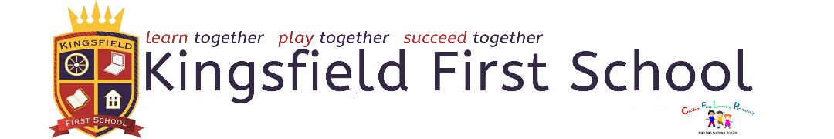
KS2 Curriculum Long-term Overview
Cycle 2

KS2 | Autumn Term | Spring Term | Summer Term
Maths | Shape and place value, addition & subtraction | Addition, subtraction, multiplication, division and fractions | Measures, money, statistics, consolidation
English core texts - suggested | The Stone Age Boy  The True Story of the Three Little Pigs | Toughest Cowboy  Toad Hall | The Iron Man  Stig of the Dump
English Genres | Narrative:  Adventure Stories  Stories with a familiar setting/alternative endings (Y3)  Stories set in an imaginary world (Y4)  Non-Fiction:  Non-Chronological reports  Letters (Y4)  Poetry:  Poety appreciation | Narrative:  Stories set in an imaginary world (Y4)  Diary Entries  Extended Stories  Non-Fiction:  Non-Chronological reports  Instructions (Y3)  Poetry:  Exploring form (Kenning & acroustic) Y3 | Narrative:  Adventure Stories  Extended Stories  Non-Fiction:  Recounts  Newspapers (Y4)  Poetry:  Exploring form (Haiku & Cinquain) Y4
Science | Rocks & Soils  Animals including humans | Magnets & Forces  Light & Shadow | Plants
Art | Drawing | Painting – mixing secondary and tertiary | Sculpture (clay) – pinch and coil
D&T | Cooking and Nutrition:  POAP – Healthy and Varied Diet  Design, make and evaluate - Pizza | Structures:  POAP – Shell Structures  Design, make and evaluate - packaging | Mechanical Systems:  POAP – Levers and Linkages  Design, make and evaluate – pop up card
Geography | The UK (features of the UK / counties ) | Location, Location, Location (Europe) | Rivers
History | The Stone Age | Ancient Greeks | Potteries
Computing | Y3 Connecting Computers/Y4 The Internet  Y3-Stop-frame animation/Y4 Audio Production | Y3 Sequencing Sounds/Y4 Repetition in Shapes  Y3 Branching Databases/Y4 Data Logging | Y3 Desktop Publishing/Y4 Photo Editing  Y3 Events and actions in Programs/Y4 Repetition in Games
Music | Developing Notation Skills  How Does Music Bring Us Closer Together?  Combining Elements to Make Music  How Does Music Connect Us with Our Past? | Composing Using Your Imagination  How Does Music Make the World a Better Place?  Creating Simple Melodies Together  How Does Music Teach Us About Our Community? | Learning More About Musical Styles  How Does Music Connect us with our Planet?  Purpose, Identity, and Expression in Music  How Does Music Connect Us with the Environment?
PE | Gymnastics  OA | Dance  Athletics | Invasion Games  Striking & Fielding
PSHE | Relationships  Health & well-being  Living in the Wider World | Relationships  Health & well-being  Living in the Wider World | Relationships  Health & well-being
RE | Christianity  Exploring Living by rules  Religion in the home | Christianity  Symbols of Worship  Sharing special food | Christianity  The beginning of the World  Religious Leaders
MFL | Year 3  Bonjour!  Year 4  Encore!  Les Fetes | Year 3  Mon Famille  Mon Corps  Les Animaux  Year 4  Quelle heure est-il? | Year 3  En Classe  Bon Anniversaire  Year 4  Ou Vas-Tu?  On Mange!  Les Fetes
Significant person – Hist/art/ | Wayne Thiebbaud | Wassley Kandinsky  Diagoras of Rhodes  Leonidas of Rhodes  Milo of Croton | Clarice Cliffe James Brindley
Educational visit - suggested | Macclesfield Forest | Standon Bowers Residential  Y3 outdoor adventurous activity | Middleport pottery / Gladstone
Careers links | Geologist  Archaeologist | Artist  Cartographer | Editor  Musician  Hydrologist  Land surveyor

