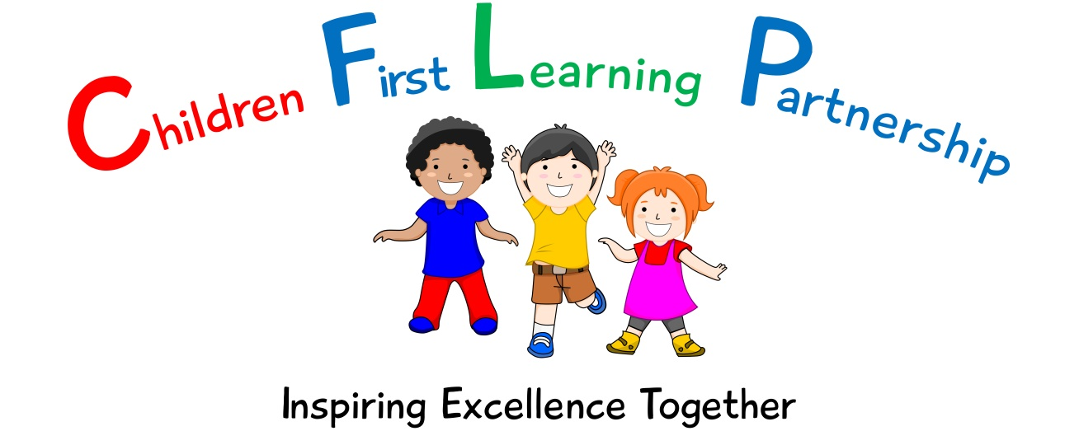

Maths Policy for
Kingsfield First School
2022-2023

February 2024 or earlier if required
To be reviewed:
07.02.22
Agreed and ratified by the Directors Board on:
Mrs R Butler - Headteacher
Responsible Officer:
Mr C. Clulow
Chair of Board:
The MathsPolicy 2022-2024 in respect of Kingsfield First School has been discussed and adopted by the Children First Learning Partnership Directors Board

Children First Learning Partnership
Maths Policy 2022
The overall intent of our school curriculum is to:
Recognise uniqueness: in our pupils, staff, resources and whole school community.
Be Inclusive: recognising learning styles, learning needs at all levels and providing solutions to any barriers to learning we encounter.
Engage and Inspire: Through knowledge rich, highly enriched, progressive and purposeful contexts.
Promote Aspiration: offering challenge, accountability and responsibility for their learning.
Create citizens of the Future: who thrive on responsibility, see difference as a strength of our community and use democracy to embed their own values and beliefs.
Our Maths curriculum strives to drive all of these intentions and links very closely to the achievement and development of them all.
Intent
- To ensure the children have a sound understanding of all mathematical concepts, we use the CPAR approach (Concrete, Pictorial, Abstract and Reasoning). Children need to make links between practical equipment, pictures and abstract numbers because they learn in different ways. The CPAR approach helps children learn new ideas and build on their existing knowledge by introducing abstract concepts in a more familiar and tangible way.
- We build on this with rich connections across mathematical ideas to develop fluency, mathematical reasoning and competence in solving increasingly sophisticated problems.
- This ensures that across the Children First Learning Partnership we provide a high quality maths curriculum that is both challenging and enjoyable, whilst expanding inquisitive and resilient minds.
Implementation-
A Unit of Work (Pathway)
Across the Children First Learning Partnership, a unit pathway enables all staff to have a clear understanding of how individual, sequenced components enables all children to have a clear composite understanding of each unit. Each unit will consist of:
- National Curriculum programmes of study
- White Rose Maths small steps
- Prior Learning
- Working Walls
- Vocabulary
- Teach-C-P-A-R (Concrete, Pictorial, Abstract and Reasoning).
- Application-varied fluency, reasoning, problem solving
- Assess
The calculation policy shows the methods we teach to solve addition, subtraction, multiplication and division problems and the progression across the school. Across the Children First Learning Partnership, children are taught a range of mental and pencil-and-paper methods, and encouraged to consider when different methods are appropriate and efficient.
A Lesson
Within each and every lesson, there are various sequential components which enables all children to progress no matter their ability. Below shows the sequenced order of a typical Mathematics lesson across the Children First Learning Partnership.

- Daily counting / time tables
- Mental starter
- Shared learning objective, success criteria and unit specific vocabulary
- Teaching exposition with opportunities to discuss learning with learning partners- Children encouraged to speak in full sentences.
- Practise - Use of manipulatives - concrete, pictorial, abstract and reasoning approach
- AfL question/task
- Scaffolding learning activities linked to the learning object to ensure all children achieve the learning outcome.
- Problem solving + reasoning- Children encouraged to explain and justify their thinking (independently and through guided sessions)
- Evaluate-refer to learning objective and success criteria
Lessons are planned from the correct year groups Programmes of Study from The National Curriculum. Teachers will be aware of the pre units that need to be secure from previous year groups to ensure new content can be understood. The Programmes of Study are then broken down into smaller steps to ensure lessons are driven by sharp learning objectives that are progressively linked.

Individual lessons are carefully designed using the most effective teaching materials so that pupils are given the best opportunities to show their understanding. Variation is consciously built in by teachers so that pupils can apply their learning to different contexts and make links.

Mathematical Language
Across the Children First Learning Partnership, we understand that mathematical language is crucial to children’s mathematical thinking. So we introduce new words from the curriculum in a suitable context, with relevant real objects, mathematical apparatus, pictures and/or diagrams, explaining their meanings carefully. Key vocabulary used in a topic are displayed on the Maths working walls.
In most lessons children work in pairs; discussing, explaining, disagreeing and proving maths ideas are integral to building understanding. Children work together so that through their dialogue they can develop a much stronger understanding.

All adults model the correct use of mathematical language and insist pupils do the same. Sentence stems are used to support children to speak about their work in full sentences using the correct terminology. Children understand and remember concepts far better when an answer is given within the context of a number sentence.

Manipulatives
A manipulative is a physical object that children or teachers can touch and move which is used to support the teaching and learning of mathematics. In our lessons Numicon, Cuisenaire rods and Dienes blocks (and many more) are used regularly to support children to engage with mathematical ideas. Manipulatives are carefully selected to be the most appropriate and effective.

Pitch, Pace and Challenge
Across the Children First Learning Partnership, the expectation is that the majority of children will move through the topics at broadly the same pace. However, decisions about when to progress will always be based on the security of children’s understanding and their readiness to progress to the next stage. Children who grasp concepts rapidly will be challenged through being offered rich and sophisticated problems before any acceleration through new content. Those who are not sufficiently fluent with earlier material will consolidate their understanding, including additional practice, before moving on.
Solving Problems
Across the Children First Learning Partnership, we teach a variety of problem-solving strategies which enable them to make sense of unfamiliar situations and tackle them intelligently.
Class teachers will seek opportunities for teaching problem solving strategies and more open ended investigations that reinforce the unit of learning and encourage children to use their reasoning skills. Within this, children will be encouraged to predict, work systematically, justify, test their answers, record and identify patterns. All children will regularly access problem solving and reasoning activities linked to the unit of work.

RUCSAC is an acronym displayed in every KS2 classroom and discussed with children within KS1 to help children remember how to tackle mathematical word problems. Read, Understand/ Underline, Choose, Solve, Answer, Check. You can help children to understand this further with these simple explanations:
- Read: Read the question. What is the important information?
- Understand/ Underline: Understand the question. What do you need to find out?
- Choose: Choose the correct method of calculation and operation(s).
- Solve: Solve the problem. Make sure you follow the steps.
- Answer: Answer the question. What were you meant to find out?
- Check: Check your answer. Use the inverse to check working out.
Bar modelling is also used to help children understand a problem. Bar models are pictorial representations of problems or concepts that can be used for any of the operations: addition, subtraction, multiplication and division. In word problems, bar models hold the huge benefit of helping children decide which operations to use or visualise problems.
While working on a problem, children are encouraged to ask questions like, ‘What am I trying to work out?’, ‘How am I going about it?’, ‘Is the approach that I’m taking working?’, and ‘What other approaches could I try?’ When the problem is completed, encourage children to ask questions like, ‘What worked well when solving this problem?’, ‘What didn’t work well?’, ‘What other problems could be solved by a similar approach?’, and ‘What similar problems to this one have I solved in the past?’ Children should communicate their thinking verbally and in writing—using representations, expressions, and equations— to both teachers and other children.
Pupils are encouraged to develop a ‘have a go’ attitude and are comfortable with making mistakes, as they are seen as part of the learning process. Working out and understanding the mathematics is valued more than the answer.

Mathematical Knowledge
Quick and automatic retrieval of number facts is important for success in mathematics. It is likely that children who have problems retrieving addition, subtraction, multiplication, and division facts, including number bonds and multiples, will have difficulty understanding and using mathematical concepts they encounter later on in their lessons. Across the Children First Learning Partnership, we ensure that children are given ample opportunities to develop fluent recall and automaticity of number facts. Mental starters are used at the start of lessons in a variety of ways to ensure prior learning is revisited and reinforced. In Foundation Stage and Key Stage One the children also take part in daily counting. In Key Stage Two times tables and number facts are taught daily to develop fluency and automaticity.

Impact-
What we aim to achieve from our maths curriculum across the Children’s First Learning Partnership

- ‘Mastery’ is something we want all children to achieve and involves utilising a range of strategies to help children develop a deep and secure knowledge and understanding of maths.
- All staff model positive attitudes towards maths and a belief that all pupils can succeed.
- An enjoyment and curiosity of mathematics and for children to feel confident to become successful;
- Children’s abilities to use and apply mathematics to solve problems in both the classroom and in ‘real life’ contexts;
- A confidence to communicate ideas in written form and orally;
- Independent and collaborative ways of working, encouraging children to share ideas and solve problems together;
- A wide range of mathematical vocabulary to be modelled and used in the classroom;
- The children’s ability to recall mental facts accurately and quickly and using effective written calculation methods;
- Children’s logical thinking, reasoning and ability to problem solve as transferable life skills.
Assessment
Our impact will be measured by using both formative and summative assessment.
Formative
Assessment is not just used to track children’s learning through the use of assessment trackers but also provides teachers with up-to-date and accurate information about the specifics of what children do and do not know. This information allows teachers to adapt their teaching so it builds on children’s existing knowledge, addresses their weaknesses, and focuses on the next steps that they need in order to make progress.
Across the Children First Learning Partnership, assessment in Maths is continuous. From the beginning of every lesson, teachers and teaching assistants will be assessing what their children are, or are not understanding and use this to scaffold each segment of the lesson. Interventions will be both planned for and ‘live’, meaning that misconceptions are dealt with immediately and high attaining children are challenged appropriately. We pride ourselves in our use of AFL to identify and direct children’s next steps in learning. Our staff are highly skilled to provide a personalised and flexible curriculum for individual children that may need reasonable adjustments to the curriculum. These adaptations increase access to the lesson content enabling them to reach their full potential.
Effective marking and feedback are an important element of teachers’ responses to children’s learning. This may be given either orally during live marking or during a marking conference, but is always:
- specific, accurate, and clear
- celebrates success
- compares what a pupil is doing right now with what they have needed to improve before
- provides specific guidance on how to improve as their next step
Summative
As part of our assessment and to support teacher’s judgements, each class will undertake a termly formal assessment, which assesses termly concepts that have been taught. This is then converted and analyzed through scaled scores which are evaluated termly by maths leaders.
Role of Leaders
- Plan an effective and varied schedule of monitoring including moderation, which is triangulated through our in school, leader and triad moderation, so that we know the Quality of Education in Mathematics is implemented and embedded throughout the school and the CFLP.
- Respond quickly and supportively to all barriers preventing outstanding implementation and impact in Mathematics.
- Use assessment information to provide effective CPD and challenge.
- Provide clear updates to the Local Advisory Board, Headteacher and SLT.

Version Control

Version | Review Date | Changes Made
V2 | 14.01.2022 | CPAR approach (Concrete, Pictorial, Abstract and Reasoning).
V2 | 14.01.2022 | Change the order of ‘a lesson’ with the addition of daily counting / times tables, the rearranging of the AFL being moved to after the practise, Differentiated changed to scaffolding and with the addition of (independent and through guided sessions) on the problem solving and reasoning
V2 | 14.01.2022 | Through the document ‘At Children First Learning Partnership change to Across the Children First Learning Partnership
V2 | 14.01.2022 | Within ‘solving problems’ - RUCSAC is an acronym displayed in every KS2 classroom and discussed with children within KS1 to help children remember how to tackle mathematical word problems. Read, Understand/ Underline, Choose, Solve, Answer, Check. You can help children to understand this further with these simple explanations:
V2 | 14.01.2022 | Within ‘mathematical knowledge’ – the addition to automaticity of number facts
V2 | 14.01.2022 | Within ‘Assessment’ – the wording ladders has been exchanged with trackers
V2 | 14.01.2022 | Within ‘Assessment’ - Effective marking and feedback are an important element of teachers’ responses to children’s learning. This may be given either orally during live marking or during a marking conference.
V2 | 14.01.22 | Within ‘Role of the Leaders’ the moderation process has been included.

