Kingsfield First School Year 1 Home Learning Menu
Please complete a selection of activities each day from the table below
English |  |  | Maths
Challenge 1 | Challenge 2 | Challenge 3 | Challenge 1 | Challenge 2 | Challenge 3
See  e-mail | Read, ‘Fee! Fi! Fo! Fum!’ We don’t see the Giant in the story. Draw a picture of what you think he looks like and write adjectives to describe him. | Read, ‘Fee! Fi! Fo! Fum!’ We don’t see the Giant in the story. Draw a picture of what you think he looks like and write sentences to describe him. | There is a range of puzzles for you to solve below. Take your pick  How many can you solve?
See  e-mail | Write a setting description for Grandma’s house. You can write about the inside or the outside. Make sure you use 2A sentences. | Write a setting description for Grandma’s house. You can write about the inside, outside – or even both. Make sure you use 2A sentences and conjunctions (and, but) | Log onto Education City and play on Play Live. Let your teacher know your best score! | Log onto Education City and play on Play Live. Let your teacher know your best score! | Log onto Education City and play on Play Live. Let your teacher know your best score!
Read ‘The Three Billy Goats Gruff’, and answer the questions on the  following page. |  |  | Go to https://www.topmarks.co.uk/learning-to-count/place-value-basketball Choose numbers up to 19. | Go to https://www.topmarks.co.uk/learning-to-count/place-value-basketball Choose numbers up to 29. | Go to https://www.topmarks.co.uk/learning-to-count/place-value-basketball Choose numbers up to 49.

Go on Education City and choose some English activities. There are lots of reading and writing ones to choose from. | Go to Education City and choose some Maths activities. Why don’t you have a go on Play Live.
Go to YouTube and search for ‘Twinkl Story Time’. Listen to the story and ask your child some of the questions below. | Go to NumBots and play in either ‘Story’ or ‘Challenge’ mode.
Create an account on Oxford Owls. There are lots of online books and phonics activities to do. | Create a free parents account at https://www.themathsfactor.com/games/ Play a range of maths based games.

There are a range of daily online lessons available on https://www.thenational.academy/online-classroom/year-1#schedule and https://www.bbc.co.uk/bitesize/tags/zjpqqp3/year-1-and-p2-lessons/1 which you may find useful for your child.
Phonics
Challenge 1 | Challenge 2 | Challenge 3
Log on to Phonics Play (Username: march20 Password: home) and play Buried Treasure– Phase 3. | Log on to Phonics Play (Username: march20 Password: home) and play Buried Treasure – Phase 5. | Log on to Phonics Play (Username: march20 Password: home) and play Buried Treasure – Phase 5.
Go to YouTube and search for Geraldine the Giraffe does ‘ch’ Can you write the words? | Go to YouTube and search for Geraldine The Giraffe does ‘ea’ Can you write the words? | Go to YouTube and search for Geraldine The Giraffe does ‘aw’ Can you write the words?
Write ‘ch’ words on pieces of paper and draw a picture on another piece to match each word. Then ask someone to play Snap with you. | Write ‘ea’ words on pieces of paper and draw a picture on another piece to match each word. Then ask someone to play Snap with you. | Write ‘aw’ words on pieces of paper and draw a picture on another piece to match each word. Then ask someone to play Snap with you.
Topic
Draw a picture of your Teacher and/or Teaching Assistant from this year. Write words around the picture to describe them. Please be nice! Please send us your pictures, we would love to see them.
What are your favourite memories from Year 1? Draw or write (or both) about some of the things we have done this year such as when the Toy Man came and helped us all to make a wooden toy, Forest School, swimming (Perfect Panthers only) or some of the wonderful topics or lessons we have had.

What are you most looking forward to about next year? It might be your new teacher, classroom or topics. It is really exciting going to a new class – we know you will have a great time

Maths – ALL
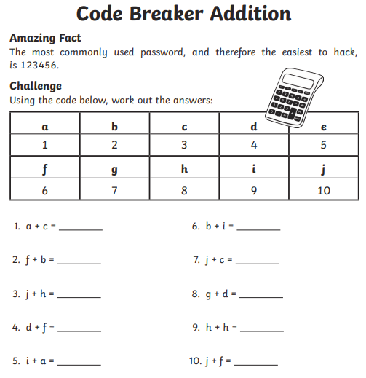
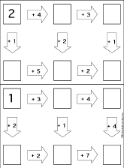

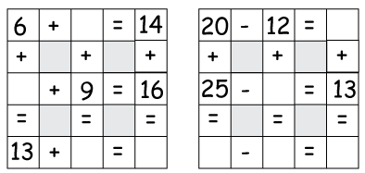

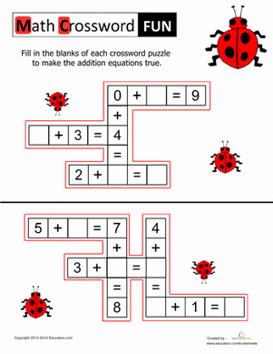
Reading
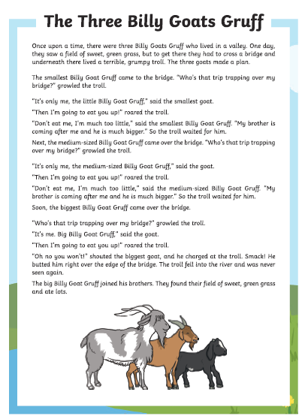
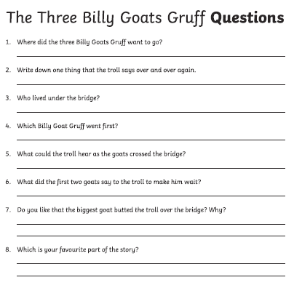

Reading Questions
