Kingsfield First School Year 1 Home Learning Menu
Please complete a selection of activities each day from the table below
English |  |  | Maths
Challenge 1 | Challenge 2 | Challenge 3 | Challenge 1 | Challenge 2 | Challenge 3
See  e-mail | Read, ‘Little Red Riding Hood.’ She takes a basket of goodies to her Grandma’s house. Write a list of things she might put in the basket. | Read, ‘Little Red Riding Hood.’ She takes a basket of goodies to her Grandma’s house. Write a list of things she might put in the basket, using 2As to describe. Such as 2 red, juicy apples) | Use the feet to help you count in 10’s. How far can you get? | Use the feet to help you count in 10’s. How far can you get? | Counting in 10’s. Count in 10’s along the kite tail.
See  e-mail | Write a character description about either Red, Granny, The Wolf or The Woodcutter. Use the words below to help you and use 2A sentences. | Write a character description about either Red, Granny, The Wolf or The Woodcutter. How many wonderful words can you use and don’t forget 2As. | Counting in 10’s.  https://www.ictgames.com/mobilePage/duckShoot/index.html Shoot the ducks in multiples of 10. | Counting in 10’s. Cut and stick the 10’ss numbers in order. | Counting in 10’s. Complete the hundred square first, then use it to help you count in 10’s from different numbers.
Read ‘All About The Fox, and answer the questions on the  following page. |  |  | Count in 10’s along the ice lollies. | Work out the answers to the counting in 10’s problems (purple border). | Work out the answers to the counting in 10’s problems (purple border).

Go on Education City and choose some English activities. There are lots of reading and writing ones to choose from. | Go to Education City and choose some Maths activities. Why don’t you have a go on Play Live.
Go to YouTube and search for ‘Twinkl Story Time’. Listen to the story and ask your child some of the questions below. | Go to NumBots and play in either ‘Story’ or ‘Challenge’ mode.
Create an account on Oxford Owls. There are lots of online books and phonics activities to do. | Create a free parents account at https://www.themathsfactor.com/games/ Play a range of maths based games.

There are a range of daily online lessons available on https://www.thenational.academy/online-classroom/year-1#schedule and https://www.bbc.co.uk/bitesize/tags/zjpqqp3/year-1-and-p2-lessons/1 which you may find useful for your child.

Phonics
Challenge 1 | Challenge 2 | Challenge 3
Log on to Phonics Play (Username: march20 Password: home) and play Space Race– Phase 3. | Log on to Phonics Play (Username: march20 Password: home) and play Dragon’s Den – Phase 5. | Log on to Phonics Play (Username: march20 Password: home) and play Acorn Adventures – Phase 5.
Go to YouTube and search for Geraldine the Giraffe does ‘igh’ Can you write the words? | Go to YouTube and search for Geraldine The Giraffe does ‘u-e’ Can you write the words? | Go to YouTube and search for Geraldine The Giraffe does ‘ew’ Can you write the words?
How many words can you make with the ‘igh’ sound? Draw a picture to go with each word then use them to test yourself or your grown up during the week. | How many words can you make with the ‘u-e’ sound? Draw a picture to go with each word then use them to test yourself or your grown up during the week. | Write ‘ew’ words on pieces of paper and draw a picture on another piece to match each word. Then ask someone to play Snap with you.

Topic
Little Red Riding Hood took a picnic basket full of delicious treats to her Grandma. Make a picnic to eat with someone at home. It could be a brother or sister or a grown up. If it’s sunny you can eat it on a blanket outside or if not have an indoor picnic.
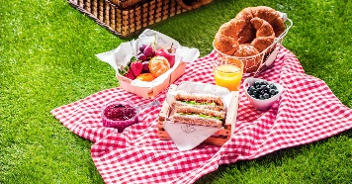
Little Red Riding Hood had a long walk through the forest to get to Grandma’s house. Draw a map of the forest with a path leading all the way to Grandma’s house. Think about what you might see in the forest – trees, other houses, maybe even a small pond.
Time for some Art! Create a picture of the forest. You can include Grandma’s house or any of the characters if you want to. There are many ways you can do this. You could draw and colour, paint, collage – the choice is yours! I can’t wait to see your results.

Maths – Challenge 1
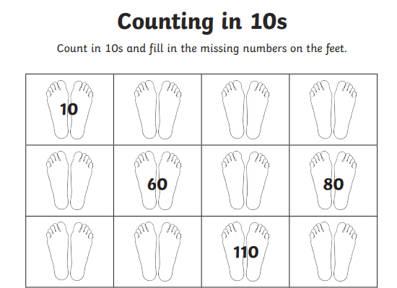

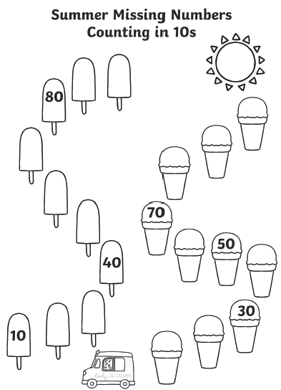

Maths – Challenge 2
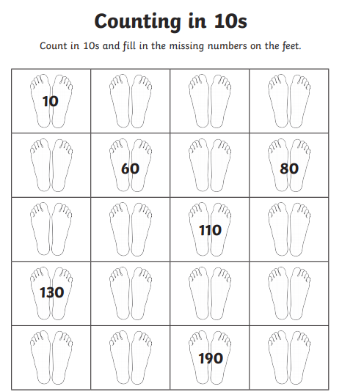

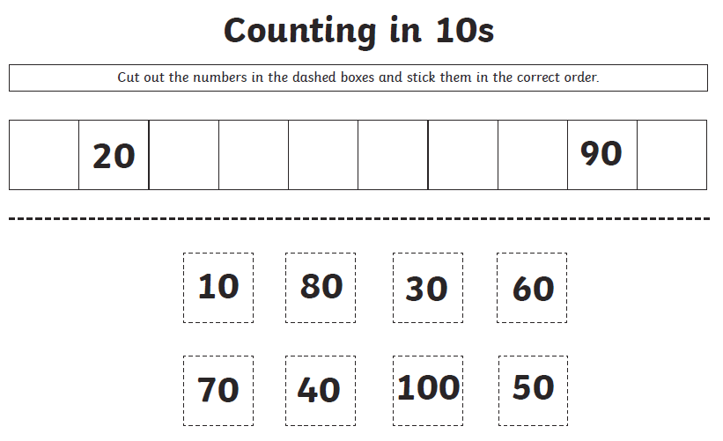
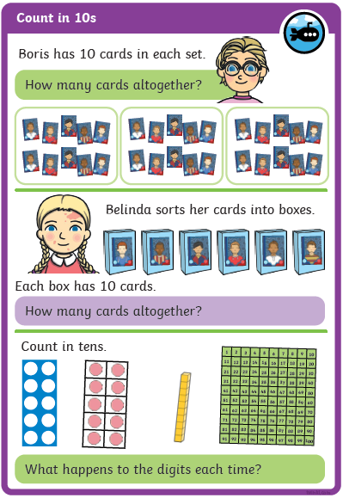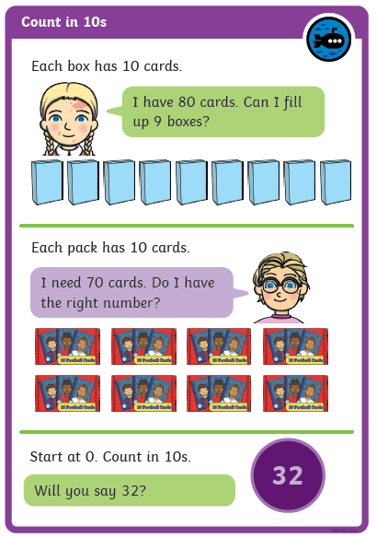
Maths - Challenge 3
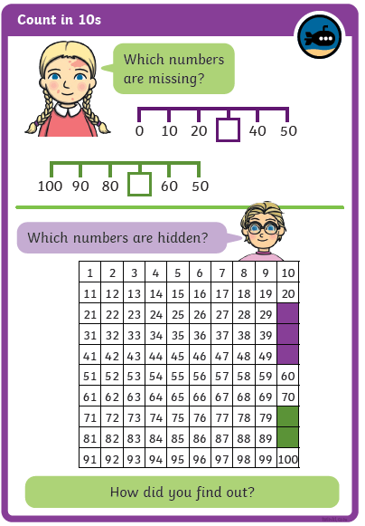
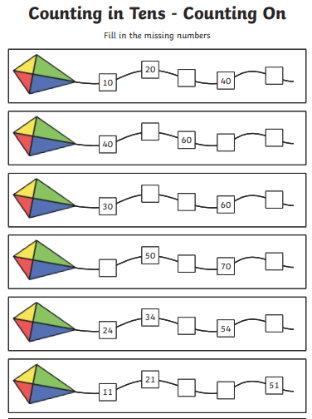

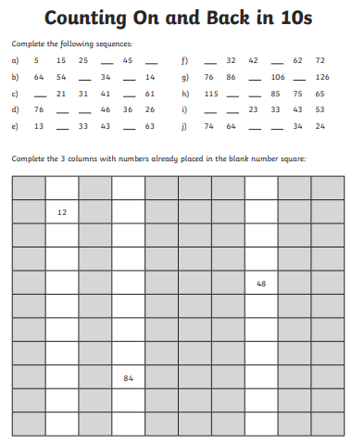

Reading
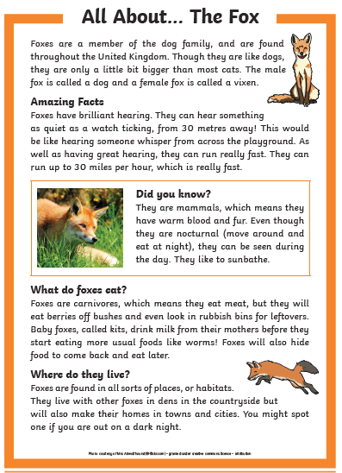

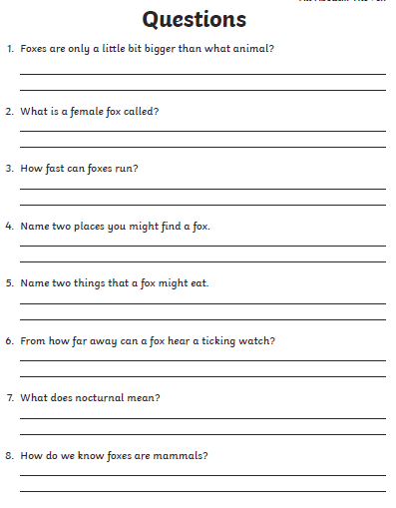

Reading Questions
