Year 2
Please find todays learning tasks below.
The table below explains the tasks and you will find the resources underneath.
Your child will know which challenge they usually access in each subject and which task will be appropriate for them.
Year group: 2 Date: 15.07.20
English | 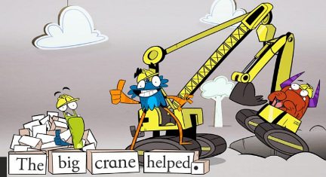  Share the link: https://www.bbc.co.uk/bitesize/articles/z7b3trd  Remind yourself about the 4 different sentence types.  Question / Command / Statement / Exclamation
 | Challenge 1 | Challenge 2 | Challenge 3
Complete the tasks on the activity sheet below.
Matching the sentences – identifying the types of sentences etc.

Maths | 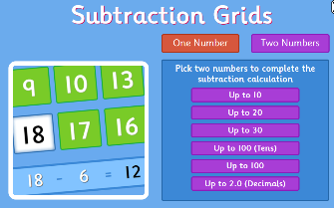  Share link and complete task: https://www.topmarks.co.uk/maths-games/subtraction-grids
 | Challenge 1 | Challenge 2 | Challenge 3
Complete the subtraction problems (see sheet below)
Remember for subtraction – you need to draw the biggest number and cross out the other to find your answer!

Reading  Phonics | Log in to Oxford Owl and continue to read the text ‘Beach Detective’ read / listen to the text from page 12 – 23.  Click on the link http://www.ictgames.com/mobilePage/forestPhonics/index.html  Phonics Forest spelling words – choose the a_e and o_e activities.
Other | Today we are continuing with our PSHRE / Memories / Transition  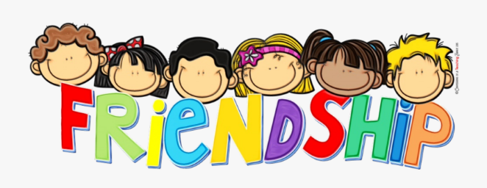  Today we want you to think about Friends and Friendship –  See the activity sheet below – draw pictures of you and your classroom friends. Then complete the writing.

Unless otherwise specified, please complete the tasks in either your home learning book or print out the document below.

English ALL Groups
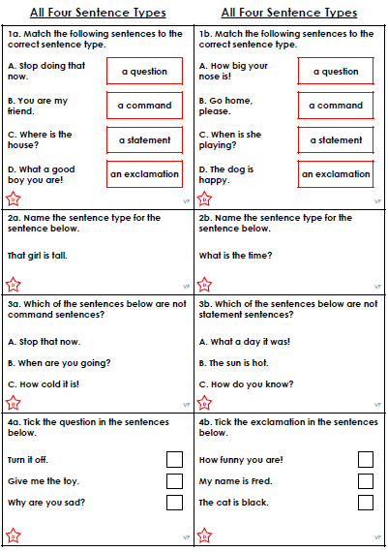

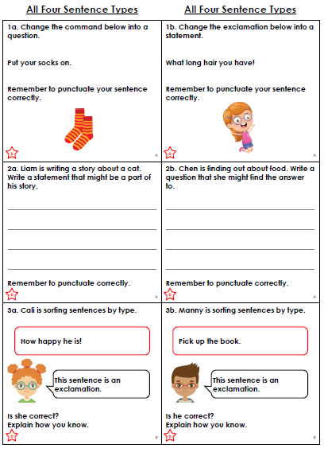

Maths ALL Groups
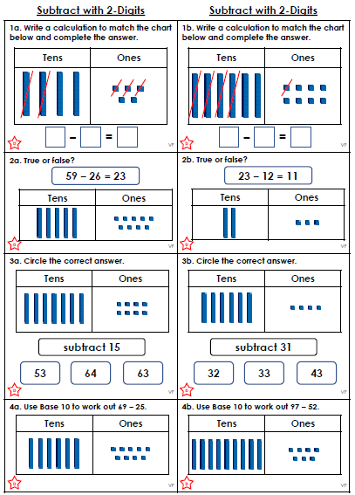
Topic Task
