Year 2
Please find todays learning tasks below.
The table below explains the tasks and you will find the resources underneath.
Your child will know which challenge they usually access in each subject and which task will be appropriate for them.
Year group: 2 Date: 08.07.20
English | 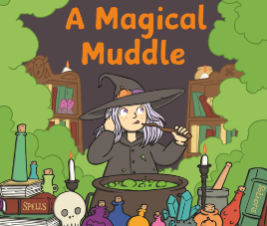  Reread the story ‘A Magical Muddle’ this time thinking about the character of Tabitha.
 | Challenge 1 | Challenge 2 | Challenge 3
 | Look at the activity sheet below and think about the character of Tabitha. Come up with 3 different headings and write a description of her. Think about what she looks like, what she does, what she enjoys doing etc.
Maths | 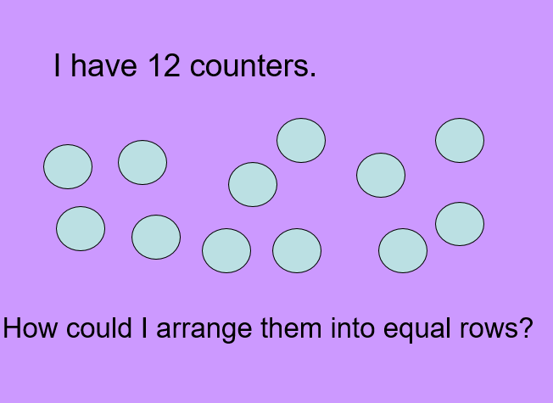  Complete the Arrays PPT as a warm up find all the different ways you can use an array to multiply and divide.
 | Challenge 1 | Challenge 2 | Challenge 3
 | Read the word problem – write the number sentence – draw the array to find the answer.  Remember to complete the reasoning questions. | Read the word problem – write the number sentence – draw the array to find the answer.  Remember to complete the reasoning questions.
Reading  Phonics | Complete the 60 second quick read sheet (see below) and answer the questions.  Complete the activity sheet below practicing the Common Exception Words and choosing the correct words to complete the sentences.
Other | Today we are continuing with our Art / D&T  Thinking about the character of Tabitha – look at the suggested craft activities below and create your own picture / image/ collage / painting using the ideas below.

Unless otherwise specified, please complete the tasks in either your home learning book or print out the document below.

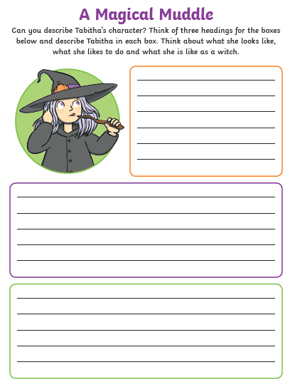
English ALL Groups

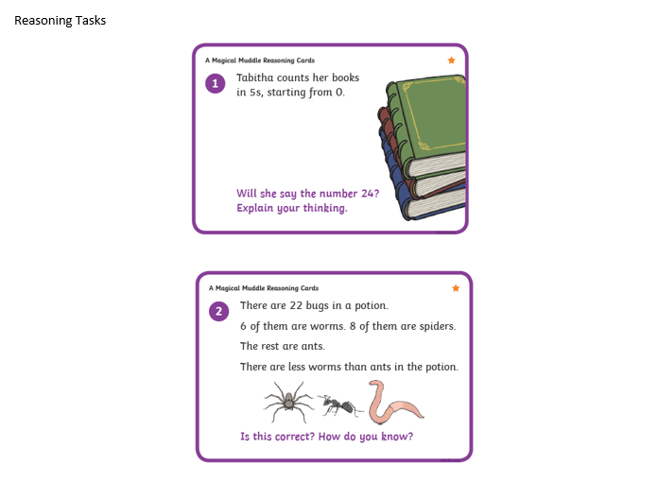
Maths Challenge 1
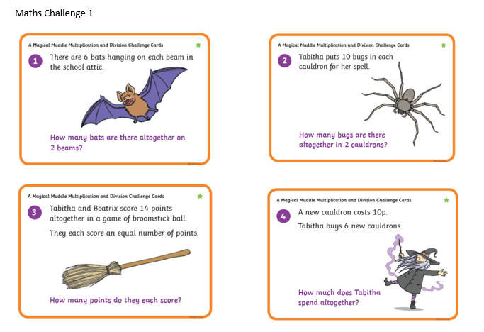

Maths Challenge 2 and 3

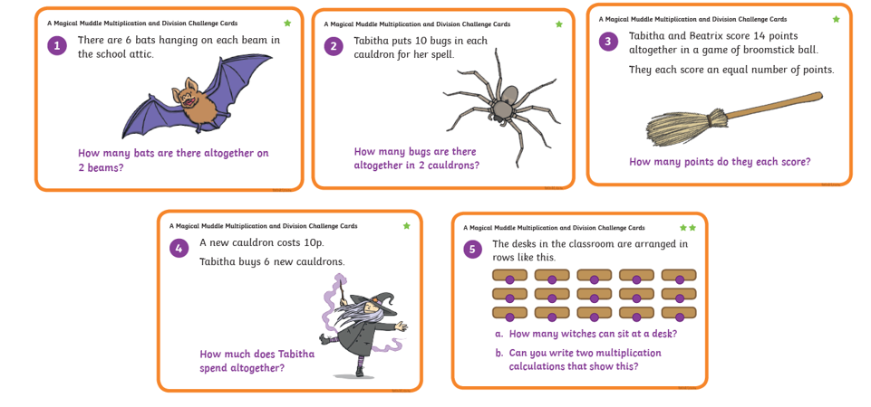

Maths Challenge 2 and 3 Reasoning

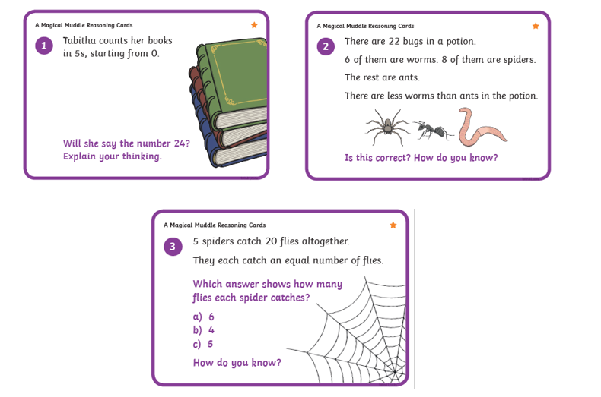

Reading Task
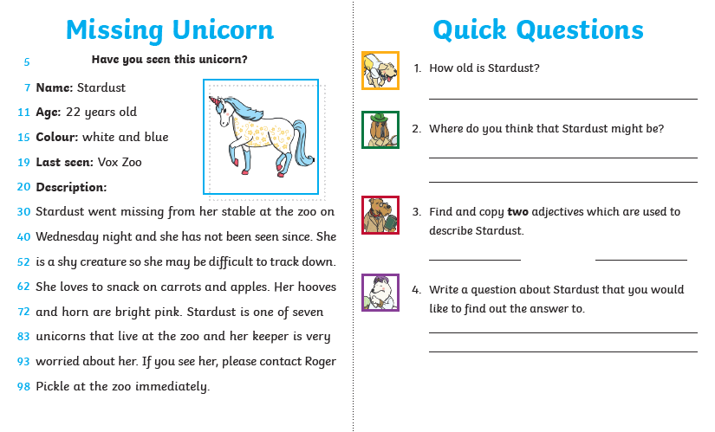

Spelling /SPAG Task
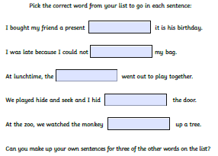
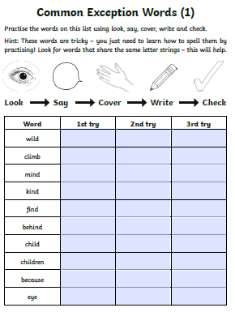

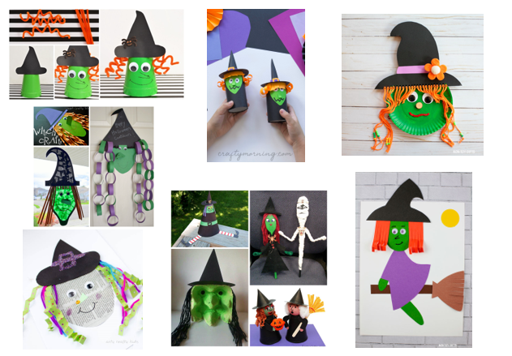
Topic Task

