Year 2
Please find todays learning tasks below.
The table below explains the tasks and you will find the resources underneath.
Your child will know which challenge they usually access in each subject and which task will be appropriate for them.
Year group: 2 Date: 16.07.20
English | Today you will write a short story called ‘A surprise at the Beach’  See sheet below for more ideas and some super vocab!  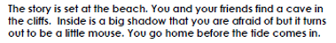
 | Challenge 1 | Challenge 2 | Challenge 3
Complete a super short story – use some of the vocabulary
on the sheet below to help may your story fabulous!

Maths | Warm Up – follow this link to complete your maths warm up.  https://www.topmarks.co.uk/maths-games/hit-the-button  Complete the Number Bonds activities.
 | Challenge 1 | Challenge 2 | Challenge 3
 | Complete the number activity below – working on subtraction.
Reading  Phonics | Log in again to Oxford Owl and continue to read / listen to ‘Beach Detective’ reading pages 24 -29.  Click on the link here: https://www.ictgames.com/littleBirdSpelling/  Complete the 7th bird box tasks – spelling common exception words.
Other | Today we are going to continue with our PSHRE / Transition / Memories  Starting to think about next year – which class will you be in? who is your new teacher? What are you looking forward to?

Unless otherwise specified, please complete the tasks in either your home learning book or print out the document below.

English ALL challenges
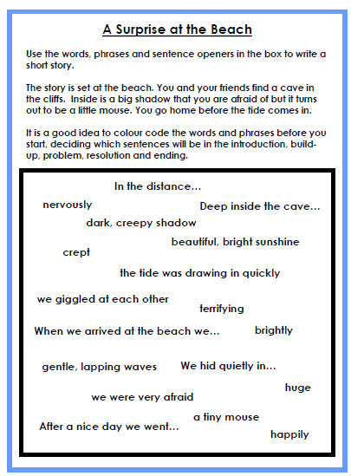
Maths Task
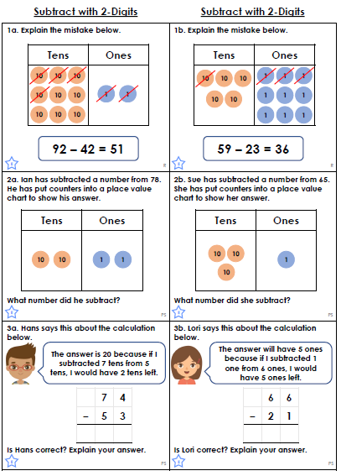
Topic Task
