Year 2
Please find todays learning tasks below.
The table below explains the tasks and you will find the resources underneath. Your child will know which challenge they usually access in each subject and which task will be appropriate for them.
Year group: 2 Date: 13.07.20
English | 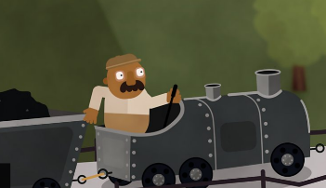  Share the link; https://www.bbc.co.uk/bitesize/articles/z6rvbdm  Learn all about conjunctions – words like and, but and because which we use to join 2 parts  of the sentence, these sorts of words don’t start sentences.
 | Challenge 1 | Challenge 2 | Challenge 3
 | Complete the activity sheet below exploring using the conjunctions.
Maths | Log in to TT Rock Stars to complete your x tables challenges  (your login is in your Blue Home School Book)
 | Challenge 1 | Challenge 2 | Challenge 3
 | Practice adding tens and ones to complete the problem cards on the worksheet below – you can draw tens and ones to help like on the sheet!
Reading  Phonics | Complete the Reading Prediction Task (See sheets below)  Complete the Common Exception Words Task (see sheet below)
Other | This week we are going to focussing on PSHRE / Transition /Memories  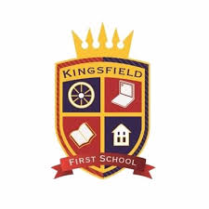  Today you can complete a page about Our School – you could draw the badge / draw the school and complete the information (the word Principal is another word for head).  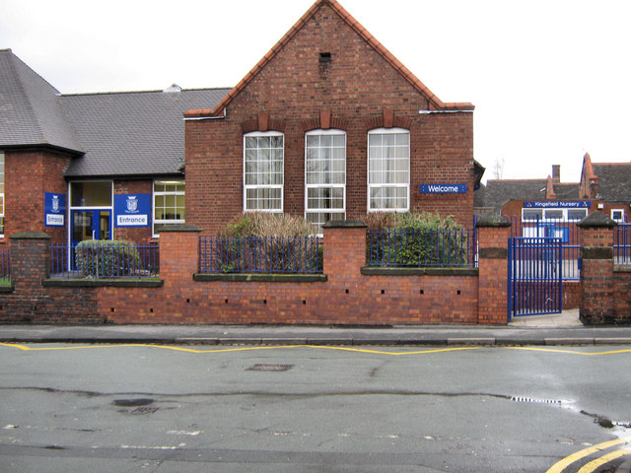

Unless otherwise specified, please complete the tasks in either your home learning book or print out the document below.

English ALL Challenges
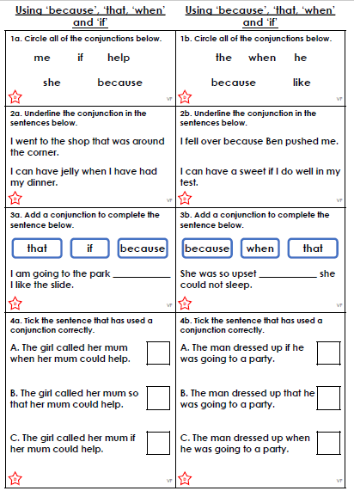

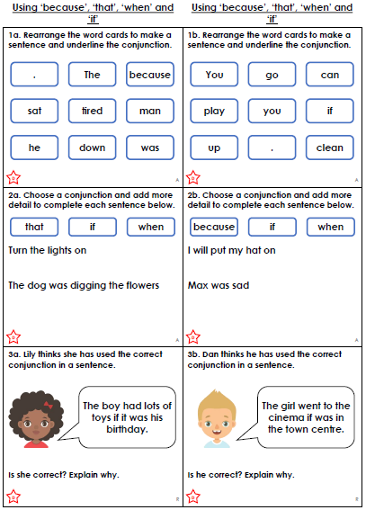

Maths ALL Challenges
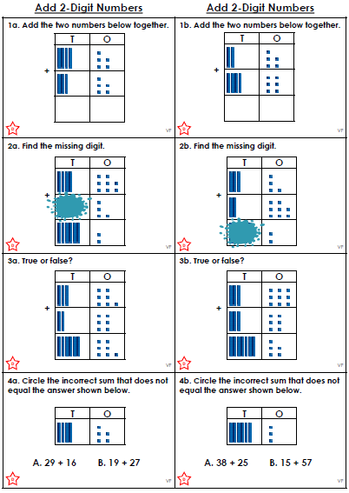

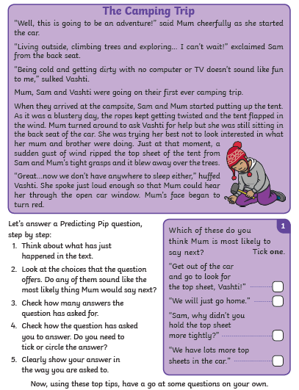
Reading Task – Making Predictions about the text
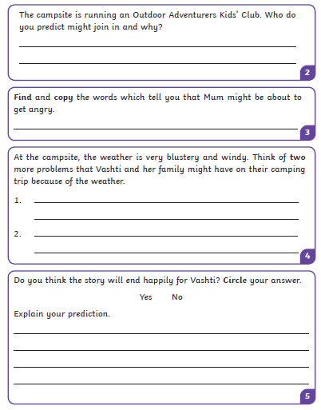

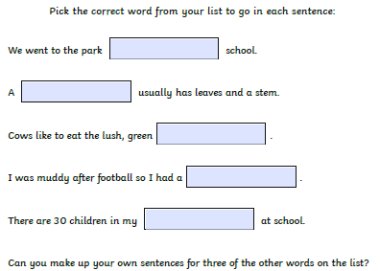
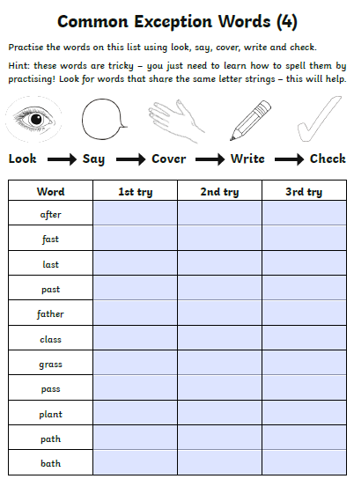

Topic Task
