Year 2
Please find todays learning tasks below.
The table below explains the tasks and you will find the resources underneath. Your child will know which challenge they usually access in each subject and which task will be appropriate for them.
Year group: 2 Date: 06.07.20
English | 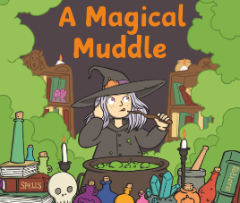  This week our work is going to be based around the story  ‘A Magical Muddle’ share the story a PDF of the story is on the website.
 | Challenge 1 | Challenge 2 | Challenge 3
 | Now you have read the story, you are going to be creating a story board of the story thinking about the sequence of the story and either use the activity sheet / draw your own story map on a page in your book. Pictures and keywords. | Now you have read the story, you are going to be creating a story board of the story thinking about the sequence of the story and either use the activity sheet / draw your own story map on a page in your book. Pictures and keywords.  You are not rewriting the story – you are putting keywords onto your map and building up the sequence of the story.
Maths | Log in to TT Rock Stars to complete your x tables challenges  (your login is in your Blue Home School Book)
 | Challenge 1 | Challenge 2 | Challenge 3
Today you will be learning about Solving Problems to identify a hidden number.

Share the link: http://www.wldps.com/gordons/Wizards_number.swf

Use the clues to help you find which number is hidden under the Wizard’s hat.

Reading  Phonics | Complete the Reading Comprehension Task (See sheets below)  Complete the questions on the Spelling / SPAG sheet below.
Other | 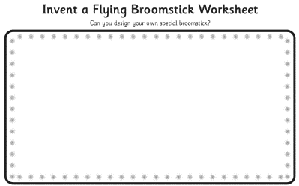  Today’s task is to design your own Broomstick and think about what special powers it might have!

Unless otherwise specified, please complete the tasks in either your home learning book or print out the document below.

English ALL challenges

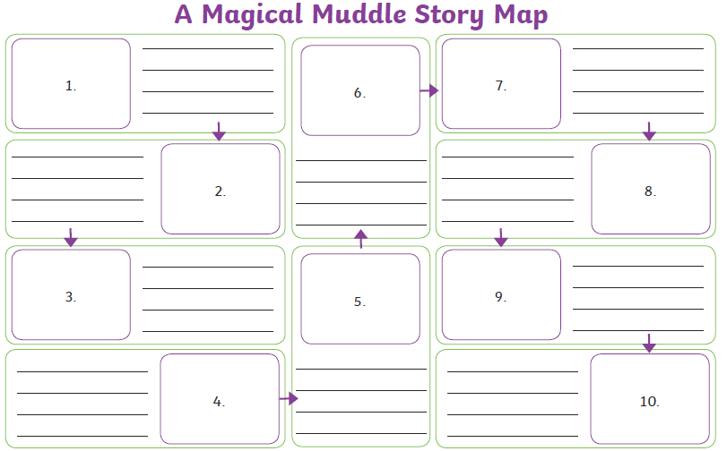

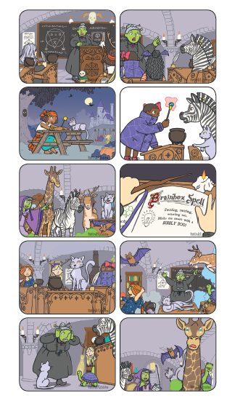

Reading Task ALL groups
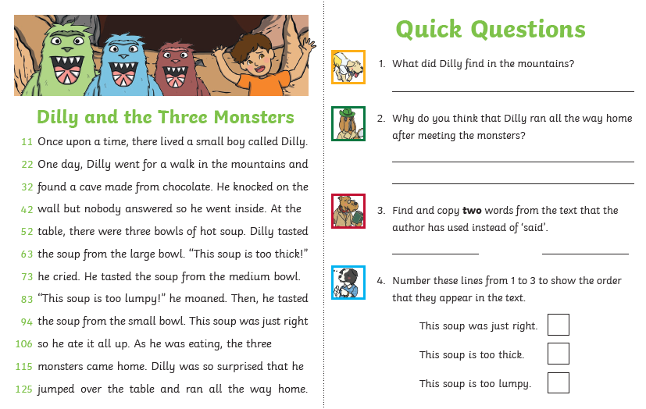

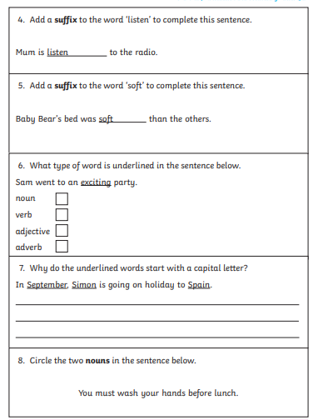
Spelling /SPAG Task

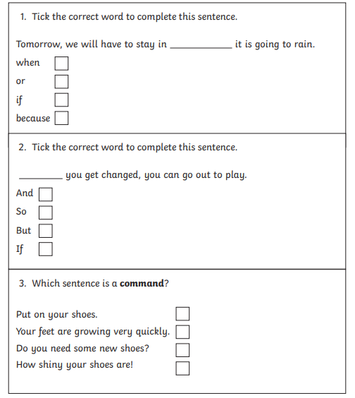

Topic Task
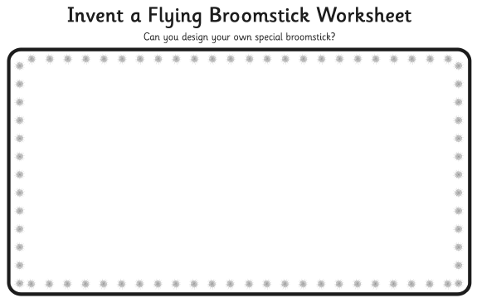

What name would you give your broomstick? ________________________________

Does it have any special powers? ____________________________________________________________________________________________________________________________________________________________________________

