Year 2
Please find todays learning tasks below.
The table below explains the tasks and you will find the resources underneath.
Your child will know which challenge they usually access in each subject and which task will be appropriate for them.
Year group: 2 Date: 17.07.20
English | 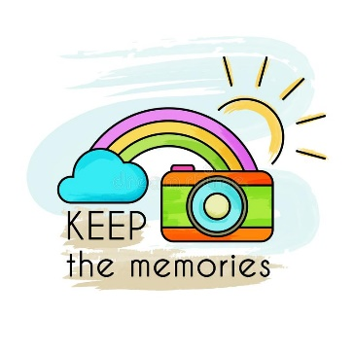
 | Challenge 1 | Challenge 2 | Challenge 3
 | Complete your memories sheet (see below) thinking about your memories of Year 2.
Maths | 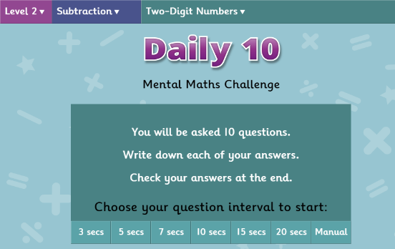  Share the link:  https://www.topmarks.co.uk/maths-games/daily10  Chose level 2 - Subtraction - Two digit Numbers
 | Challenge 1 | Challenge 2 | Challenge 3
 | Complete the subtraction tasks (see sheet below)
Reading  Phonics | Log into Oxford Owl and complete the story – ‘Beach Detective’ reading/listening to pages 30 –end.  Share the link and activity on:  http://www.ictgames.com/mobilePage/phonicFinder/index.html  complete activities – sion, ssion and tion.
Other | 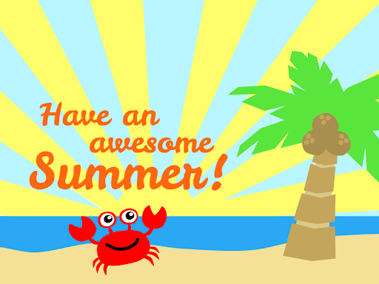  Today we would normally be having a really fun afternoon – end of year parties, extra playtimes and getting ready for the 6 week holidays so this afternoon we would like you to chill out – play in the garden – go for a walk – watch a film or choose whatever you want to do!!!!

Unless otherwise specified, please complete the tasks in either your home learning book or print out the document below.

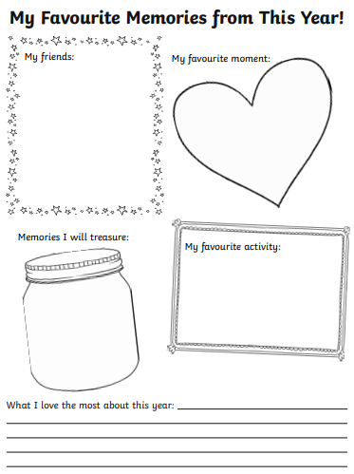
English All challenges

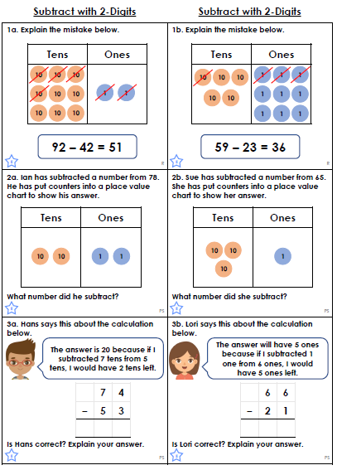
Maths Task

