Year 2

Please find todays learning tasks below.

The table below explains the tasks and you will find the resources underneath.

Your child will know which challenge they usually access in each subject and which task will be appropriate for them.

|  |  |  |  |
| --- | --- | --- | --- |
| **Year group: 2 Date: 10.07.20** | | | |
| **English** | Share the PowerPoint (on the website) ‘How to write the Perfect Magic Spell!’ | | |
|  | **Challenge 1** | **Challenge 2** | **Challenge 3** |
|  | Follow the instructions on the slides to help you come up with words and ideas to help you write your own Magic Potion!  What could you make a potion to do?  Perhaps make yourself invisible? Make somebody disappear? Change something into something else?  I’ve added some suggestions for your ingredients here  I’m sure you will have lots of brilliant ideas ☺ | | |
| **Maths** | **Complete the interactive ‘Add to 10 and Add to 100’ activity on the following link:**  <http://www.wldps.com/gordons/Triangular_cards.swf> | | |
|  | **Challenge 1** | **Challenge 2** | **Challenge 3** |
|  | The witch has lots of ingredients in her store cupboard.  What should she use to make her potion?  It must contain exactly 20 legs.  Investigate different combinations of creatures she can add to her witch’s brew!  How many different combinations can you find?  Complete the challenge extension – if you can! | | |
| **Reading**  **Phonics** | Complete the reading activity (sheet below).  Complete the activity sheet below practicing the Common Exception Words and choosing the correct words to complete the sentences. | | |
| **Other** | Today we are going to complete Music    Look at the PowerPoint (on the website) read through the words to the Make A Spell Song, then sing along using the tune from Twinkle, Twinkle… | | |

Unless otherwise specified, please complete the tasks in either your home learning book or print out the document below.

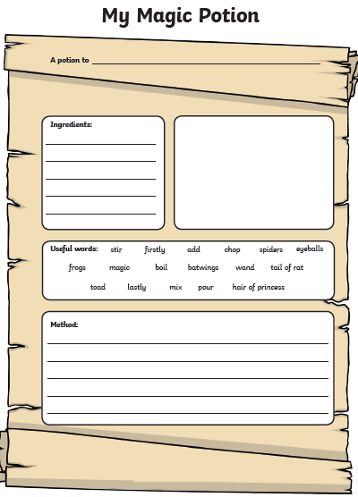**English All challenges**

Maths ALL Challenges

# The Witch’s Brew

The witch has lots of ingredients in her store cupboard. What should she use to make her potion? It must contain exactly 20 legs.

j0093345

For example:

1 spider, 1 boy, 1 frog and 1 bee = 8 + 2 + 4 = 6 = 20

________________________________________________________________________________________________________

Extension Challenge

Can you make the following number of legs in each potion?

12 ________________________________________

14 ________________________________________

18 ________________________________________

16 ________________________________________

Can you explain why you cannot make odd numbers like 13, 15 or 17?

_______________________________________________________________________________________________________________________________________________________________________________________________________________________________________________________________________________________________

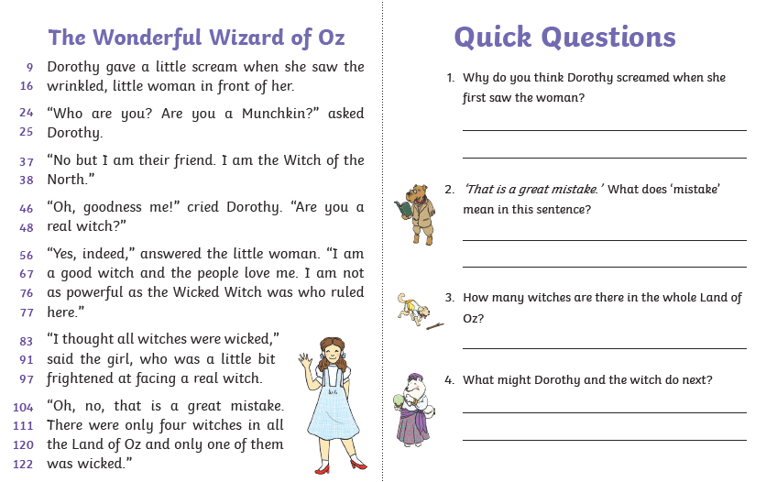Reading Task

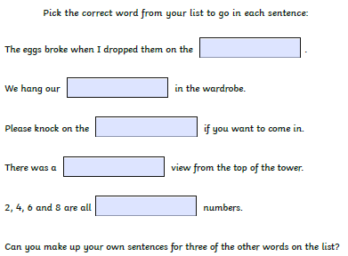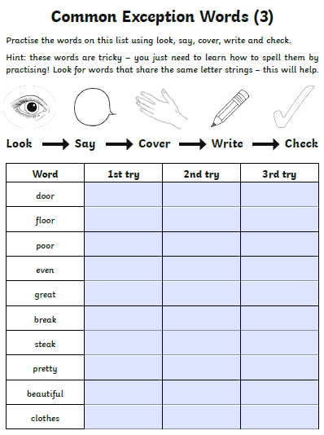Spelling / SPAG Task