Kingsfield First School Year 1 Home Learning Menu
Please complete a selection of activities each day from the table below
English |  |  | Maths
Challenge 1 | Challenge 2 | Challenge 3 | Challenge 1 | Challenge 2 | Challenge 3
See e-mail | Read, ‘What is the Bear Thinking?’ The bear only says ‘Grrr’. Write about what the bear is thinking in the picture. | Read, ‘What is the Bear Thinking?’ The bear only says ‘Grrr’. Write about what the bear is thinking in the picture and how you know. | Cut out the numbers and place them in order, counting in 2’s. | Counting in 2’s. Write in the missing numbers on the socks. Can you get all the way to 50? | Complete the sequences and then the hundred square below.
See e-mail | The children need to say thank you to the bear for looking after them. Write a thank you letter to the bear. | The children need to say thank you to the bear for looking after them. Write a thank you letter to the bear. Don’t forget to use 2A sentences! | Counting in 2’s. Write in the missing numbers on the paths. | Count the 2 pence coins in the jars. How much money is in each jar? | Complete the counting in 2’s numbers, colour in the 2’s numbers and finish the number line.
Read ‘Jazzy Jellyfish’ and answer the questions about the text. |  |  | Count the objects and complete the counting in 2’s sequences. | Answer the counting in 2’s reasoning questions below. | Answer the counting in 2’s reasoning questions below.

Go on Education City and choose some English activities. There are lots of reading and writing ones to choose from. | Go to Education City and choose some Maths activities. Why don’t you have a go on Play Live.
Go to YouTube and search for ‘Twinkl Story Time’. Listen to the story and ask your child some of the questions below. | Go to NumBots and play in either ‘Story’ or ‘Challenge’ mode.
Create an account on Oxford Owls. There are lots of online books and phonics activities to do. | Create a free parents account at https://www.themathsfactor.com/games/ Play a range of maths based games.

There are a range of daily online lessons available on https://www.thenational.academy/online-classroom/year-1#schedule and https://www.bbc.co.uk/bitesize/tags/zjpqqp3/year-1-and-p2-lessons/1 which you may find useful for your child.

Phonics
Challenge 1 | Challenge 2 | Challenge 3
Log on to Phonics Play (Username: march20 Password: home) and play Obb and Bob – Phase 3. | Log on to Phonics Play (Username: march20 Password: home) and play Obb and Bob – Phase 5. | Log on to Phonics Play (Username: march20 Password: home) and play Obb and Bob – Phase 5.
Go to YouTube and search for Geraldine the Giraffe does ‘ck’ Can you write the words? | Go to YouTube and search for Mr Thorne does ‘i-e’ Can you write the words? | Go to YouTube and search for Mr Thorne does ‘ie’ Can you write the words?
Write the ‘ck’ sound on a piece of paper. What other sounds can you put in front of it to make new words?  luck pack _ _ c k | Write the ‘i-e’ sound on a piece of paper. What other sounds can you put around the split digraph to make new words?  kite like _ i _ e | Write the ‘ie’ sound on a piece of paper. What other sounds can you put in front of it to make new words?  tie lied _ i e

Topic
Ask your grown to draw you the outline of a bear. Then hunt around your house to find bits of paper, card, fabric etc to make a collage with. Make sure you check before you cut anything!! Collage your bear and make him look fantastic!
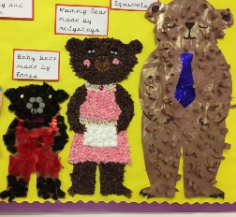
Research bears. You can use books or the internet. A grown up can help you if you need. Then you need to show what you have found out. You might want to make a poster or use the computer to show off your learning.
Where do bears live? Polar bears live in cold areas but brown bears prefer warmer weather. Design or make a habitat for a bear. For example a polar bear will live around ice, snow, icebergs etc.

Maths – Challenge 1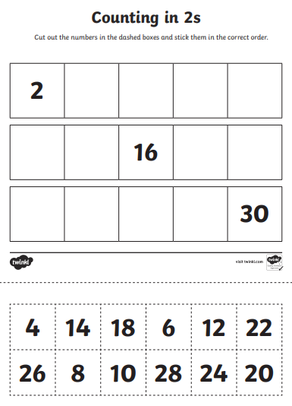 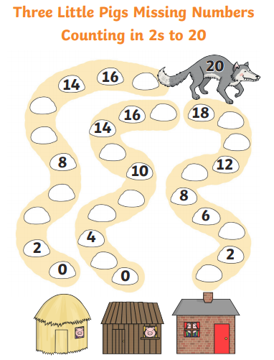

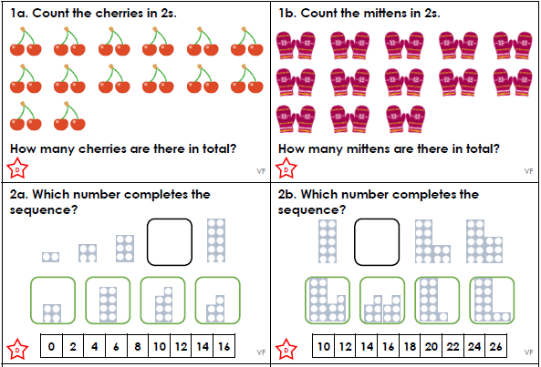
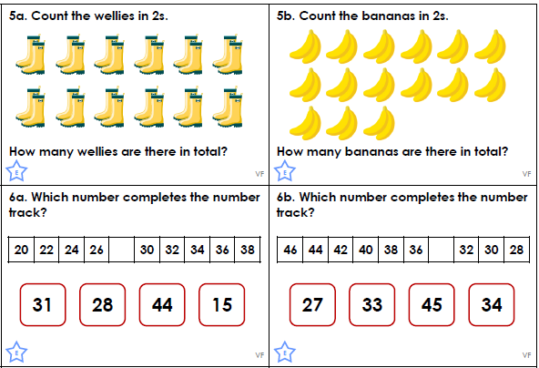

Maths – Challenge 2
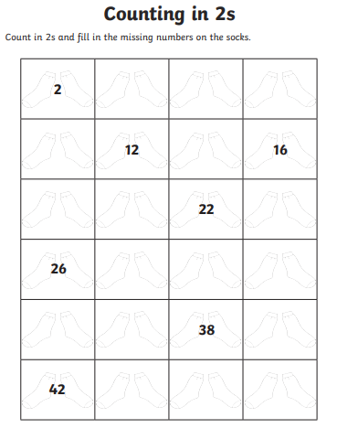

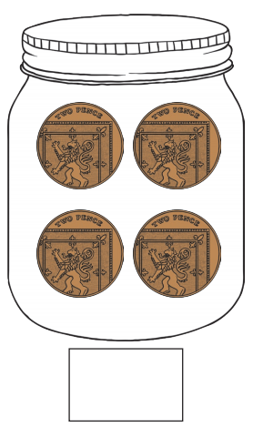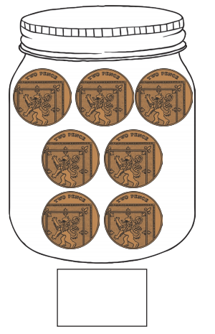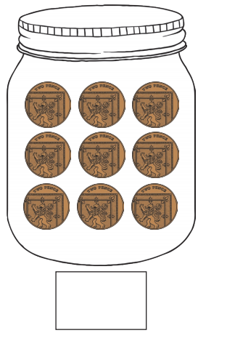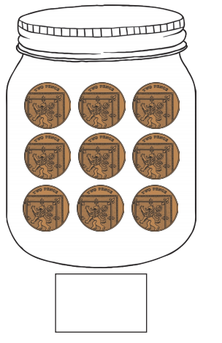

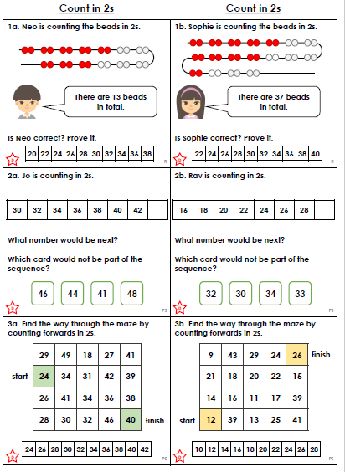

Maths – Challenge 3

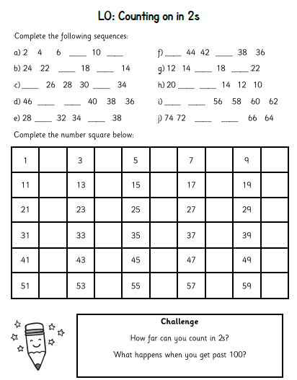

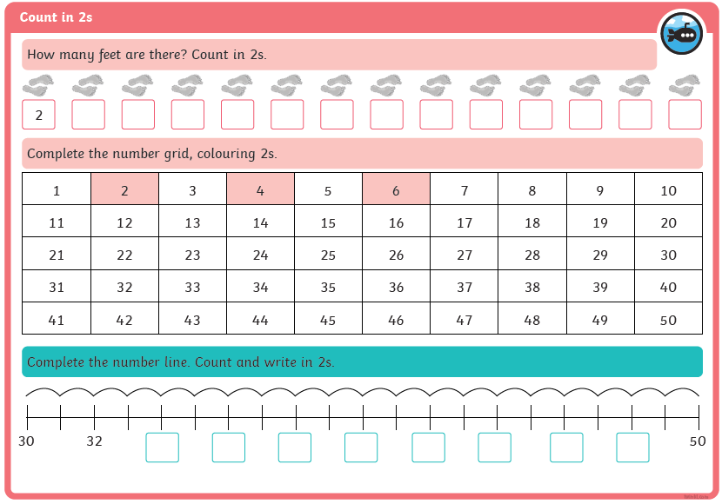
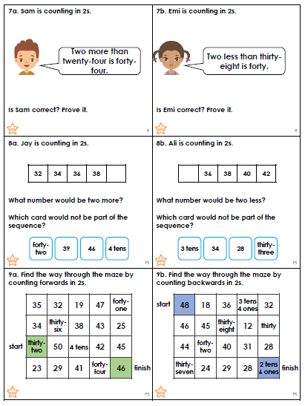

English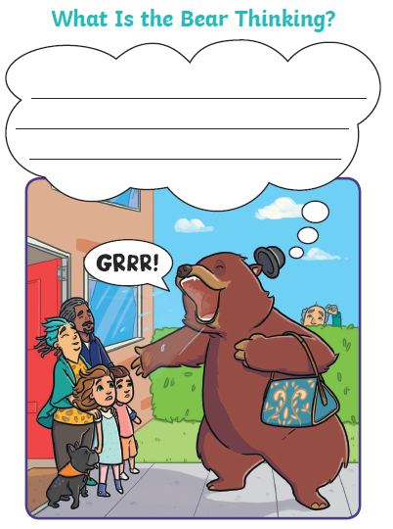 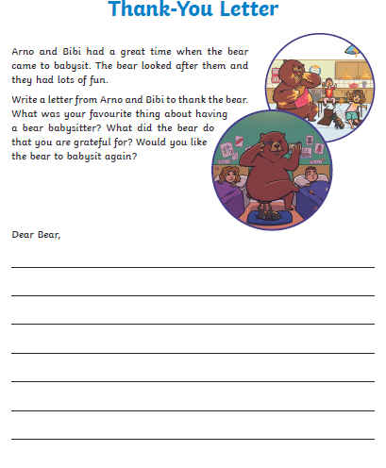 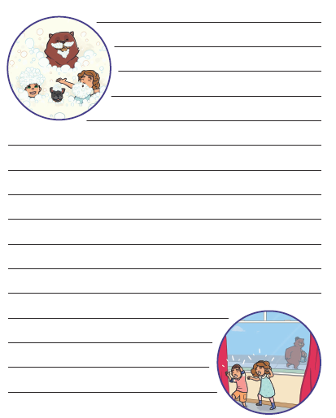
Reading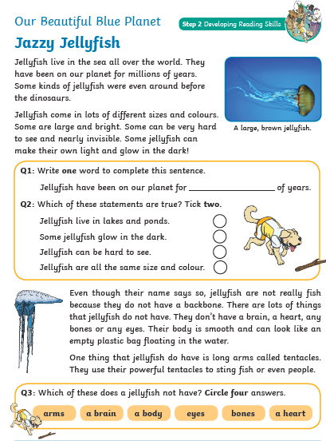 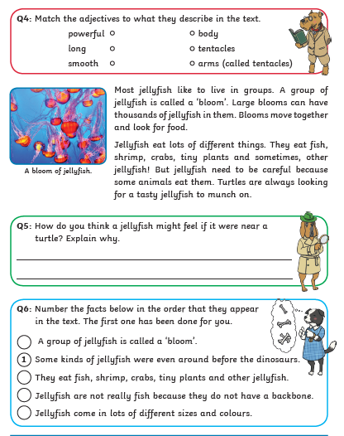

Reading Questions
