Kingsfield First School Year 1 Home Learning Menu
Please complete a selection of activities each day from the table below
English |  |  | Maths
Challenge 1 | Challenge 2 | Challenge 3 | Challenge 1 | Challenge 2 | Challenge 3
See e-mail | Read the story ‘The Zoo Vet’. Write some questions that the vet might ask his patients. | Read the story ‘The Zoo Vet’. Write some questions that the vet might ask his patients. Then write some possible replies. | On a piece of paper paint blobs to show the numbers 1-5 (see example below) fold it in half so the print makes doubles. | On a piece of paper paint blobs to show the numbers 1-10 (see example below) fold it in half so the print makes doubles. | On a piece of paper paint blobs to show the numbers 1-20 (see example below) fold it in half so the print makes doubles.
Read ‘Bats’ and answer the questions below. |  |  | Find 2 dice. Roll the first one to find a number. Get the second to make the same number so you can count the spots to find double. | Use dominoes, find the doubles. Then add them together to find how much double is.  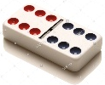Double 6 = 12 | Solve the challenge cards below. Match the starting number to its double.
See e-mail | Read the story ‘The Zoo Vet’. Design and write a thank you card to the vet from one of the animals. | Read the story ‘The Zoo Vet’. Design and write a thank you card to the vet from one of the animals. Tell him why you are grateful. | Answer the questions on the card below. You can use items you have at home to help you find doubles and check if they are correct. | Answer the questions on the card below. You can use items you have at home to help you find doubles and check if they are correct. | Answer the questions on the card below. You can use items you have at home to help you find doubles and check if they are correct.

Go on Education City and choose some English activities. There are lots of reading and writing ones to choose from. | Go to Education City and choose some Maths activities. Why don’t you have a go on Play Live.
Go to YouTube and search for ‘Twinkl Story Time’. Listen to the story and ask your child some of the questions below. | Go to NumBots and play in either ‘Story’ or ‘Challenge’ mode.
Create an account on Oxford Owls. There are lots of online books and phonics activities to do. | Create a free parents account at https://www.themathsfactor.com/games/ Play a range of maths based games.

There are a range of daily online lessons available on https://www.thenational.academy/online-classroom/year-1#schedule and https://www.bbc.co.uk/bitesize/tags/zjpqqp3/year-1-and-p2-lessons/1 which you may find useful for your child.

Phonics
Challenge 1 | Challenge 2 | Challenge 3
Log on to Phonics Play (Username: march20 Password: home) and play Buried Treasure – Phase 3. | Log on to Phonics Play (Username: march20 Password: home) and play Buried Treasure – Phase 5. | Log on to Phonics Play (Username: march20 Password: home) and play Buried Treasure – Phase 5.
Go to YouTube and search for Mr Thorne does ‘ar’ Can you write the words? | Go to YouTube and search for Mr Thorne does ‘e-e’ Can you write the words? | Go to YouTube and search for Mr Thorne does ‘ir’ Can you write the words?
Play I spy. With your grown up, find how many things you can find that have the ‘ar’ sound in. Can you write some of them down? | Play I spy. With your grown up, find how many things you can find that have the ‘e-e’ sound in. Write some of them down. | Play I spy. With your grown up, find how many things you can find that have the ‘ir’ sound in. Write them down.

Topic
Share the link https://www.scholastic.com/parents/school-success/learning-toolkit-blog/drinking-straw-rockets-science-activity.html
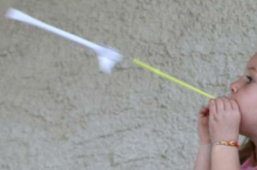
Complete the activity to make a Drinking Straw Rocket!

Design and make a 3D planet. You can pick any planet you wish. Use the internet (or what you have already learnt) to find out what it looks like. You might make it from paper mache, an old ball, recycled materials – the choice is yours! 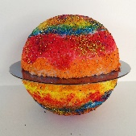
Learn about day and night. Go to https://www.bbc.co.uk/bitesize/topics/zkvv4wx/articles/ztdnyrd watch the videos and complete the quiz. Let me know how you get on.

Maths – EXAMPLE
Doubles

1 |  |  | 2
2
3
4
5

Maths – Challenge 1
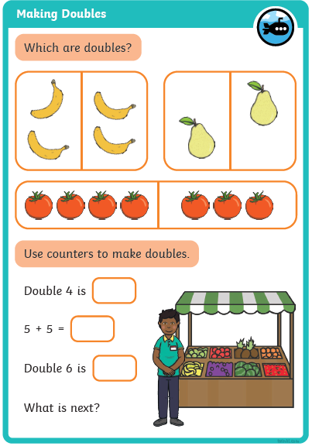

Maths – Challenge 2
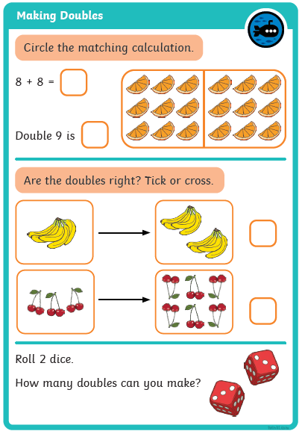

Maths – Challenge 3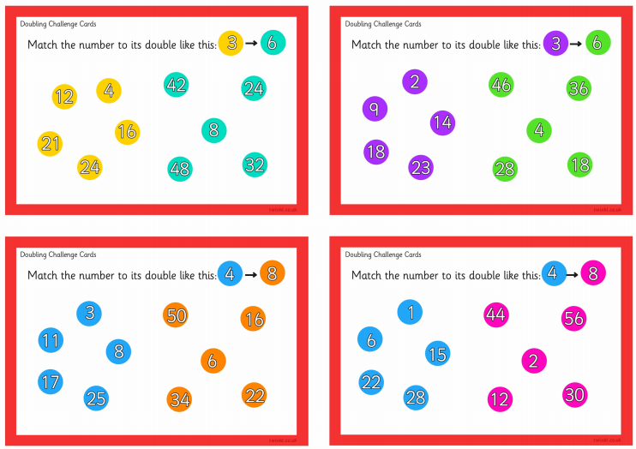

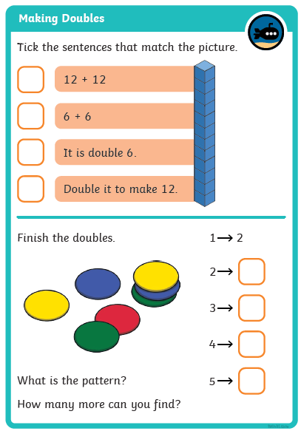

Reading
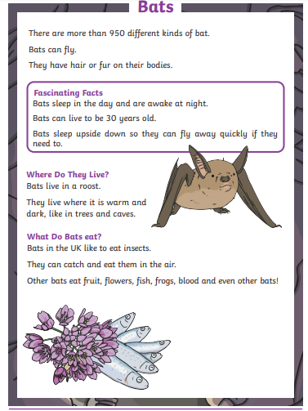
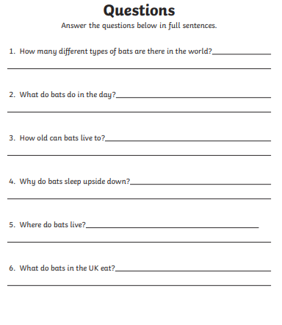

Reading Questions
