Kingsfield First School Year 1 Home Learning Menu
Please complete a selection of activities each day from the table below
English |  |  | Maths
Challenge 1 | Challenge 2 | Challenge 3 | Challenge 1 | Challenge 2 | Challenge 3
Choose a selection of activities from the sent email. | Choose the correct verb to complete the sentences on the sheet below. | How many different verbs can you think of? (ie. running, walking) write a list of verbs and write 6 of these in sentences. | Do the shapes roll? Cut out the shapes and place them in the correct column. ‘Roll’ and ‘Do not roll’. | Cut out the 3D shapes and names below and match the correct name to the correct shape. | Name the 3D shapes in the table then carefully try to draw them.
https://www.oliverjeffers.com/abookaday There are videos of author Oliver Jeffers reading some of his books aloud. Choose one to listen to and enjoy. Answer some of the questions below. |  |  | Can you count and sort the shapes on the second sheet below? | Can you count and sort the shapes on the second sheet below? | Can you count and sort the shapes on the second sheet below?
Choose a selection of activities from the sent email. | How many different verbs can you think of? (ie. running, walking) write a list of verbs and write 3 of these in sentences. | Each sentence has 2 verbs missing. Add the missing verbs. | How many 3D shapes can you find? (ie a can is a cylinder) What 2D shapes are they made from? (ie a cube has 6 squares) | How many 3D shapes can you find? (ie a can is a cylinder) then draw or write them down. | How many 3D shapes can you find? (ie a can is a cylinder) then draw or write them down.

Go on Education City and choose some English activities. There are lots of reading and writing ones to choose from. | Go to Education City and choose some Maths activities. Why don’t you have a go on Play Live.
Go to YouTube and search for ‘Twinkl Story Time’. Listen to the story and ask your child some of the questions below. | Go to NumBots and play in either ‘Story’ or ‘Challenge’ mode.
Create an account on Oxford Owls. There are lots of online books and phonics activities to do. | Create a free parents account at https://www.themathsfactor.com/games/ Play a range of maths based games.

There are a range of daily online lessons available on https://www.thenational.academy/online-classroom/year-1#schedule and https://www.bbc.co.uk/bitesize/tags/zjpqqp3/year-1-and-p2-lessons/1 which you may find useful for your child.

Phonics
Challenge 1 | Challenge 2 | Challenge 3
Log on to Phonics Play (Username: march20 Password: home) and play Picnic on Pluto – Phase 3. | Log on to Phonics Play (Username: march20 Password: home) and play Picnic on Pluto – Phase 5. | Log on to Phonics Play (Username: march20 Password: home) and play Picnic on Pluto – Phase 5.
Go to YouTube and search for Geraldine the Giraffe does ‘ee’ Can you write the words? | Go to YouTube and search for Geraldine the Giraffe does ‘e-e’ Can you write the words? | Go to YouTube and search for Geraldine the Giraffe does ‘ea’ Can you write the words?
With your grown up, write words with the ‘ee’ sound on seperate pieces of card or paper. Do each word twice. Then shuffle the cards and play snap! | With your grown up, write words with the ‘e-e’ sound on seperate pieces of card or paper. Do each word twice. Then shuffle the cards and play snap! | With your grown up, write words with the ‘ea’ sound on seperate pieces of card or paper. Do each word twice. Then shuffle the cards and play snap!

Topic
https://www.youtube.com/watch?v=vphJ6WyuxGk&pbjreload=10 imagine it would be like to go to Mars. Draw yourself as an astronaut and the items you will need to take with you.

Go to https://www.j2e.com/jit5#turtle can you use a space background and move your rocket around the page.

Let’s do some Cosmic Yoga! Visit https://www.cosmickids.com/category/watch/ and choose a yoga for you to do today. You might pick something calm or maybe a story, there’s so many to choose from. You can even do one every day if you want

English – Challenge 2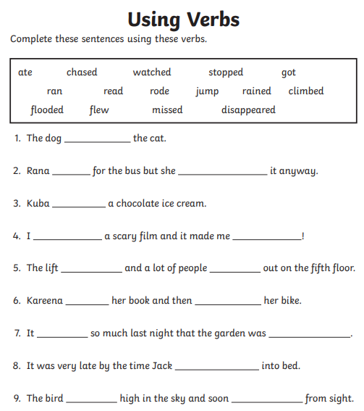

English – Challenge 3
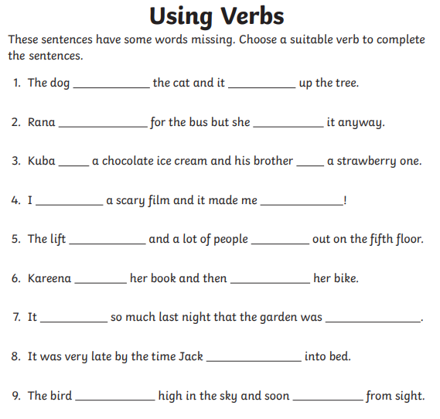

Maths – Challenge 1
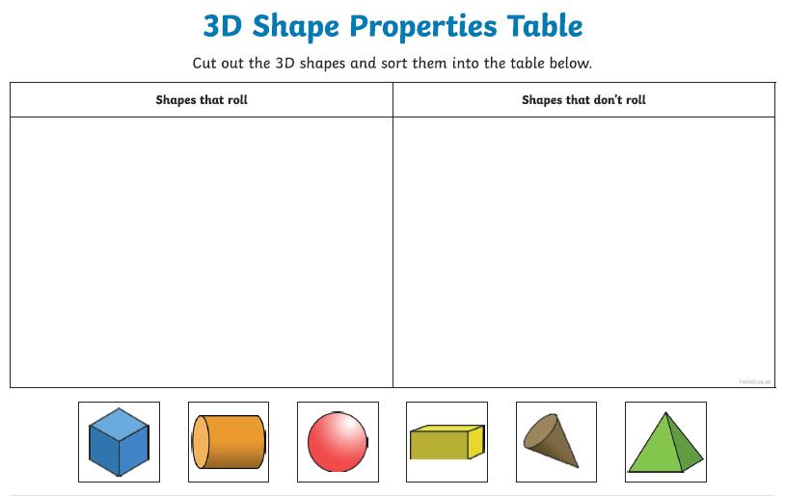

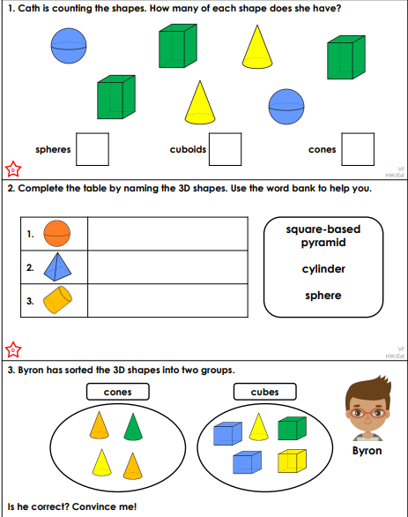

Maths – Challenge 2
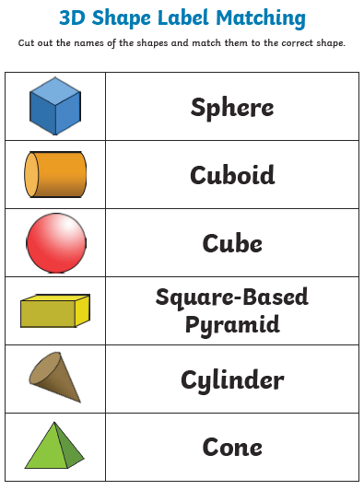

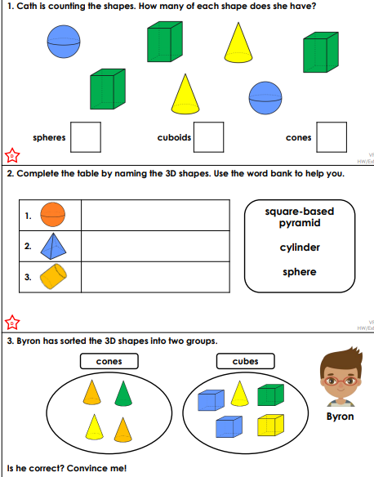

Maths – Challenge 3

Picture of the shape | My drawing of the shape | Name of the shape
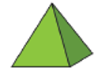

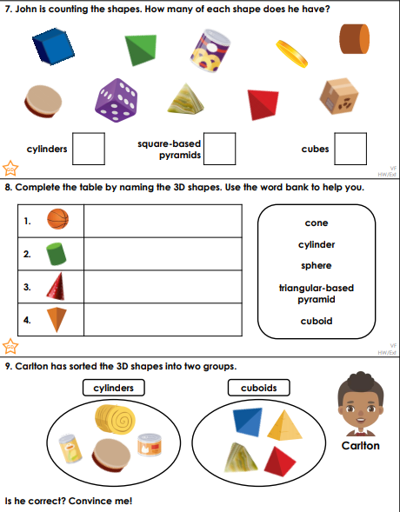

Reading Questions
