Please find todays learning tasks below.
The table below explains the tasks and you will find the resources underneath. Your child will know which challenge they usually access in each subject and which task will be appropriate for them. There is a sticker in the front of their Red Home Learning Books if they were able to get one in the last week. If they did not any exercise book or lined paper will be fine.
Year group: 1/2 Date: Wednesday 6th May
 | Challenge 1 | Challenge 2 | Challenge 3 |  | Challenge 4 | Challenge 5
Watch https://www.youtube.com/watch?v=wU1GxlOfqyw
Carla’s Sandwich by David Pelham
English | Please see separate e-mail | Today we will make a sandwich. Make a note of the ingredients you use and how you made it as you will write these instructions tomorrow. It will be helpful if you can take some photos as you’re making it to help you remember tomorrow. |  |  | Today we will make a sandwich. Make a note of the ingredients you use and how you made it as you will write these instructions tomorrow. It will be helpful if you can take some photos as you’re making it to help you remember tomorrow.
Maths | Use what you have been practicing about Doubling and Halving to play this game. You can use objects or pictures to help you find the answers. If you can’t print it out ask someone at home to help you make it. Good luck J
Reading | Log onto Education City. Choose which reading task you would like to do. I will check tomorrow who has done it and give them all an extra Class Dojo point.
Phonics | Go to https://www.starfall.com/h/ltr-lv-e/petes-sheep/?sn=ltr-classic  and read Pete’s Sheep. You can click on each word in the story and it will sound it out for you!  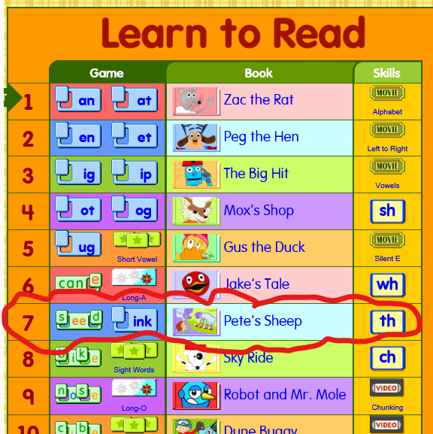 | Go to  https://www.starfall.com/h/ltr-pc-vt/soap-boat/?sn=ltr-classic  and read Soap Boat. You can click on each word in the story and it will sound it out for you!  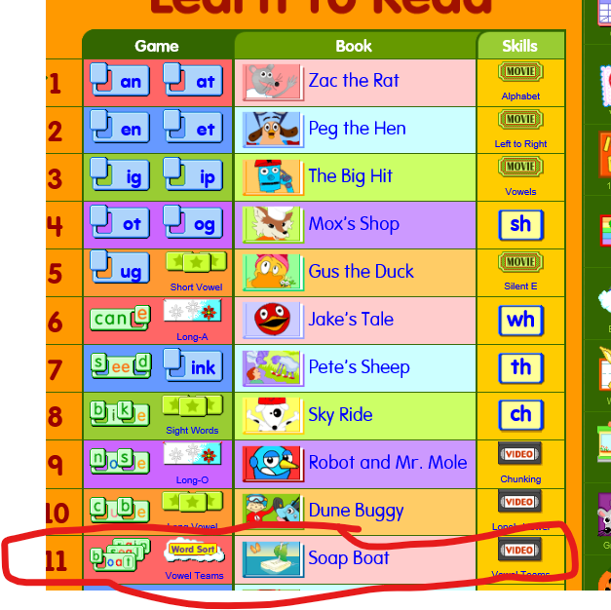 |  | Go to  https://www.starfall.com/h/ltr-pc-y/my-family/?sn=ltr-classic  and read  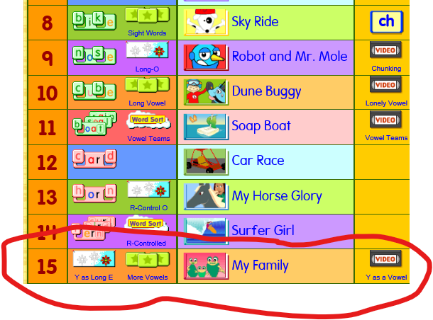 You can click on each word in the story and it will sound it out for you! | Cut out the contractions and stick with the matching words. If you can’t print then write them out.
Other | Today we are continuing to think and learn about VE Day.  Read the sheets below (use challenge 1, 2 or 3 as you do for English)  After you have read the sheet, see if you can answer the questions and tell your adult the answer (you don’t need to write them down unless you really want to).  Have a go at making bunting – maybe you could decorate your window ready for Friday?
Unless otherwise specified, please complete the tasks in either your homework book or on a word document.
Maths - Challenge 1/2/3/4/5
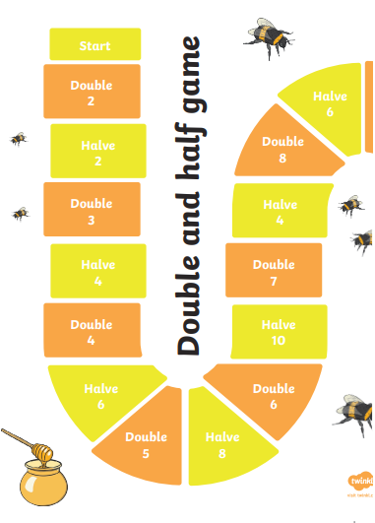
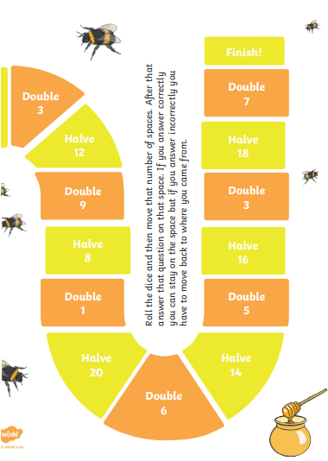

Spelling – Challenge 4/5
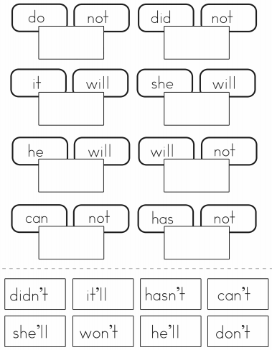

VE Day - Challenge 1/2 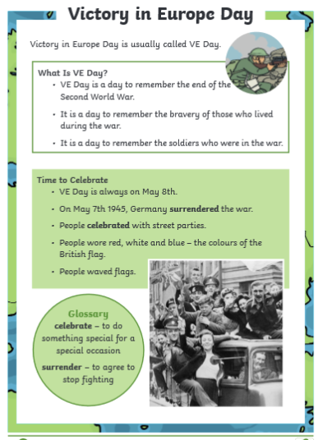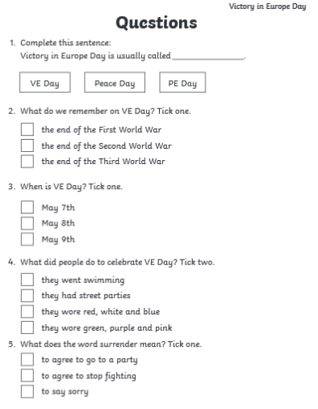

VE Day - Challenge 3/4/5 