Year 2
Please find todays learning tasks below.
The table below explains the tasks and you will find the resources underneath.
Your child will know which challenge they usually access in each subject and which task will be appropriate for them.
Year group: 2 Date: 17.06.20
English | 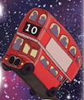  Read the poem below ‘Back from the moon on a number 10’  As you are reading the poem can you spot the rhyming words in the poem.  Rhyme is a feature of lots of poems, but remember the rhyming words might have the same spelling pattern in like words such as kind / mind or they might have the same sound but a different spelling pattern such as rode / load.
 | Challenge 1 | Challenge 2 | Challenge 3
Can you find the words in the poem that rhyme?
Match them to the words I have added to the activity sheet (below).

Maths | Warm Up – follow this link to complete your maths warm up.  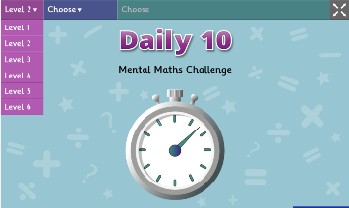  https://www.topmarks.co.uk/maths-games/daily10  Choose Level 2  Complete the Digit Values activity.
 | Challenge 1 | Challenge 2 | Challenge 3
Today we are going to ‘interpret’ data from pictograms / bar charts.

Complete the interactive activities on this link
https://www.topmarks.co.uk/Flash.aspx?f=pictograms

Now complete the activity sheets and problem solving tasks – look carefully at the scale (it might be worth 1 / 2 / 5 etc.)

Reading  Phonics | Log in to Oxford Owl and continue to read the text ‘Spread the Word’ read / listen to the text from page 13 to the end.  Click on the link http://www.ictgames.com/mobilePage/forestPhonics/index.html  Phonics Forest spelling words including the various different phonic sounds.
Other | 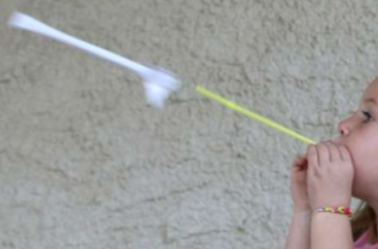  Today we are going to start to plan some Science  Share the link https://www.scholastic.com/parents/school-success/learning-toolkit-blog/drinking-straw-rockets-science-activity.html  Complete the activity to make a Drinking Straw Rocket!

Unless otherwise specified, please complete the tasks in either your home learning book or print out the document below.

English ALL Groups
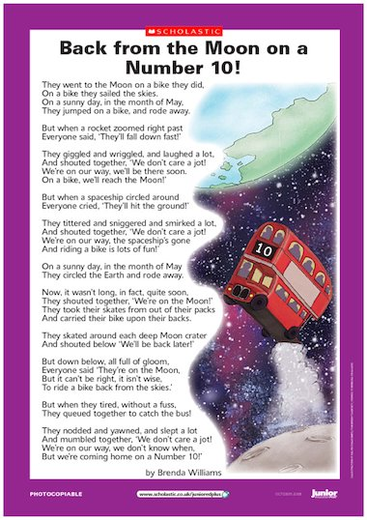

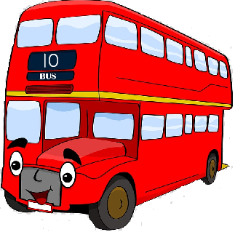
Can you find the rhyming words from the poem?
later
________
bloom
________
match
________
plates
________

funny
________
tune
________

toad
________
pocket
________
frowned
________

worth
________

Maths Task 3 ALL Groups
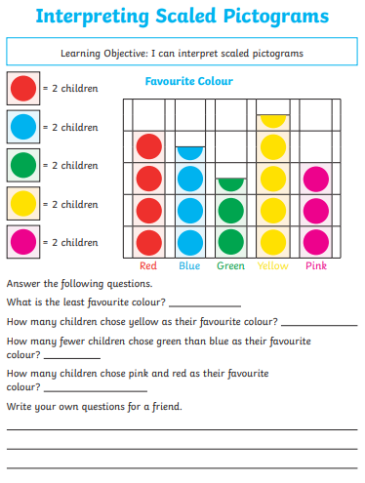
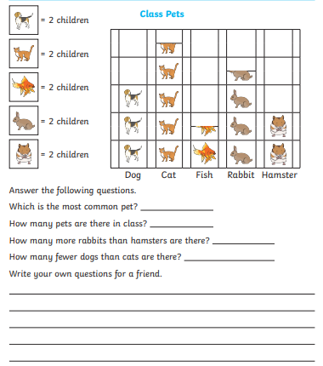
Reasoning Tasks ALL groups
