Year 2
Please find todays learning tasks below.
The table below explains the tasks and you will find the resources underneath.
Your child will know which challenge they usually access in each subject and which task will be appropriate for them.
Year group: 2 Date: 01.07.20
English | 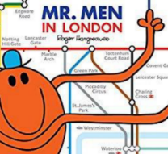  Reread the story of the Mr Men in London.
 | Challenge 1 | Challenge 2 | Challenge 3
Today you are going to be retelling the first parts of the story in your own words – look at the pictures on the activity sheet (below) and think about what happens in the story from each picture.
Retell the story and try and think about some of these to include as you write.
- Capital letters, finger spaces and full stops throughout.
- Speech “ “ if characters are speaking.
- Start your sentences in different ways you could use time connectives, exciting words etc.
- Remember to use capital letters for character names and places too!
- Reread your writing to make sure it makes sense
Remember to stop after you have written about Mr Small going to Buckingham Palace and meeting the Queen’s Guards.
Maths | Share PowerPoint Clockwise and Anti-Clockwise (on website)  Stand up and ask your adult to challenge you to moving around the room clockwise and anti-clockwise e.g. take 2 steps forward, turn anti-clockwise, 3 steps forward, turn clockwise etc.
 | Challenge 1 | Challenge 2 | Challenge 3
Now you have learnt all about clockwise and anti-clockwise complete the activity sheets below or alternatively choose 5 items from around the house and move them clockwise and anti-clockwise to understand that they will look different after they are turned.

Remember to complete the reasoning task!

Reading  Phonics | Log in to Oxford Owl and continue to read the text ‘The Dinosaur Hunters’ read / listen to the text from page 12 – 17.  Click on the link http://www.ictgames.com/mobilePage/forestPhonics/index.html  Phonics Forest spelling words – choose the ng and nk activities.
Other | Today we are continuing with our History  Share the information PowerPoint on the website and continue to learn about The Great Fire of London.  Complete a newspaper report to tell people what happened.  Remember to write as though you were alive in that time  e.g. On Sunday a small fire began in the baker’s shop on Pudding Lane. A spark from the oven started the fire and it spread quickly. Houses all around the bakery have been burnt to the ground. Local people used buckets and carried water from the river to put the fire out…

Unless otherwise specified, please complete the tasks in either your home learning book or print out the document below.

English ALL Groups

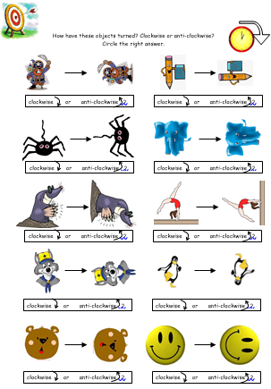
Maths ALL Groups

Maths Extension for challenge 2 and 3
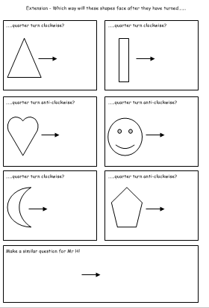
Maths Reasoning ALL Groups
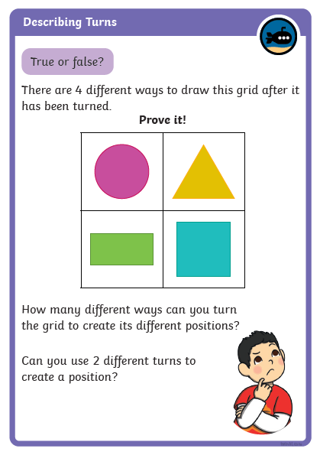

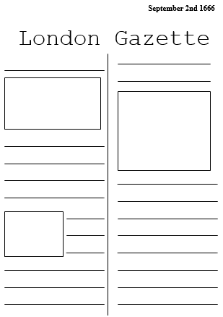
Topic Task

