Please find todays learning tasks below.
The table below explains the tasks and you will find the resources underneath. Your child will know which challenge they usually access in each subject and which task will be appropriate for them. There is a sticker in the front of their Red Home Learning Books if they were able to get one in the last week. If they did not any exercise book or lined paper will be fine.
Year group: 1/2 Date: Tuesday 5th May
 | Challenge 1 | Challenge 2 | Challenge 3 |  | Challenge 4 | Challenge 5
Watch https://www.youtube.com/watch?v=M-aceEquCtY
Carla’s Sandwich by Debbie Herman
English | Please see separate e-mail | Think about the sandwiches made in the story. Which sounded tasty to you? If you could have anything in your sandwich, what would you have? Write a list of ingredients for your delicious sandwich. (See below) |  |  | Think about the sandwiches made in the story. Which sounded tasty to you? If you could have anything in your sandwich, what would you have? Write a list of ingredients for your delicious sandwich. Make sure you use 2 adjectives to describe the ingredients. (See below)
Maths | Finding half. Share the bees equally onto the flowers. | Solve the halving problems. You can use objects or draw counters to help you. | Solve the halving problems. You can use objects or draw counters to help you. |  | Solve the halving problems. You can use objects or draw counters to help you.
Reading | Log on to Rising stars, reading planet today and choose an e book to read.
Phonics | Go to http://phonicsplaycomics.co.uk/comic_ph2_a_bug.html and read A bug  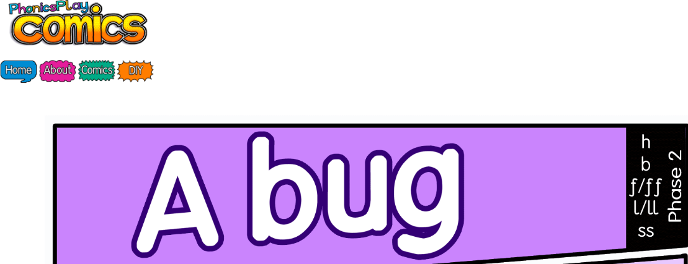 | Go to  http://phonicsplaycomics.co.uk/comic_ph3_lets_go.html  and read Let’s Go  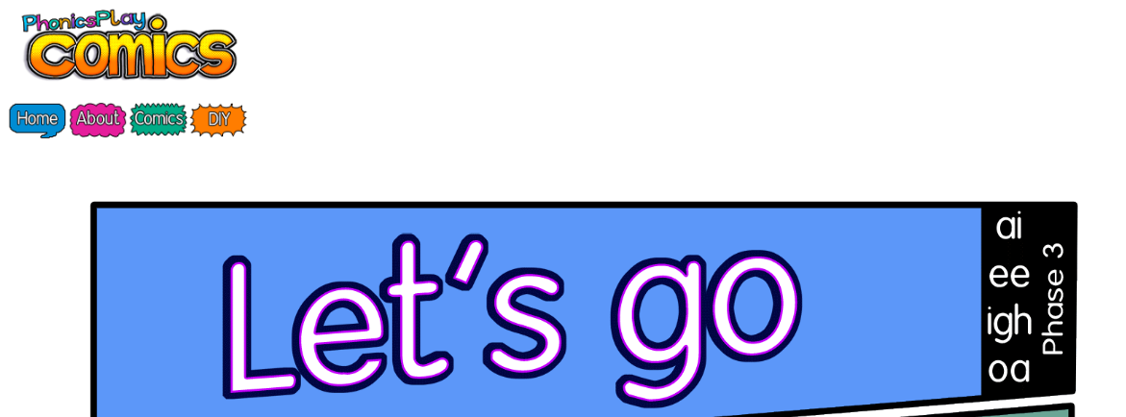 |  | Go to  http://phonicsplaycomics.co.uk/comic_ph5a_the_holiday.html  and read The Holiday  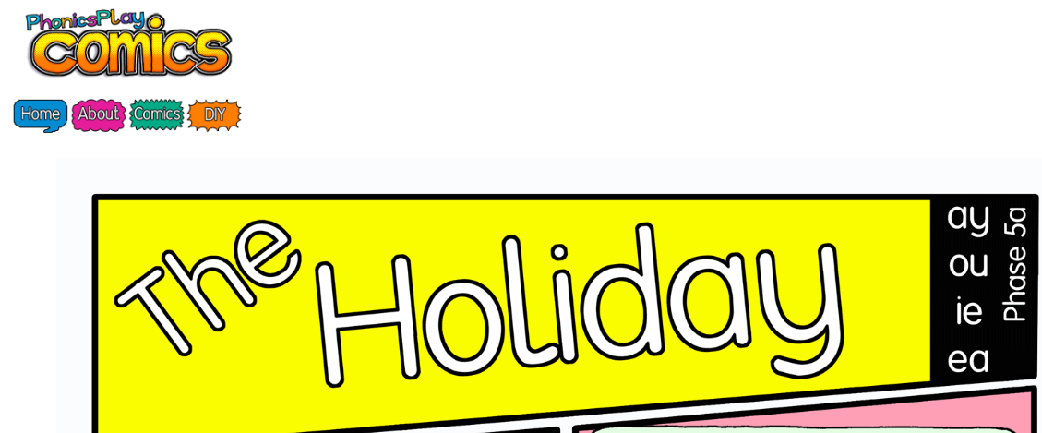 | Log onto Education City. In Year 2, English, Writing, Activities look for ‘Force Field’. The activity today is using what you learnt yesterday so if you struggle, watch the Learn Screen again.
Other | Today we are continuing to think about VE Day.  Go to youtube and watch and listen to https://www.bbc.co.uk/cbbc/watch/horrible-histories-songs-ve-day-song  Go to YouTube and search for VE Day music.  Can you find and listen to Andrews Sisters Boogie Woogie Bugle Boy or In the Mood.  How do these songs make you feel? Are they happy or sad songs? Why is that?  Which songs do you like that make you happy? Can you sing one with someone in your house or find it on YouTube and listen to it?
Unless otherwise specified, please complete the tasks in either your homework book or on a word document.
English – Challenge 2/3

Mrs Gray’s Super Deluxe Sandwich
Ingredients
2 slices of soft, white bread,
Mayonnaise,
Crispy lettuce,
4 slices of cucumber,
Smoked ham,
2 slices of cheddar cheese,
Chicken,
Roast beef,
6 chocolate buttons,
1 pack of ready salted crisps.

What would you put in your sandwich?

English – Challenge 4/5

Mrs Gray’s Super Deluxe Sandwich
Ingredients
2 slices of soft, white bread,
Fresh, homemade mayonnaise,
Crispy, fresh lettuce,
Sliced, green cucumber,
Smooth, smoked ham,
2 slices of creamy, cheddar cheese,
Fresh, white chicken,
Warm, roast beef,
6 round, chocolate buttons,
1 pack of cooked, salty crisps.

What would you put in your sandwich?

Maths - Challenge 1
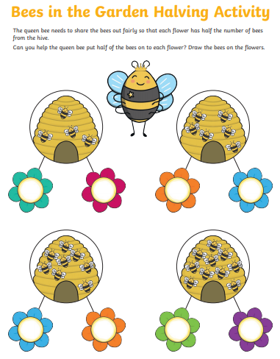
Extension
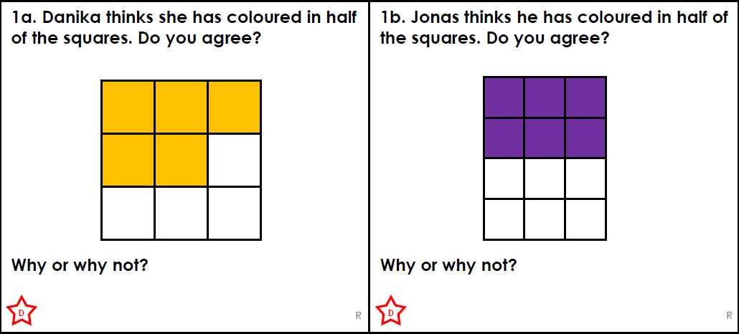
Maths – Challenge 2
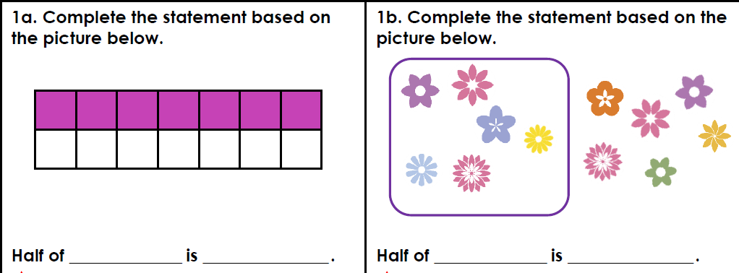
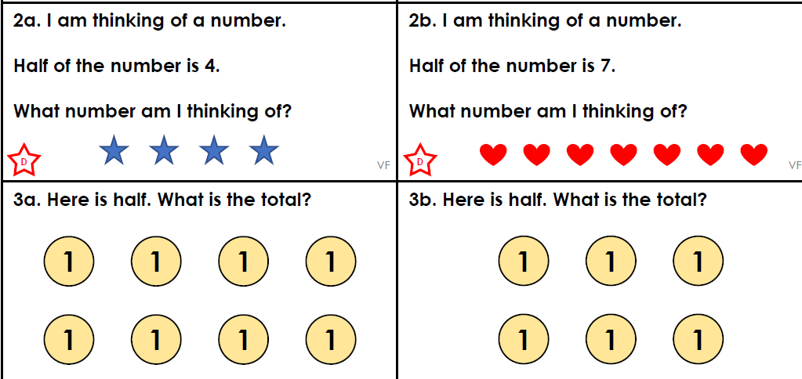
Extension
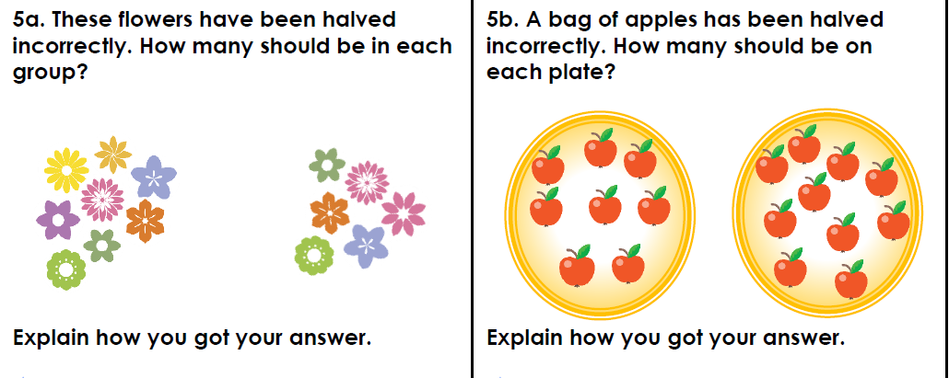

Maths - Challenge 3
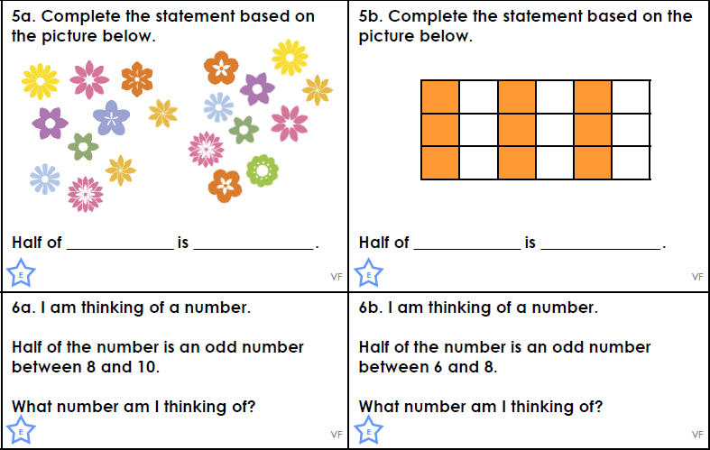
Extension
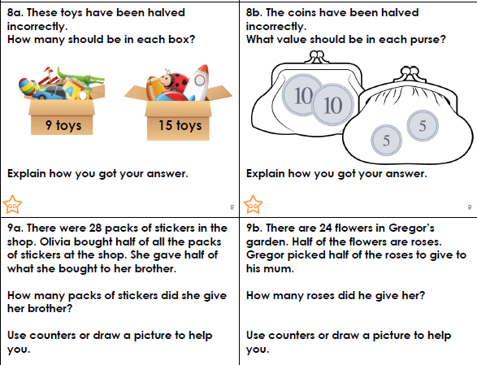
Maths - Challenge 4/5
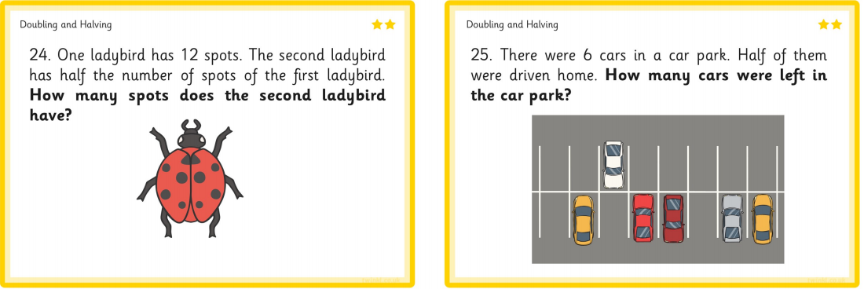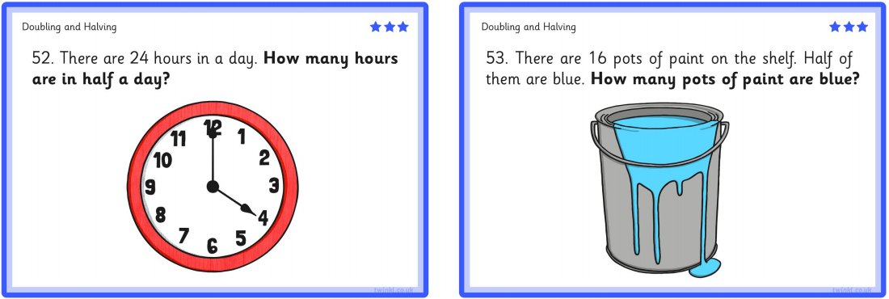
Extension