Year 2
Please find todays learning tasks below.
The table below explains the tasks and you will find the resources underneath.
Your child will know which challenge they usually access in each subject and which task will be appropriate for them.
Year group: 2 Date: 30.06.20
English | 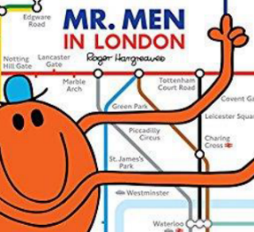  Reread the story of the Mr Men in London.
 | Challenge 1 | Challenge 2 | Challenge 3
Through the story you will find speech between the characters.
Look at the sheet below and find the pages in the book – write 2 pieces of speech for each part.
I have written the first speech on the sheet so you need to respond to that
” What are you doing up there, get down at once!” yelled Mr Busy.
Complete 2 parts for each section of the story (see worksheet below) you can look back at the book or come up with your own ideas about what the characters might say remember to punctuate your speech correctly.
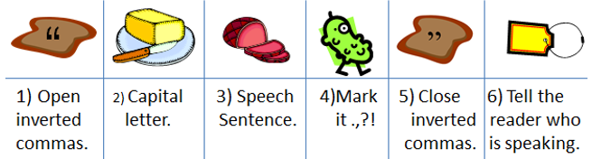

Maths | 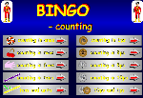  Click on the link http://www.wldps.com/gordons/Bingo_-_counting_v4.swf  Complete the Bingo activities of your choice – see if you can play with someone from your family.
 | Challenge 1 | Challenge 2 | Challenge 3
Share the PowerPoint ‘Half and Quarter Turns’ (on website)

Pick up your pencil and practise moving it ¼ turn, ½ turn and a full turn.

Every time you turn an object it will look different after each turn until it completes a full turn and ends up in the same place that it started.
Complete the activity sheets and reasoning tasks below.
Reading  Phonics | Log in to Oxford Owl and search for the text ‘The Dinosaur Hunters’ read / listen to the text up to Page 12.  Click on the link https://www.ictgames.com/littleBirdSpelling/  Choose the orange bird box and practise spelling the words such as child / children.
Other | Today we are continuing to focus on History.  Share the Link  https://www.youtube.com/watch?v=VarSSAwiimU&safe=active  Watch the clip and go back in time with the children and Grandad to learn more about the events of the Great Fire of London.  Once you have watched the clip –complete the topic task (see sheet below).

Unless otherwise specified, please complete the tasks in either your home learning book or print out the document below.

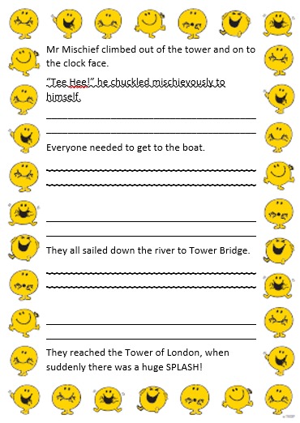
English ALL groups
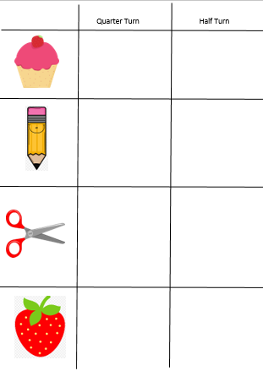
Maths ALL groups

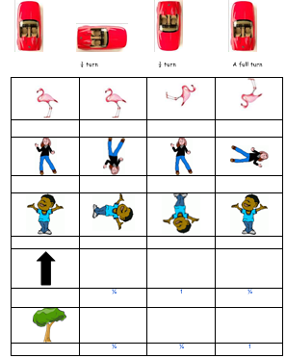
Maths Extension for Challenge 3

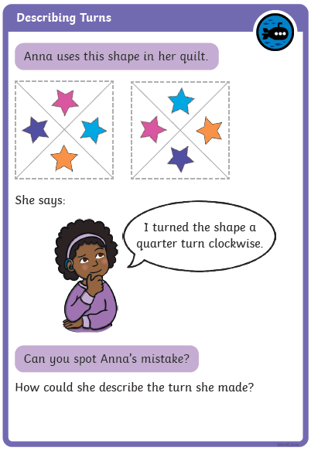
Reasoning Task ALL groups

Topic Task
Draw a picture to go with each sentence.
Complete these sentences about the Great Fire of London

There was no f_____ b_________ in 1666.

People carried water in ________ buckets.

They fetched water from the R___ T______.

Soldiers helped to carry _______ and tools.

They squirted water on the h_________.

The fire spread very quickly because the houses were close t_______________.

The King also helped to put out the f_____.

Houses were pulled down using h_________.

hooks together fire brigade
fire water
leather River Thames houses

