Year 2
Please find todays learning tasks below.
The table below explains the tasks and you will find the resources underneath.
Your child will know which challenge they usually access in each subject and which task will be appropriate for them.
Year group: 2 Date: 16.06.20
English | Read the poem ‘Sailing Out to Space’  .
 | Challenge 1 | Challenge 2 | Challenge 3
Understanding different features of poems is important.
This poem has some rhyming words, but it also has some interesting words in the text you may / may not know the meaning of.
Understanding the meaning of words is very important so you understand the text / poem.
Complete the activities on the task sheet below.
Maths | 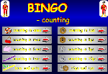  Click on the link http://www.wldps.com/gordons/Bingo_-_counting_v4.swf  Complete the Bingo activities of your choice – see if you can play with someone from your family.
 | Challenge 1 | Challenge 2 | Challenge 3
Today you are going to be completing some work on Pictograms

Share the link
https://www.bbc.co.uk/bitesize/clips/zg4d2hv

Now complete the activity sheets and reasoning tasks below.
Reading  Phonics | Log in to Oxford Owl and search for the text ‘Spread the Word’ read / listen to the text up to Page 12.  Click on the link http://www.ictgames.com/mobilePage/spookySpellings/index.html  Spooky Spellings to spell the Common Exception Words
Other | Today we are going to do some Art.  Today you are going to do some work based on the largest planet in the Solar Sytem Jupiter  Share the PPT (PDF version on our website)  Look carefully at the picture of Jupiter – look at the swirls and whirls of the planet.  Create your own image based on the photographs of Jupiter – you could use whatever materials you have / want to such as chalk, crayons, pastels, paint, paper!

Unless otherwise specified, please complete the tasks in either your home learning book or print out the document below.

English Task ALL Groups
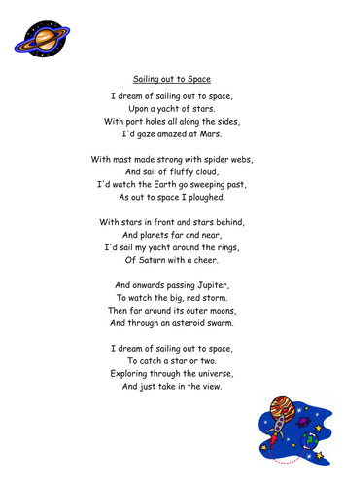

- Read the poem – can you spot any rhyming words?

- What do you notice about the pattern?

- Put these words into alphabetical order.

yacht port holes gaze ploughed storm

asteroid swarm exploring universe

3)Write a glossary of the meaning of these words – you can look for the word in a dictionary if you have one. Otherwise, click on this link and use an online dictionary.
https://kids.britannica.com/kids/browse/dictionary

Maths Task 2 ALL groups
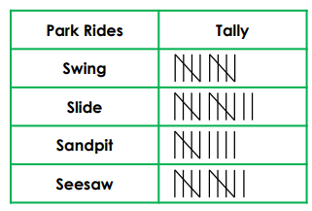
Look at the pictogram below and answer the questions below:
- How many times was the slide used? _________________________
- How many more times was the slide used than the sandpit? ________
- How many times were the slide and the sandpit used altogether? ____________________
- Which equipment was used the least? _________________________
- Which equipment was used the most? _________________________

Swing
Slide
Sandpit
Seesaw

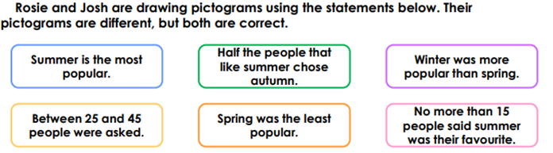
Complete a pictogram to show how Rosie might present the data.
Now draw a different pictogram to show the data how Josh might present it.

Reasoning Task ALL groups
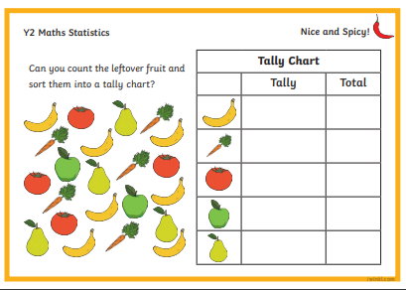
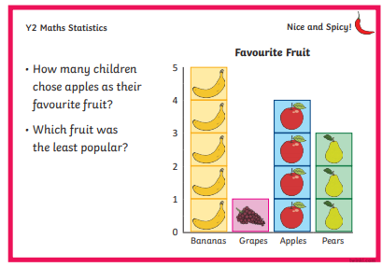

Topic Task
