Please find todays learning tasks below.
The table below explains the tasks and you will find the resources underneath. Your child will know which challenge they usually access in each subject and which task will be appropriate for them. There is a sticker in the front of their Red Home Learning Books if they were able to get one in the last week. If they did not any exercise book or lined paper will be fine.
Year group: 1/2 Date: Tuesday 12th May
 | Challenge 1 | Challenge 2 | Challenge 3 | Challenge 4 | Challenge 5
Can you remember the story we read yesterday? You might like to have another look at the Powerpoint.
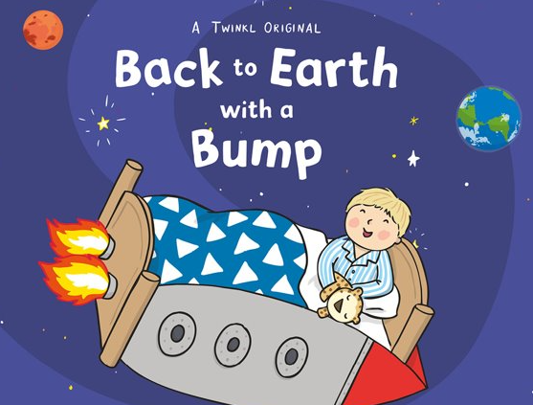
English | Please see separate e-mail | Today we are writing a list of things you might like to take in your rocket. Use the sheet below or write it in your home learning book.  What will be the first thing on your list? Remember you may be in space for a long time so don’t forget anything important and you can only take 10 things!  Try and include 2A in your list. |  | Today we are writing a list of things you might like to take in your rocket. Use the sheet below or write it in your home learning book.  What will be the first thing on your list? Remember you may be in space for a long time so don’t forget anything important and you can only take 10 things!  Try and include 2A in your list.
Maths | Use a ruler to measure the snakes. Remember to start at 0cm. | Find the objects around your home and measure them using a ruler. Remember to start at 0cm. |  | Can you find the odd one out? Why is it different?
Reading | Log on to Rising stars, reading planet today and choose an e book to read.
Phonics | Go to https://phonicsplaycomics.co.uk/comic_ph3_i_can_spot.html and read I can Spot with the sounds sh, ch, th and ng. | Go to  https://phonicsplaycomics.co.uk/comic_ph3_moon_farm_park.html and read Moon Farm Park with the sounds oo, ar, or  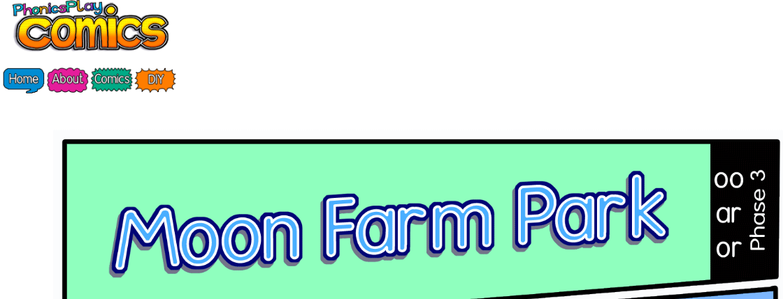 |  | Play spelling activity on Topmarks http://www.missmaggie.org/scholastic/fishemup2_eng_launcher.html  Practise spelling words including ing / ed rules.
Other | Today we are continuing to think about Space.  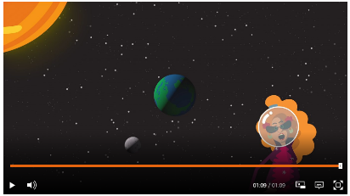  Click the link below and watch the short animation on day and night (sun and moon).  https://www.bbc.co.uk/bitesize/topics/zwccwmn/articles/zqbxb82  In order to get into space, you would need a space rocket – following on from this morning’s English work make a rocket! (see the suggested task below!)  If you don’t have all of the materials on the suggested task – be as creative as you can!  Remember to share your pictures with us for Twitter!
Unless otherwise specified, please complete the tasks in either your homework book or on a word document.
Maths - Challenge 1

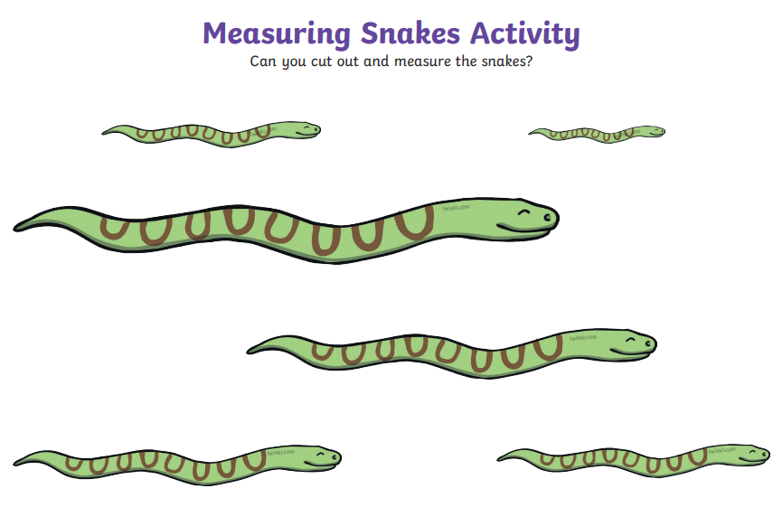
Maths – Challenge 2/3
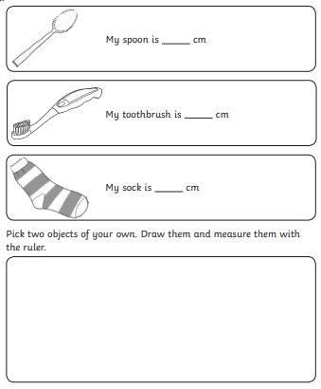
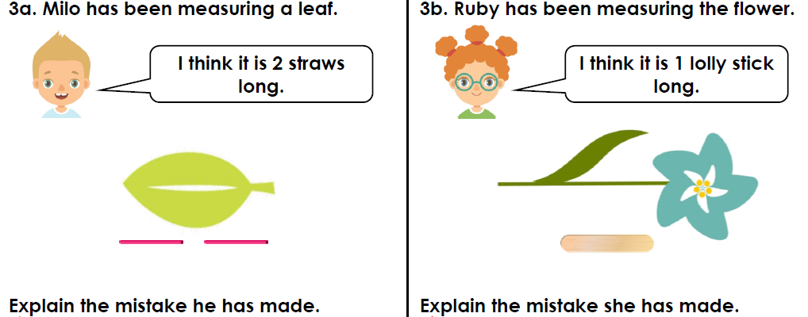

Maths - Challenge 4/5
