Year 2
Please find todays learning tasks below.
The table below explains the tasks and you will find the resources underneath.
Your child will know which challenge they usually access in each subject and which task will be appropriate for them.
Year group: 2 Date: 25.06.20
English | Share the link https://www.youtube.com/watch?v=lqUToqGiwc4 and watch the clip to begin to learn about the Underground.  Share the page (below) and read all about the London Underground.
 | Challenge 1 | Challenge 2 | Challenge 3
Complete a fact page about the London Underground.
Read the information on the fact page below and complete your own page (use the sheet below / straight into your own book).
Maths | 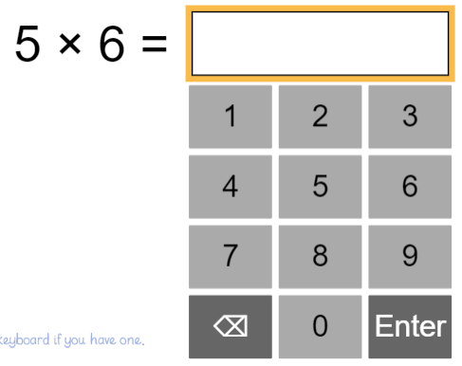  Share the link  https://www.ictgames.com/mobilePage/bunny/index.html  Complete the Bunny Battlefront Activity for Y2.
 | Challenge 1 | Challenge 2 | Challenge 3
Today you will be learning about temperature.
Look at the PowerPoint about temperature on the website and then answer the questions below for your Maths Challenge.

There is a problem solving task for everyone to complete.

Reading  Phonics | Log in again to Oxford Owl and continue to read / listen to ‘Chamber of Treasures’ reading pages 15 – 19 (chapter 4).  Click on the link here: https://www.ictgames.com/littleBirdSpelling/  Complete the 10th bird box tasks – spelling number words.
Other | Today we are going to complete some History  As you know our current Monarch is Queen Elizabeth II, but today you are going to learn about Queen Elizabeth I.  Share the link: https://www.youtube.com/watch?v=dfgeLdXA87I&safe=active  Read the topic information about Queen Elizabeth I and then answer the questions about her.

Unless otherwise specified, please complete the tasks in either your home learning book or print out the document below.

English ALL challenges
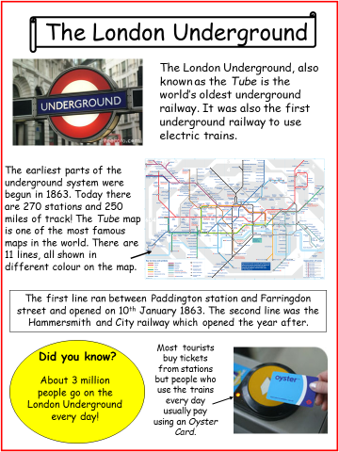

English ALL groups

________________________________________________________________________________________________________________________________________________________________________________________________________________________________________________________________________________________________________________________________________________________________________________________________________
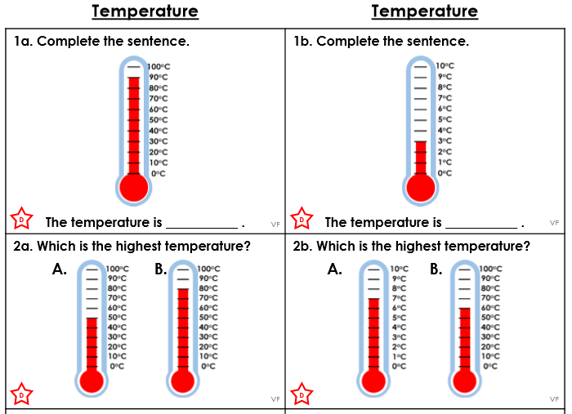
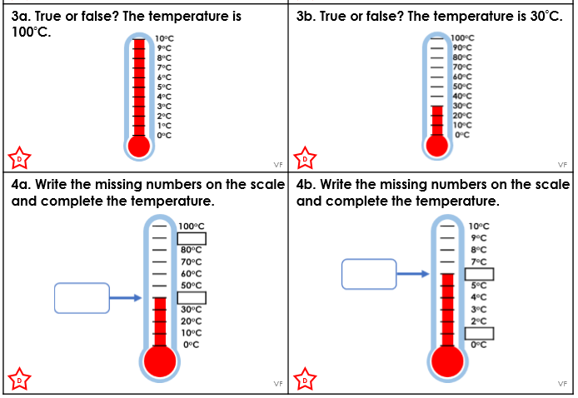
Maths Challenge 1
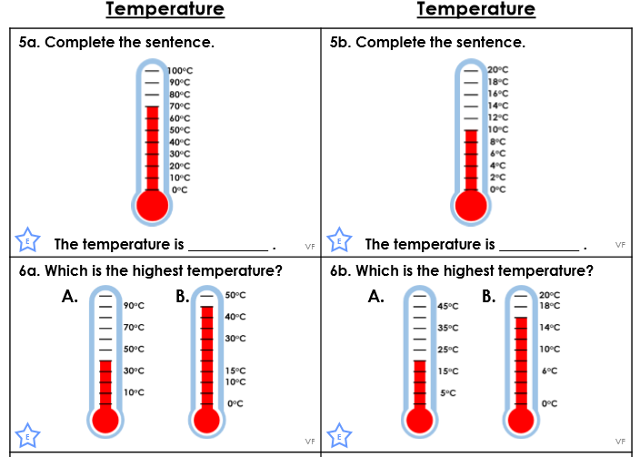
Maths Challenge 2

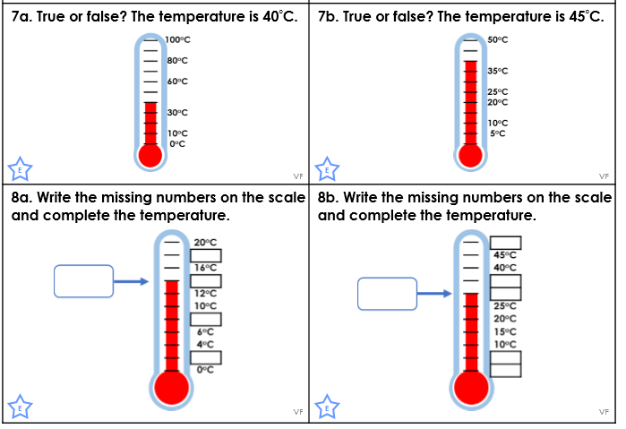

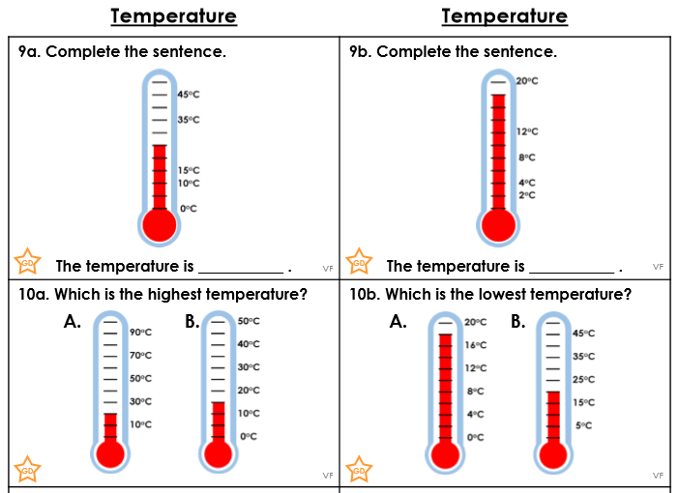
Maths Challenge 3

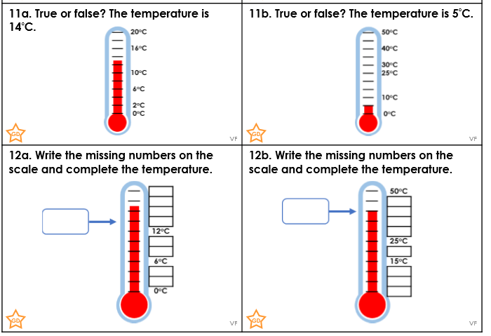
Reasoning / Problem Solving ALL Groups
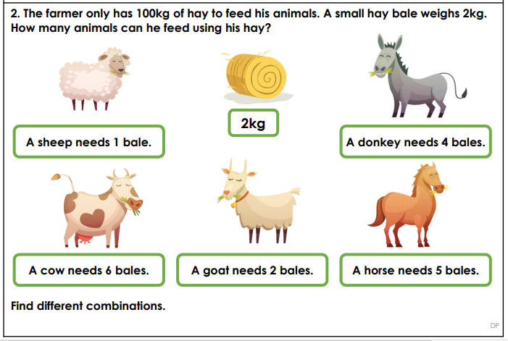
Discuss this problem with your grown up – can you find different combinations?

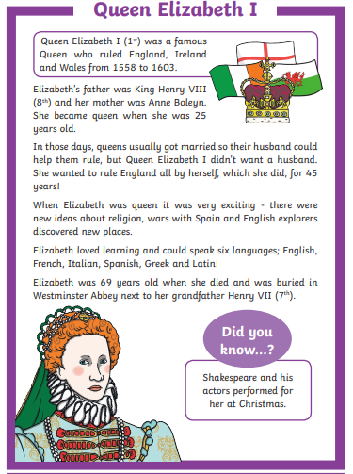
Topic

