Please find todays learning tasks below.
The table below explains the tasks and you will find the resources underneath. Your child will know which challenge they usually access in each subject and which task will be appropriate for them. There is a sticker in the front of their Red Home Learning Books if they were able to get one in the last week. If they did not any exercise book or lined paper will be fine.
Year group: 1/2 Date: Monday 18th May
 | Challenge 1 | Challenge 2 | Challenge 3 |  | Challenge 4 | Challenge 5
Our new text for this week is all about an Alien who comes down to Earth and struggles to find some friends.
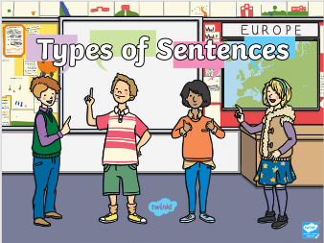
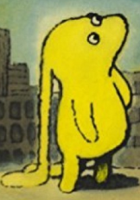
Today we are going to start by writing some different sentence types about the character picture.
Share the PowerPoint Different Sentence Types.

PowerPoint as PDF on homework page.
Next think about the picture of the alien.
Is it a boy or girl?
Where do you think they are?
What time of day is it?
Can you describe the character?
What do you think they are looking at?
What does their expression tell us?

English | Please see separate e-mail | Today you are going to be writing questions in your writing task. Share some questions with your adult verbally and remember to say question mark to remind you! Then write them down. |  | Today you are going to be writing different sentences in your writing task. Share some sentences with your adult verbally can they identify which type of sentence it is? Then write them down. | Today you are going to be writing different sentences in your writing task.  Share the PPT about sentence types and think about the 4 sentence types.  Share some sentences with your adult verbally can they identify which type of sentence it is? Then write them down.  Remember the rules for each type of sentence!
Maths | This week we are going to learn about 2D shapes. Log onto Education City. Look in the Homework section and find Maths 18th May and complete the activities.
Reading | Go to Rising stars, Reading Planet and choose a book to read from your selection.
Phonics | Watch https://www.youtube.com/watch?v=33kvsqyOYdg Then, how many words with the ‘or’ sound can you find around your house? Write them down. | Watch https://www.youtube.com/watch?v=7BOih-iw1u4Then, how many words with the ‘ue’ sound can you find around your house? Write them down. |  |  | Log on to Education City and find the homework task for today. One is done online, the other you can either print out or just write the correct spelling in your book.
Other | Today we are going to do some History.  We will learn about a famous astronaut called Neil Armstrong, who was the first man to walk on the moon. Visit https://www.bbc.co.uk/bitesize/topics/zhpchbk/articles/z4w3mfr where you can read some facts and watch a short video. You can also watch this short video of when Apollo 11 took off from Earth at the start of its journey to the moon.  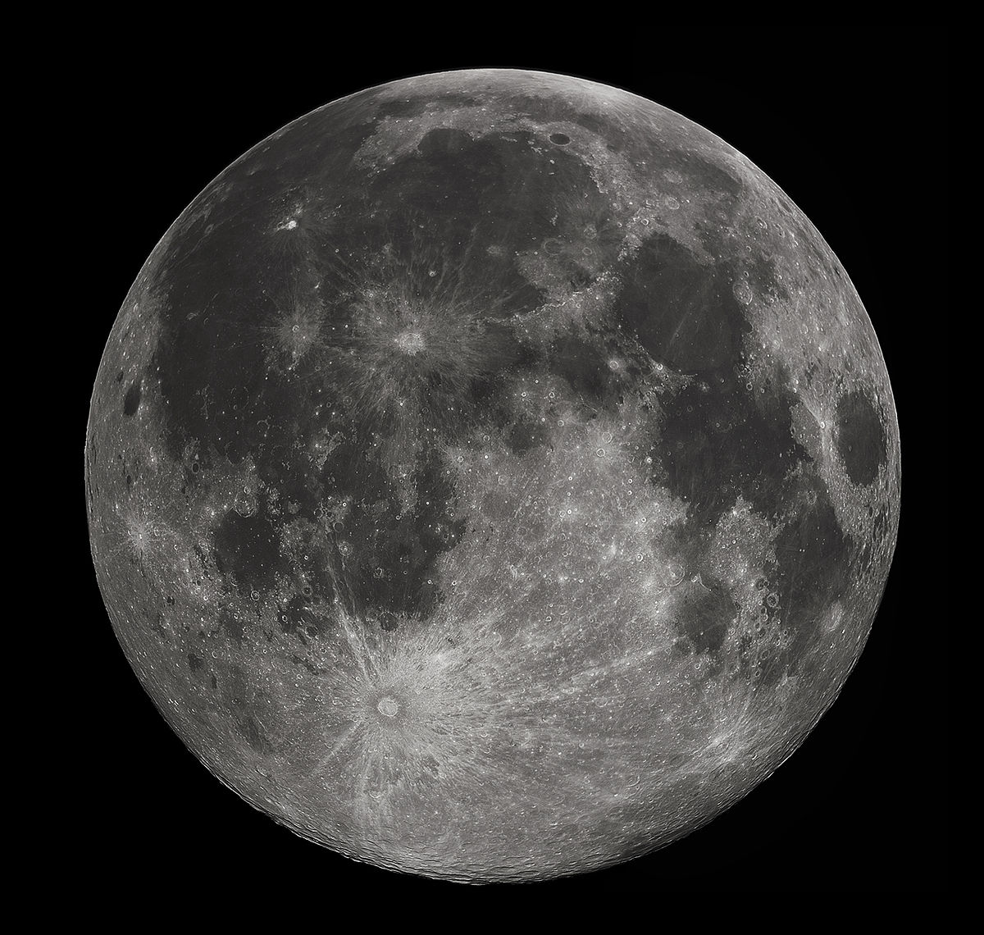  https://www.youtube.com/watch?v=UExTN3_UOIY Then write a short factfile about that first ever journey to the  moon. If you wish you can print out the footprint to write it in.
Unless otherwise specified, please complete the tasks in either your homework book or on a word document.
English – Challenge 2
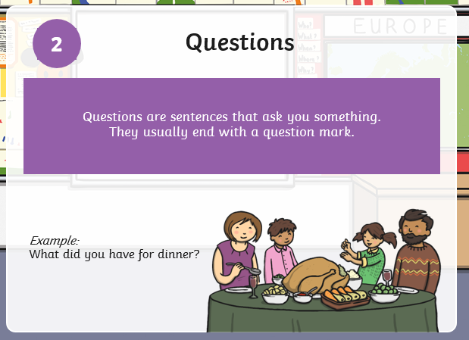

Write some super questions about the Alien Picture remember you must include a question mark (?).

English – Challenge 3
English Challenge 3
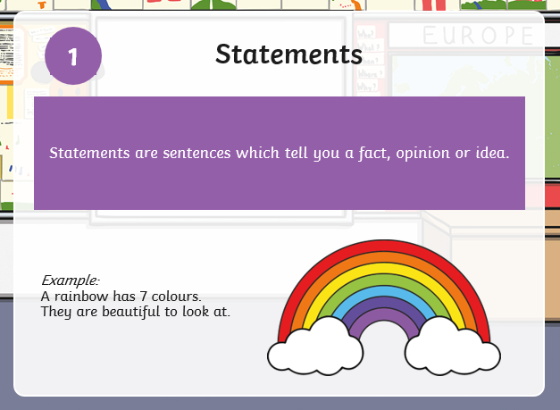

Write some super question and statement sentences about the Alien Picture.

Split your page into 2 and write 3 question sentences about the Alien and then 3 statement sentences.

English - Challenge 4/5
English Challenge 3
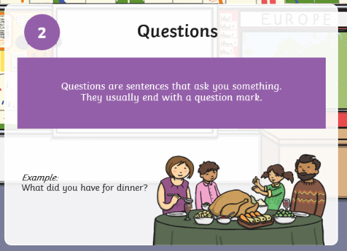
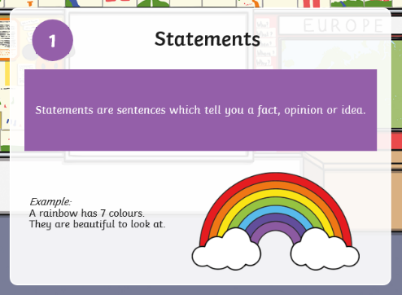

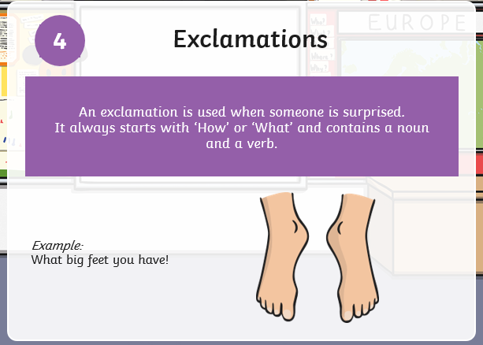
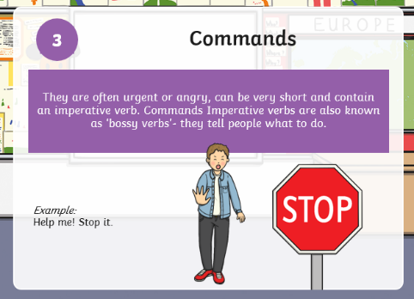

Write some brilliant different sentence types about the Alien Picture.

Split your page into 4 (quarters) and write 3 question sentences, 3 statement sentences, 3 command sentences and 3 exclamation sentences about the Alien.

Maths - Challenge 1/2/3

Maths - Challenge 4/5

History

