Year 2
Please find todays learning tasks below.
The table below explains the tasks and you will find the resources underneath. Your child will know which challenge they usually access in each subject and which task will be appropriate for them.
Year group: 2 Date: 15.06.20
English | 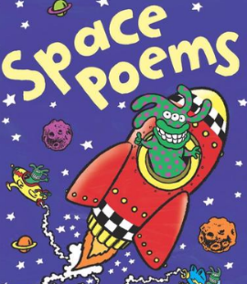  This week we are continuing to focus on Space, but through looking at some Poetry.
 | Challenge 1 | Challenge 2 | Challenge 3
Read the Poem called ‘BLAST OFF!’

Share the link https://www.bbc.co.uk/bitesize/topics/z4mmn39/articles/ztdvw6f
to learn all about Acrostic Poems
Today you are going to write your own acrostic poem for the words BLAST OFF, remember to start each line of your poem with the letters given e.g.
Blasting off into the night go rockets.

Maths | Log in to TT Rock Stars to complete your x tables challenges  (your login is in your Blue Home School Book)
 | Challenge 1 | Challenge 2 | Challenge 3
This week we are completing some work on Statistics – data.
Today we are going to complete some work on Tally Charts – we’ve done this topic in our maths already, so you should be able to practise the skills already learnt this week.
Click on this link to remind yourself of Tally Charts
https://www.bbc.co.uk/bitesize/clips/z7r9jxs
Complete the activity sheet below completing a Tally Chart for the vehicles and answering questions about the data.

Reading  Phonics | Complete the Reading Comprehension Task (See sheet below)  Complete the spelling activity sheet below – correcting the misspelt words.
Other | Today we are going to do some Geography  Venus is one of the planets we have been learning about. Share this link to remind yourself / learn about it. https://www.bbc.co.uk/bitesize/clips/zjspyrd  Share the PPT (PDF version on website) and then complete a fact sheet (below) about the planet Venus to share what you have learnt.

Unless otherwise specified, please complete the tasks in either your home learning book or print out the document below.
English Challenge ALL Groups
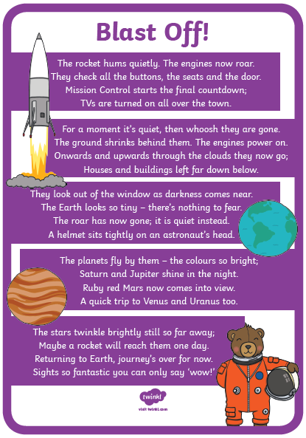

B_____________________
L_____________________
A_____________________
S_____________________
T_____________________
O_____________________
F_____________________
F______________________
Maths Task ALL Groups
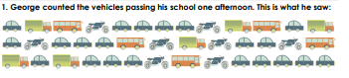
Complete a tally chart to show the vehicles that George saw. https://www.bbc.co.uk/bitesize/clips/z7r9jxs
Vehicle | Tally | Total
Cars

Lorries

Buses

Motorbikes

Answer the questions using the vehicle data.
- How many more cars than lorries did he saw? ________________________

- Which vehicle did he see the least? _______________________

- Can you put the vehicles in order from smallest to largest?

________________ ___________________ _____________________ ____________________
- Which type of vehicle did he see the least? _____________________

- How many buses and motorcycles did he see altogether? ______________________

- How many more motorbikes did he see than buses? _______________________

- How many less buses than lorries did he see? _________________________

- How many vehicles did he see altogether? ____________________________
- What is wrong with this tally? ___________________________________________________

- Can you write a statement to explain something you have noticed in the data?

Reasoning Task ALL groups
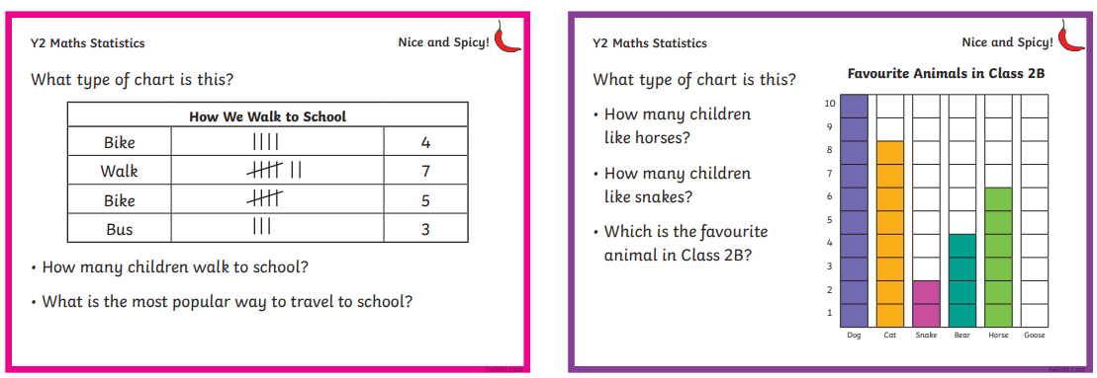

Reading

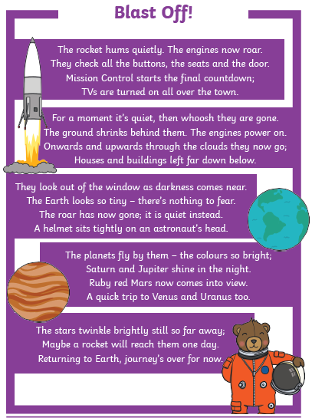

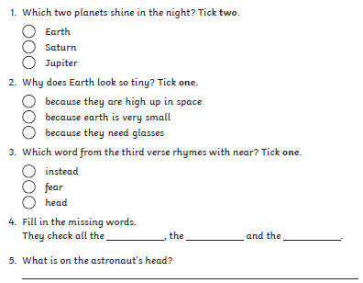

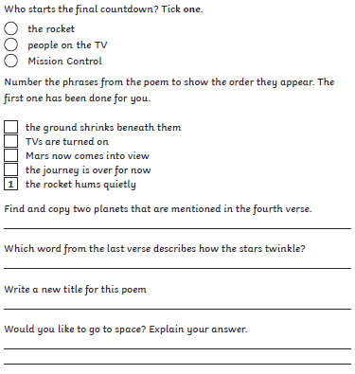

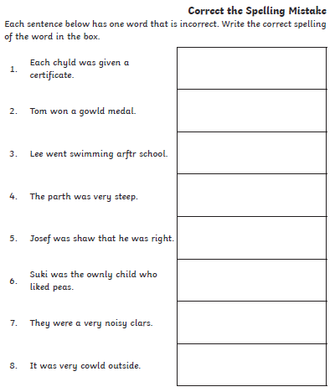
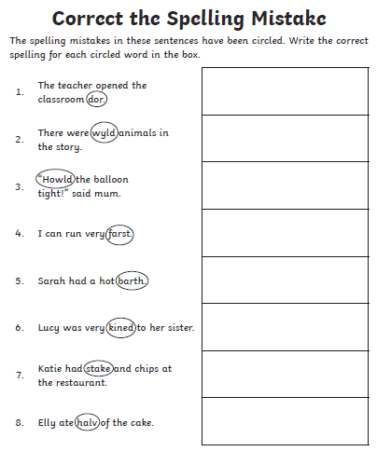
Spelling / Phonics Task
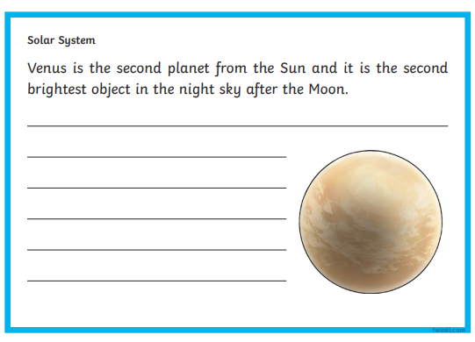
Topic Task

