Year 2
Please find todays learning tasks below.
The table below explains the tasks and you will find the resources underneath. Your child will know which challenge they usually access in each subject and which task will be appropriate for them.
Year group: 2 Date: 08.06.20
English | This week we are looking at a new story all about Space.  Go to https://www.youtube.com/watch?v=Nn73STXrPP0 and watch and listen to the story of Whatever Next by Jill Murphy.  The story starts with a question – ‘Can I go to the moon?’ and today we are focussing on questions.  After the story, think about some questions you might have for Baby Bear. You could ask  - What was the moon like – was it hot or cold?  - What was the sky like?  - Was it quiet or loud on the moon?  - How could you see where you were going?  - Did you want to stay or were you ready to come home? Why?  Can you think of more questions to ask?
 | Challenge 1 | Challenge 2 | Challenge 3
Pretend to be Baby Bear and ask your grown up or someone in your family to ask you questions.
Then swap over and you ask the questions. What will you ask?
Use the questions above to help but try and think of your own too!
Next – write down at least five questions and remember to use a question mark (?)
You do not need to answer them when you write them down but you could tell someone in your house what you think the answers would be, or ask someone else to answer them!

Maths | Log in to TT Rock Stars to complete your x tables challenges  (your login is in your Blue Home School Book)
 | Challenge 1 | Challenge 2 | Challenge 3
 | Today we are starting to look at the inverse of multiplication, which is division. Complete the activity below to write the division number sentences from the array  e.g. 2 x 3 = 6  so  6 ÷ 3 = 2  Complete your reasoning tasks too! | Today we are looking at the link between multiplication and division – complete the activity sheet below to show the division facts and the related x facts.  Complete your reasoning tasks too!
Reading  Phonics | Complete the Reading Comprehension Task (See sheet below) Answer the questions in full sentences using the question to scaffold your answer – remember I should know what the question was from your answer.  Complete the spelling activity sheet below.
Other | Today we are going to do some History.  Neil Armstrong is one of the most famous Astronauts – share this link to remind yourself / learn about him.  https://www.bbc.co.uk/bitesize/topics/zhpchbk/articles/z4w3mfr  Share the PPT (PDF version on website) and then complete a timeline showing the 5 key dates.  You can write a sentence and draw a picture for each key date.

Unless otherwise specified, please complete the tasks in either your home learning book or print out the document below.
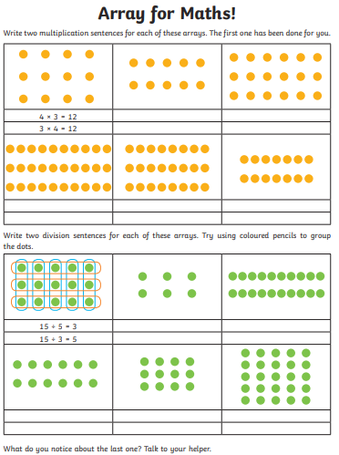
Maths Challenge 1

Maths Challenge 2 and 3
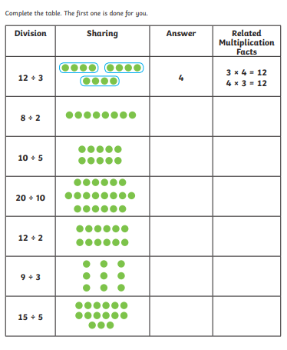

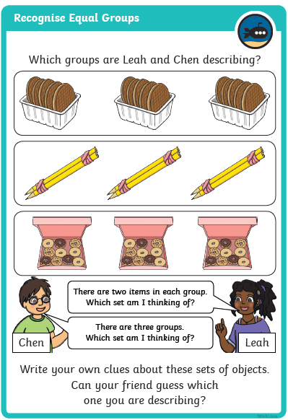
Reasoning Task
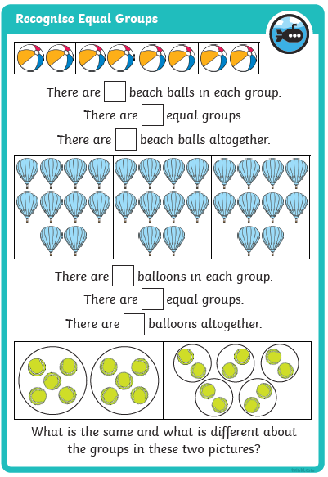

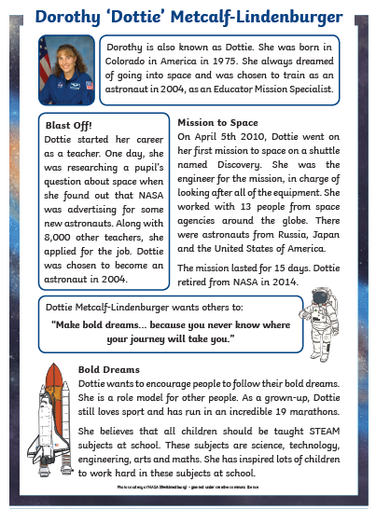
Reading

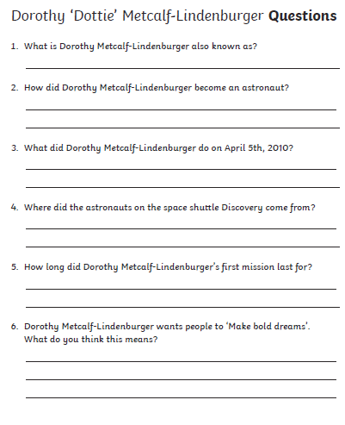

Spelling / Phonics Task

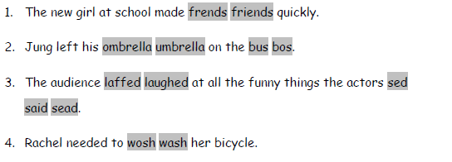
Rewrite the sentences choosing the correct spelling

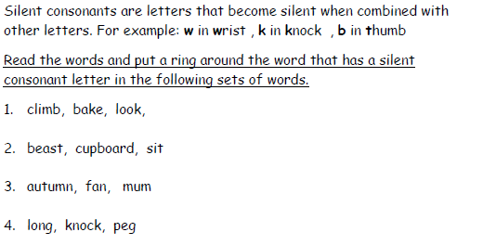
Write down the words that have silent consonants in your own sentence.

Can you work out these muddled time connectives?
feboer = _________ xnte = _________

tfaer = __________ nflylai = ___________
History Task
