Please find todays learning tasks below.
The table below explains the tasks and you will find the resources underneath. Your child will know which challenge they usually access in each subject and which task will be appropriate for them. There is a sticker in the front of their Red Home Learning Books if they were able to get one in the last week. If they did not any exercise book or lined paper will be fine.
Year group: 1/2 Date: Friday 1st May
 | Challenge 1 | Challenge 2 | Challenge 3 |  | Challenge 4 | Challenge 5
Retell the story of Jack and The Beanstalk to a grown up.
They can help you if you forget some.
English | Please see separate e-mail | Time to sequence the final three pictures of the story today.  Can you write a sentence for each, remembering capital letters and full stops, finger spaces and 2A? Don’t forget to use conjunctions and maybe an exclamation mark? |  |  | Today we are going to write the ending of the story, Jack and The Beanstalk. Read the character description you wrote the other day. It might give you ideas to include in your story.  Make sure you include 2A sentences, speech, conjunctions and interesting vocabulary.
Maths | Solve the emoji puzzles using + and -. | Solve the emoji puzzles using + and -. |  |  | Solve the space puzzles using + and -. Can you find out what each word is?
Reading | Go to https://www.roythezebra.com/guided-reading-stories/chapter5.html#/section0  Roy the zebra website tells the story of the worst zoo in the world. You can read or listen to the story, answer questions before and after reading. Following on from yesterday, read Chapter 5 today.  If you like you can finish reading the rest of the chapters today ☺ Will Roy find his herd?
Phonics | Go to https://www.ictgames.com/littleBirdSpelling/  ICT games Little Bird Spelling and select Year 1 and then go. Spell the words. | Go to https://www.ictgames.com/littleBirdSpelling/  ICT games Little Bird Spelling and select Year 1 and then go. Spell the words. |  | Go to https://www.ictgames.com/littleBirdSpelling/  ICT games Little Bird Spelling and select Year 2 and then go. Spell the words. | Go to https://www.ictgames.com/littleBirdSpelling/  ICT games Little Bird Spelling and select Year 2 and then go. Spell the words.
Other | Today’s subject focus will be PSHRE  Draw a picture of your house and your family.  Complete the sentences below.  My family are special because…  When I am with my family I feel…  The people living with me in my house are…  My wider family are…
Unless otherwise specified, please complete the tasks in either your homework book or on a word document
English – Challenge 2/3/4/5
Number the pics or cut and stick if you can. Otherwise tell an adult the order and write your sentence in your book.
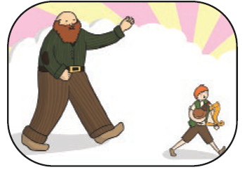
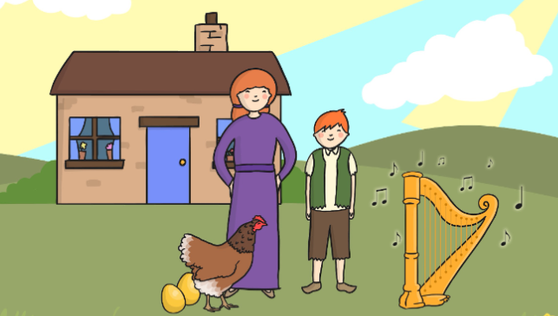
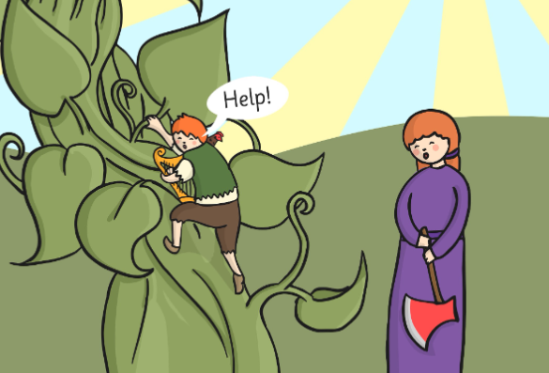

________________________________________________________________________________________________________________________________________________________________________________________________________________________________________________________________________________________________
Maths – Challenge 1
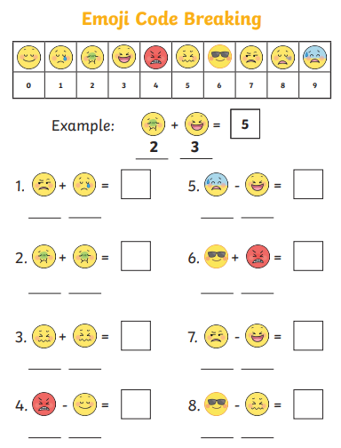

Maths – Challenge 2
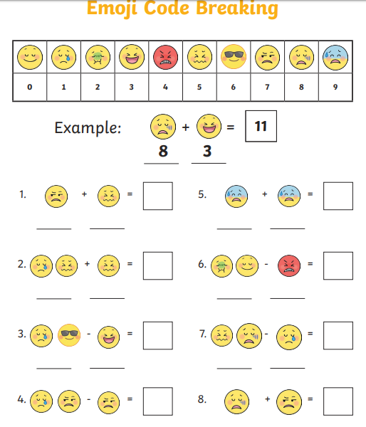

Maths – Challenge 3
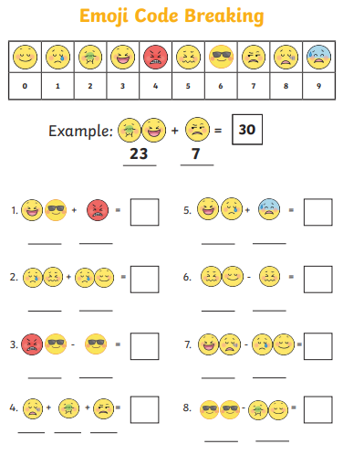

Maths – Challenge 4/5
