Please find todays learning tasks below.
The table below explains the tasks and you will find the resources underneath. Your child will know which challenge they usually access in each subject and which task will be appropriate for them. There is a sticker in the front of their Red Home Learning Books if they were able to get one in the last week. If they did not any exercise book or lined paper will be fine.
Year group: 1/2 Date: Friday 22nd May
 | Challenge 1 | Challenge 2 | Challenge 3 | Challenge 4 | Challenge 5
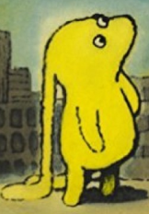
You have got 2 tasks to
complete today linked
to our text Beegu.
English | Please see separate e-mail | - Read the written version of the story and complete the reading comprehension questions in full sentences (activity sheets below).  - Complete a book review sheet (below) to review this story.
Maths | Can you draw a picture made from 2D shapes? There are some examples below. Be as creative as you like.
Reading | You can choose which book to read today. It could be your favourite story, a non-fiction book or an e-book. The choice is yours! I would love to hear what you have chosen.
Phonics | https://www.spellzone.com/word_lists/games-4781.htm Bouncing Anagram game. Spell the words with the suffixes –er and –est. |  |  | https://www.spellzone.com/word_lists/games-4606.htm Bouncing Anagram game. Spell the words with the different suffixes.
Other | Today we are thinking about SPACE again but through Dance!  Click on the link here:  https://www.bbc.co.uk/programmes/b03g6vs3  Click to watch or use the download button.  The session takes about 20 minutes – enjoy!
Unless otherwise specified, please complete the tasks in either your homework book or on a word document.
English – Challenge 2/3/4/5
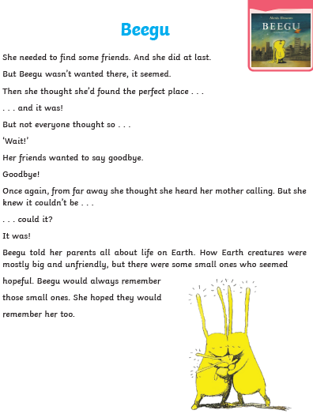

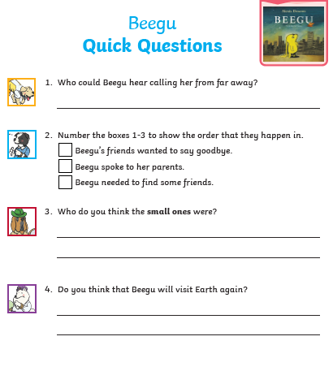

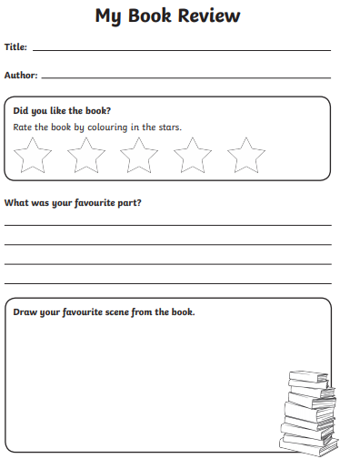

Maths - Challenge 1/2/3/4/5
