Year 2
Please find todays learning tasks below.
The table below explains the tasks and you will find the resources underneath.
Your child will know which challenge they usually access in each subject and which task will be appropriate for them.
Year group: 2 Date: 19.06.20
English | 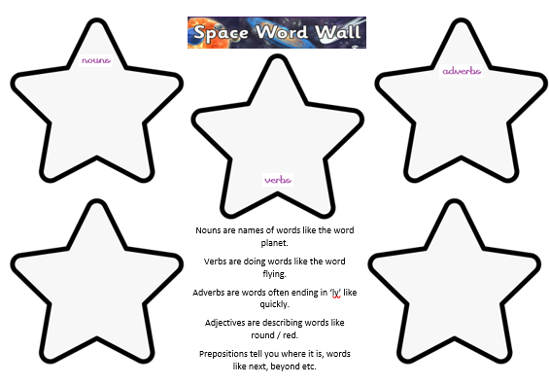  Yesterday you planned words that you might want to use in your own acrostic poem for the word SPACE.
 | Challenge 1 | Challenge 2 | Challenge 3
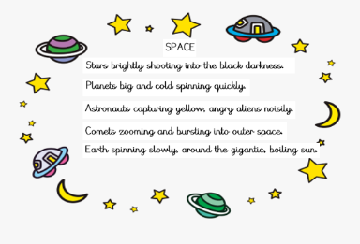

Today write your poem referring back and
using the words that you completed yesterday.
You can create your poem on a page in your books / print out the writing sheet below.

Maths | 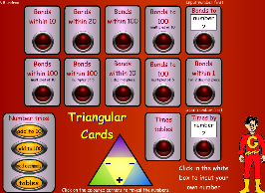  Complete the interactive number bonds within 10 and 20 activities on the following link  http://www.wldps.com/gordons/Triangular_cards.swf
 | Challenge 1 | Challenge 2 | Challenge 3
Today you can collect your own data such as favourite colours, favourite foods etc.
Collect some data – you can then use this to complete your own Tally Chart, Pictogram/Block Graph and write some statements about what your data shows. (see activity sheet below).

You can draw a tally chart / graph on a page in your books / print out the sheet below.

Reading  Phonics | Complete the reading task below.  Complete the misspelt words task below.
Other | Today we are going to complete PE  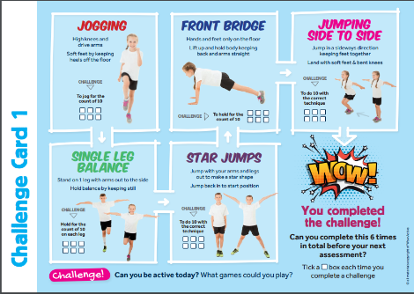  There is a Task Card below to complete different activities.

Unless otherwise specified, please complete the tasks in either your home learning book or print out the document below.

WAGOLL (What a good one looks like!)
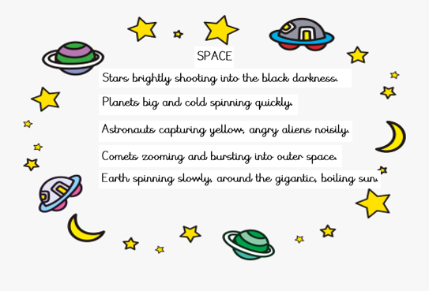

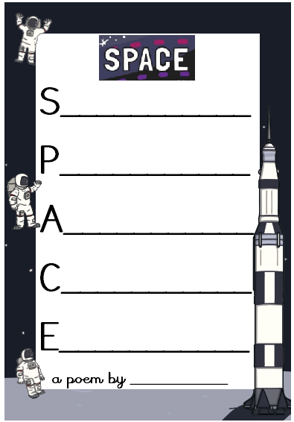
English All challenges
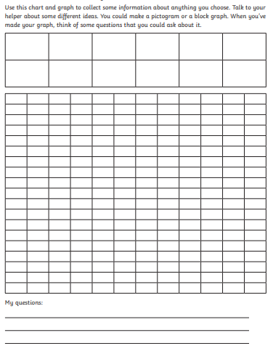
Maths Task ALL Groups

Reading Task ALL Groups

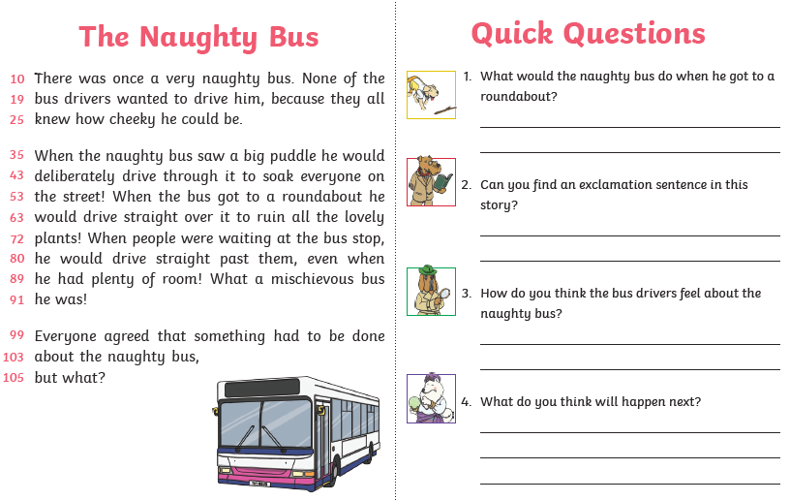

Spelling Task
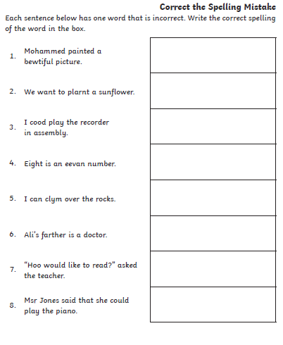
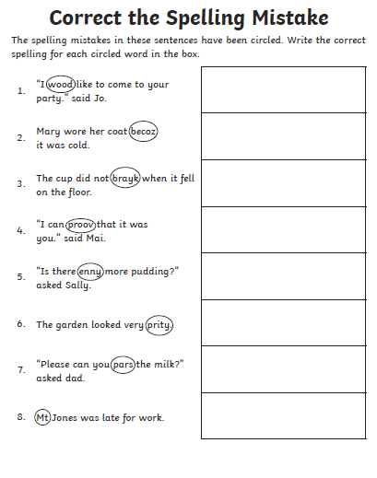

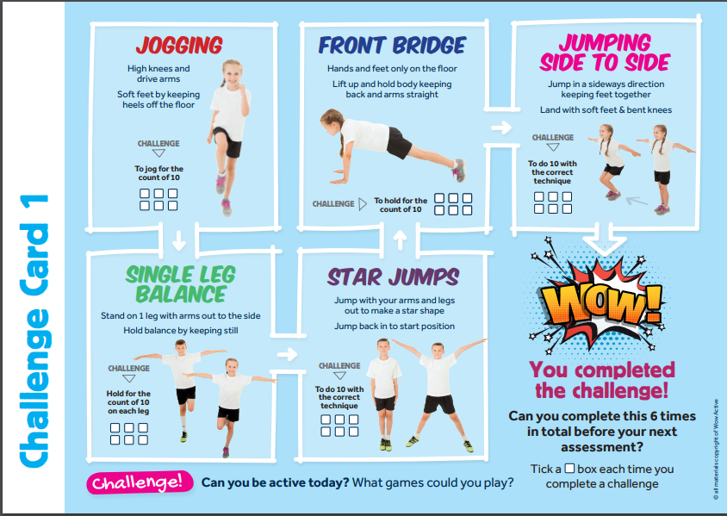
Topic Task

