Please find todays learning tasks below.
The table below explains the tasks and you will find the resources underneath. Your child will know which challenge they usually access in each subject and which task will be appropriate for them. There is a sticker in the front of their Red Home Learning Books if they were able to get one in the last week. If they did not any exercise book or lined paper will be fine.
Year group: 1/2 Date: Friday 15th May
 | Challenge 1 | Challenge 2 | Challenge 3 |  | Challenge 4 | Challenge 5
Read the Back to Earth with a Bump Powerpoint
to help with today’s learning.
English | Please see separate e-mail | Read the story again on the sheet below and then answer the questions. If you can print it out, or just write the answers in your home learning book. |  |  | Read the story again on the sheet below and then answer the questions. If you can print it out, or just write the answers in your home learning book.
Maths | Compare the lengths by answering the questions. | Compare the lengths by answering the questions. | Compare the lengths by answering the questions. |  | Compare the lengths by answering the questions. |  | Compare the lengths by answering the questions.
Reading | Go to Rising stars, reading planet and read an ebook.
Phonics | Go to phonics bloom and select Phase 2 Fishy Phonics https://www.phonicsbloom.com/uk/game/fishy-phonics?phase=2  You can choose the set number for the words used. | Go to Phonics bloom  https://www.phonicsbloom.com/uk/game/alien-escape?phase=3  And select Alien escape. Let’s practise spelling and help the alien! |  | Go to phonics bloom and select phase 5 Yes No yeti https://www.phonicsbloom.com/uk/game/yes-no-yeti?phase=5  Can you rescue the penguin? | Log onto Education City and choose a spelling task.
Other | Today we are thinking about SPACE again but through Dance!  Click on the link here:  https://www.bbc.co.uk/programmes/b03g6vs2  Click to watch or use the download button.  The session takes about 20 minutes – enjoy!
Unless otherwise specified, please complete the tasks in either your homework book or on a word document.
English – Challenge 2
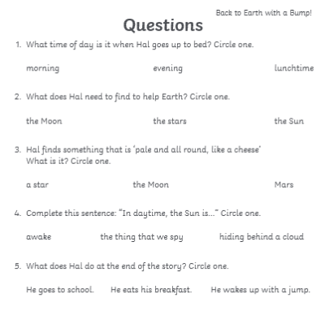

English – Challenge 3/4/5
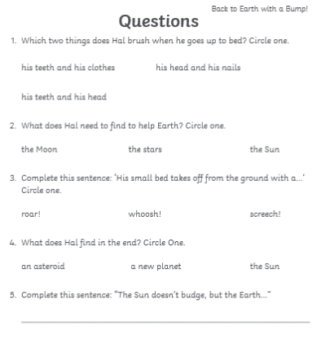

Maths - Challenge 1

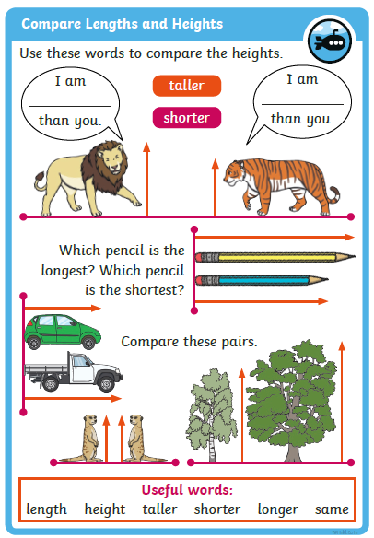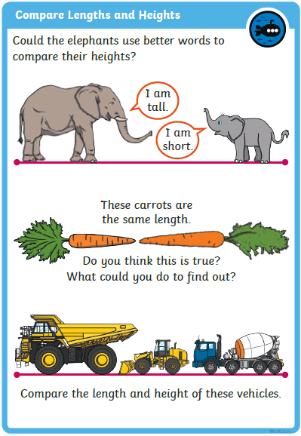
Maths – Challenge 2
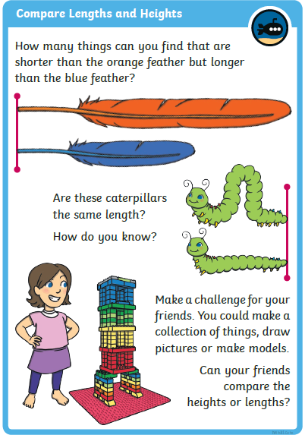

Maths - Challenge 3
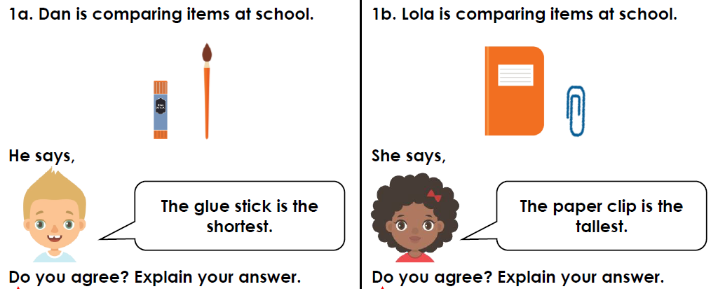
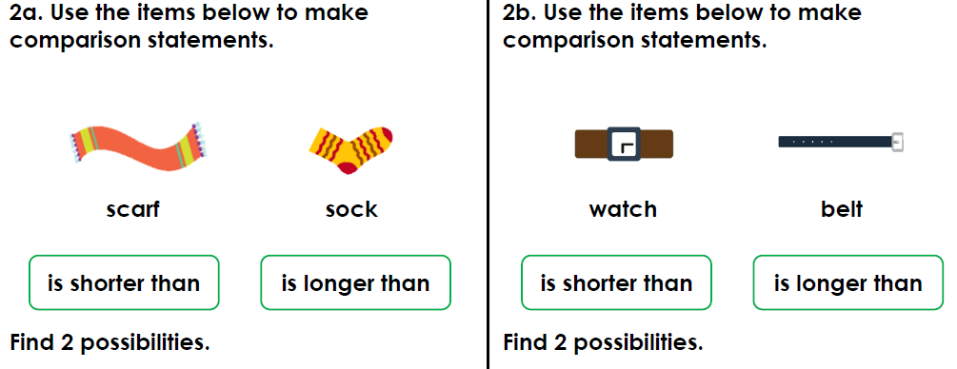
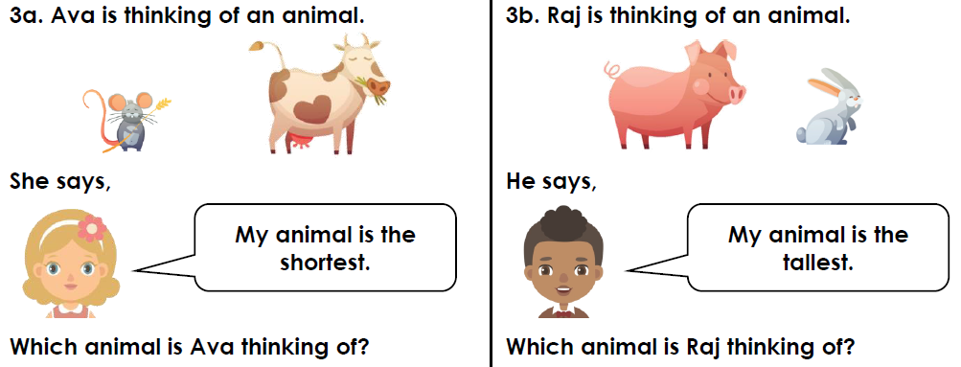

Maths - Challenge 4
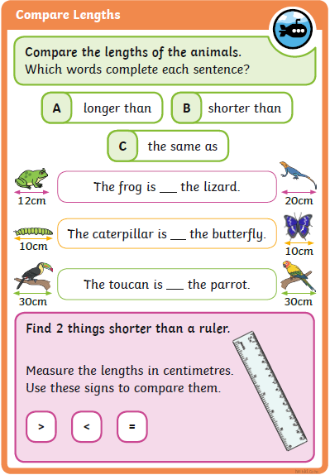
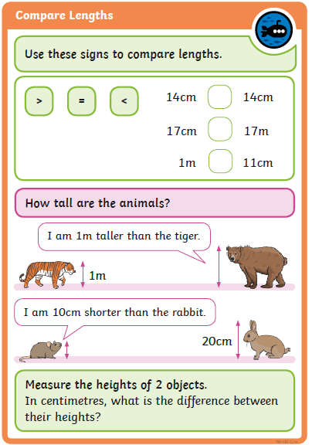
Maths – Challenge 5
