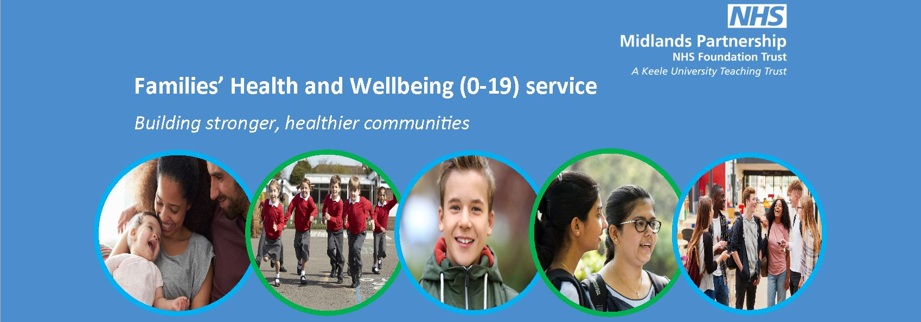

Families Health and Wellbeing Newsletter- May 15th 2020

Well, things have changed a lot since we were last in touch with you all. We understand that the last few months have been difficult and it has impacted everyone in different ways. Our thoughts are with everyone who has been directly affected by coronavirus.
As well as the concern around the pandemic, we understand that children and families may be struggling in other ways and we want to ensure that families know that we are still here and that we can still support them. Please see the sunshine image below which highlights some of the different ways that we can support families.
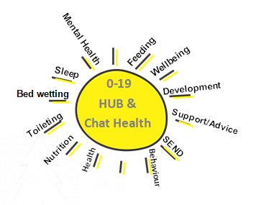
We support families with children from newborn up to19 years of age. We have school nurses, health visitors and nursery nurses who are based throughout the county. We can give information and help to families on topics such as: toilet training, bed wetting, emotional health and wellbeing, behaviour, poor sleep, breastfeeding, weaning, immunisations and healthy nutrition and so much more.
Please can you help us to support families by sharing the many ways that they can contact our service? Due to the coronavirus and following current national guidance, we are not routinely visiting families at home. We continue to offer support to families through appointed clinics, our hubs, telephone contacts or through virtual clinics.
We will still offer targeted face to face contacts where we have assessed that there is a need.

Families can get in touch with us via the various means below.

TELEPHONE:
We have two 0-19 hubs where families can call in for any advice or information on health and wellbeing. These are open Monday –Friday from 9am-5pm.
Families in the Moorlands, Newcastle, Stafford and Seisdon districts can call 0300 303 3923.
If you live in East Staffordshire, Tamworth, Lichfield or Cannock districts, you can call 0300 303 3924

CHAT HEALTH TEXT SERVICE: 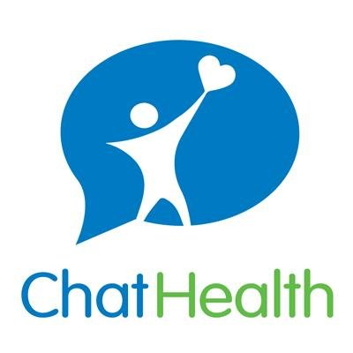
Parents can text the service for advice by texting 07520 625722
Children who are over 11 years old can text for advice on 07520 615721

SOCIAL MEDIA
We have various social media platforms on Facebook, Twitter and Instagram. Families cannot contact these platforms for advice, however we share important public health and service information through these platforms.

FACEBOOK

Each district has their own facebook page. These are:
Burton and Uttoxeter Families Health and Wellbeing Service 0-19
Cannock and Rugeley Families Health and Wellbeing Service
Lichfield Families Health and Wellbeing Service 0-19
Newcastle Families Health and Wellbeing Service 0-19
Seisdon Families Health and Wellbeing Service 0-19
Tamworth Families health & wellbeing service 0-19

INSTAGRAM
Fhws_0_19: Information shared for all children and families
Staffs_school_nurse: Information shared more specifically for school aged children

TWITTER

A range of information for families and for professionals alike @fhws0

Over the coming weeks we will be sharing more information about the key public health concerns that have been identified recently and how families and children can look after themselves during the current pandemic. If families feel that they need support currently, then please advise them to contact the hub on the numbers above.
In the meantime, take care and keep safe.

Best wishes,

Families Health and Wellbeing Service.

