Please find todays learning tasks below.
The table below explains the tasks and you will find the resources underneath. Your child will know which challenge they usually access in each subject and which task will be appropriate for them. There is a sticker in the front of their Red Home Learning Books if they were able to get one in the last week. If they did not any exercise book or lined paper will be fine.
Year group: 1/2 Date: Wednesday 29th April
 | Challenge 1 | Challenge 2 | Challenge 3 |  | Challenge 4 | Challenge 5
Retell the story of Jack and The Beanstalk to a grown up.
They can help you if you forget some.
English | Please see separate e-mail | Today we are writing a description of the Giant. Use the adjectives you thought of yesterday and there are some on the sheet too to help.  Remember we aren’t writing the story, just what the Giant looks like and what sort of a person he might be...such as The huge, terrifying giant has an enormous, scruffy beard and strong, long legs. |  |  | Today we are writing a description of the Giant. Use the adjectives and conjunctions you thought of yesterday and there are some on the sheet too to help.  Remember we aren’t writing the story, just what the Giant looks like and what sort of a person he might be...such as The huge, terrifying giant has an enormous, scruffy beard and strong, long legs.
Maths | Read the word problems. Write out the number sentence and then solve it. | Use the bar models to help answer the questions. |  |  | Solve the problems below. You might want to make notes to help you.
Reading | Go to https://www.roythezebra.com/guided-reading-stories/chapter3.html#/section0  Roy the zebra website tells the story of the worst zoo in the world. You can read or listen to the story, answer questions before and after reading.  Following on from yesterday, read Chapter 3 today, we are going to read the rest during the week.
Phonics | Go to https://www.phonicsbloom.com/uk/game/phonics-frog?phase=3  And choose ch, sh, th, ng  Can you get the frog to safety? | Go to https://www.phonicsbloom.com/uk/game/phonics-frog?phase=3  And choose one of the vowel digraphs such as ai, ee etc. Can you get the frog to safety? |  | Go to https://www.phonicsbloom.com/uk/game/phonics-frog?phase=5  Choose any of the sounds and try and get the frog to safety! | Can you unscramble the words below?
Other | Today’s subject focus will be Art  Follow the link below and draw a self portrait!  https://www.bbc.co.uk/teach/class-clips-video/art-and-design-draw-self-portrait/z6ytscw
Unless otherwise specified, please complete the tasks in either your homework book or on a word document
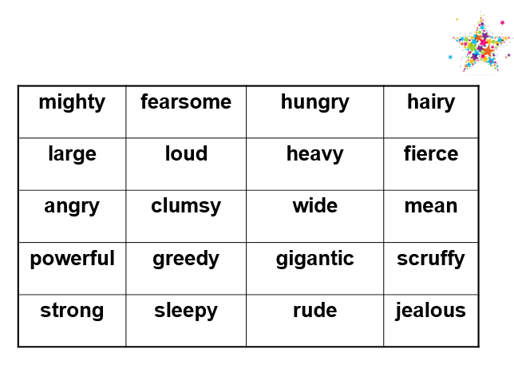
English – Challenge 2/3/4/5
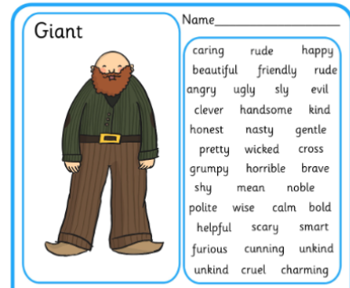

Maths - Challenge 1

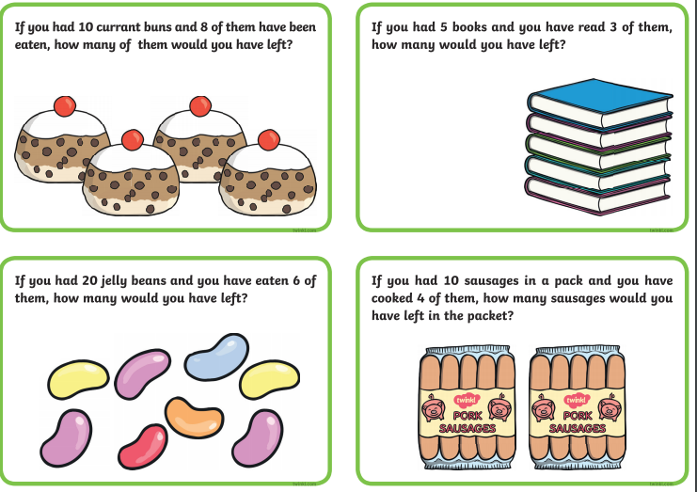
Maths – Challenge 2/3
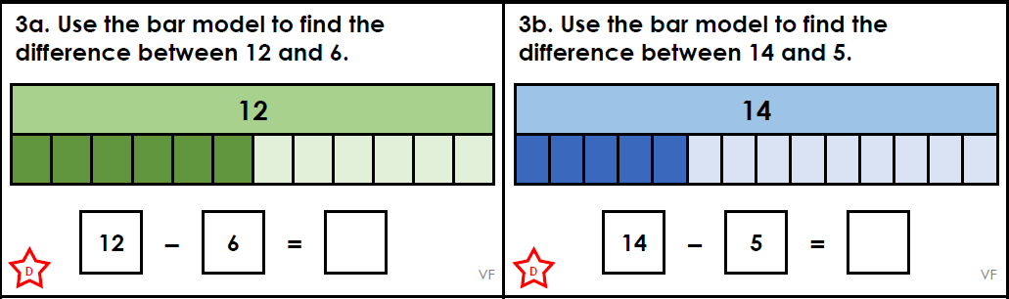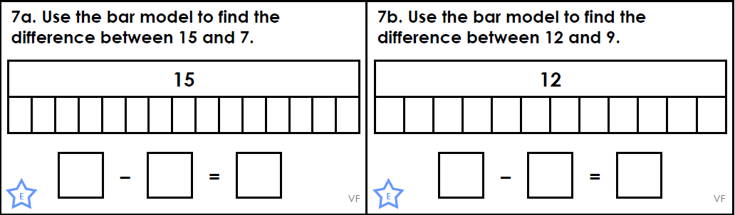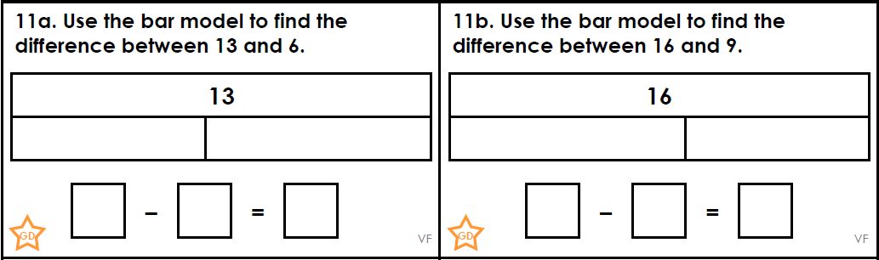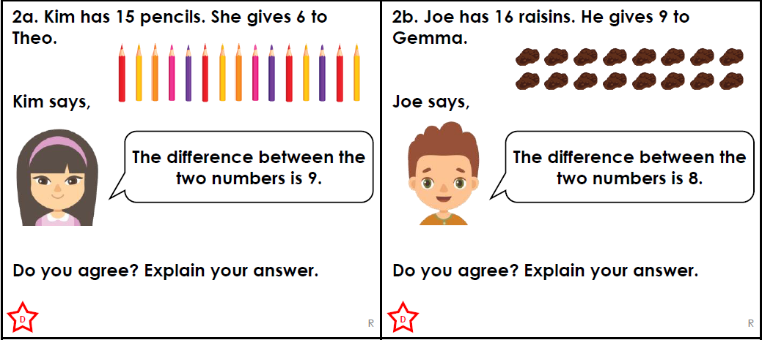

Maths - Challenge 4
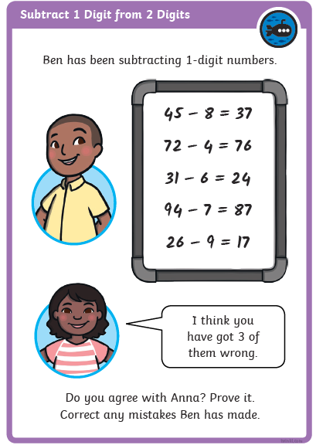
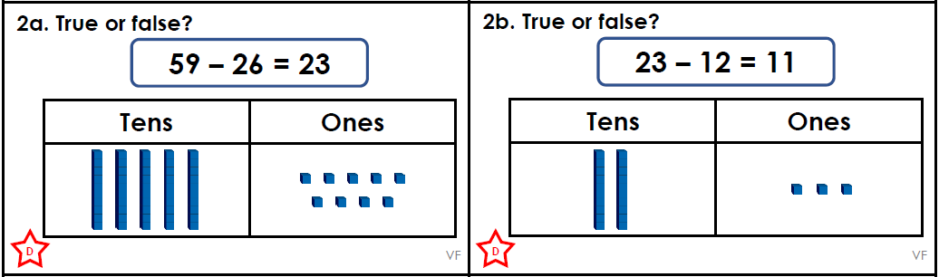

Maths – Challenge 5
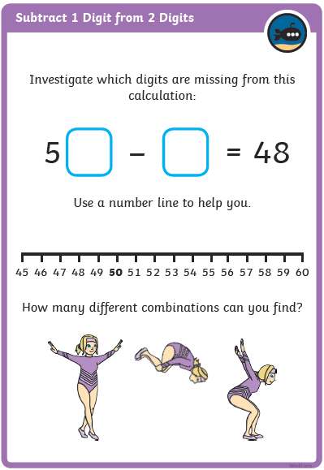

Spelling – Challenge 4/5
Can you unscramble these words?

frtae = ________ slao = ____________
lopepe = _____________ ehwn = ____________
ebfroe = ____________ ecbsaue = ______________
hcwcih = ______________ thfear = _______________
bmicl = _______________ twear = _______________

