Please find todays learning tasks below.
The table below explains the tasks and you will find the resources underneath. Your child will know which challenge they usually access in each subject and which task will be appropriate for them. There is a sticker in the front of their Red Home Learning Books if they were able to get one in the last week. If they did not any exercise book or lined paper will be fine.
Year group: 1/2 Date: Wednesday 22nd April
 | Challenge 1 | Challenge 2 | Challenge 3 | Challenge 4 | Challenge 5
Read the three Tongue Twister Poems. Try and learn one and say it to
someone in your family. Can you say it really fast?!

English | Please see separate e-mail | What on earth is that on your face?  Draw a picture of your own face.  Label all the different parts of your face using a rhyming word for each  part (A nose like a hose; Two eyes like pies, etc.)
Maths | Add the numicon. Can you write the question as a number sentence? ie  5+4=9 | Solve the addition word problems. Write the number sentence for each problem. |  | Solve the addition sums. I have done the first on to help you. If you struggle you can draw the dienes to help you.
Reading | https://www.booktrust.org.uk/books-and-reading/have-some-fun/storybooks-and-games/open-very-carefully/  Read along to ‘Open Very Carefully’ by Nick Bromley.
Phonics | Match the pictures to the word. https://www.phonicsplay.co.uk/PictureMatch.html# | Balloon Pop. Choose 3 sounds you wish to practice. Pop the balloons that have the sound shown in the bottom left corner.  https://www.ictgames.com/phonicsPop/index.html |  | Look at the words that are often spelt wrong. Click on the correct spelling.  https://howtospell.co.uk/misspelled-words-quiz-1
Other | Today is Earth Day.  Read the info below and choose one of the activities to do.  Please send in photos so we can share on Twitter
Unless otherwise specified, please complete the tasks in either your homework book or on a word document.
English – starter task
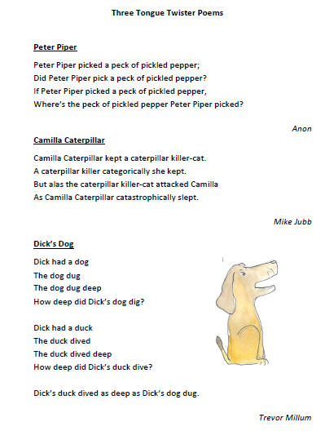

Maths - Challenge 1
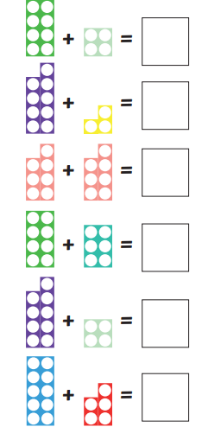
Maths – Challenge 2/3
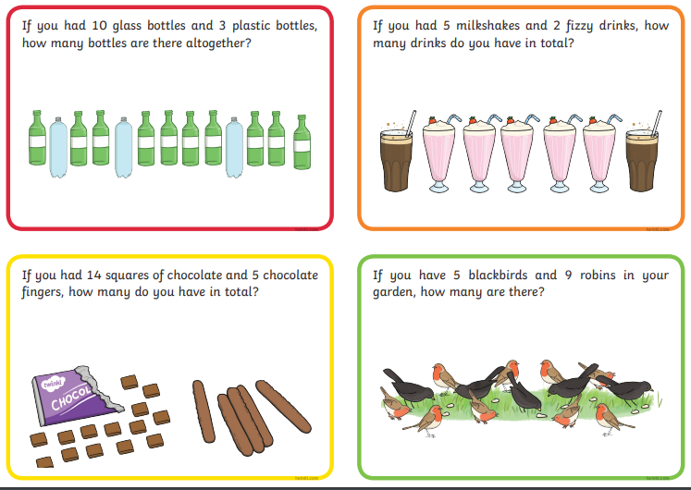
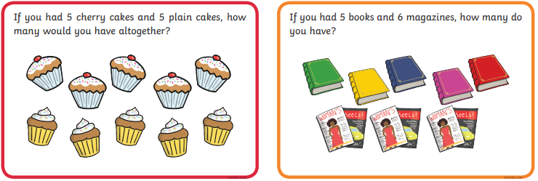

Maths - Challenge 4/5
5 4 3 7 6 2
+ 2 7 + 2 6 + 3 8
8 1

4 8 5 6 4 3
+ 3 3 + 3 5 + 3 9

Extension
7 8 6 6 9 7
+ 8 6 + 9 6 + 7 8

