Please find todays learning tasks below.
The table below explains the tasks and you will find the resources underneath. Your child will know which challenge they usually access in each subject and which task will be appropriate for them. There is a sticker in the front of their Red Home Learning Books if they were able to get one in the last week. If they did not any exercise book or lined paper will be fine.
Year group: 1/2 Date: Tuesday 28th April
 | Challenge 1 | Challenge 2 | Challenge 3 |  | Challenge 4 | Challenge 5
Share the story by following the link below;
https://www.youtube.com/watch?v=zurz-pL-uzw
English | Please see separate e-mail | Today we are thinking of adjectives to describe the Giant then we will use this plan to write a description tomorrow.  Think of interesting adjectives and use the word bank to help. Can you use some 2A phrases?  We are not writing in sentences today. | Today we are thinking of adjectives to describe the Giant then we will use this plan to write a description tomorrow.  Think of interesting adjectives and use the word bank to help. Use 2A and maybe think where you could use an exclamation mark. We are not writing in sentences today. |  | Today we are thinking of adjectives to describe the Giant and then we will use this plan to write a description tomorrow.  Remember to think of interesting adjectives and use the word bank to help. Use 2A and think about the different conjunctions you could use (and, but, so, because) We are not writing in sentences today.
Maths | Jump along the number line by the amount you are taking away. | Read the word problems. Write out the number sentence and then solve it. |  |  | Subtract using a column. Don’t worry there aren’t any exchanging questions.
Reading | Go to https://www.roythezebra.com/guided-reading-stories/chapter2.html#/section0  Roy the Zebra website tells the story of the worst zoo in the world. You can read or listen to the story, answer questions before and after reading.  Following on from yesterday, read Chapter 2 today, we are going to read the rest during the week .
Phonics | I Spy  Look at the sheet below, read the words and find it in the picture. Don’t worry about printing – just show an adult when you have found it. | I Spy  Look at the sheet below, read the words and find it in the picture. Don’t worry about printing – just show an adult when you have found it. |  | I Spy  Look at the sheet below, read the words and find it in the picture. Don’t worry about printing – just show an adult when you have found it. | Complete a quick spell of these 10 Common Exception Words.  Father plant path everyone kind beautiful Mr Mrs Money children
Other | Today’s subject focus will be Geography  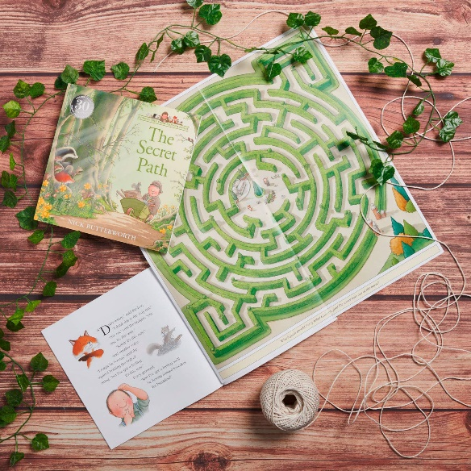  Watch the link here:  https://www.youtube.com/watch?v=Q9nlu19VU9M  (watch the story of Percy the Park Keeper and the Secret Path)  Create your own maze for Percy and the Park animals – look at the picture here and create your own maze.
Unless otherwise specified, please complete the tasks in either your homework book or on a word document.
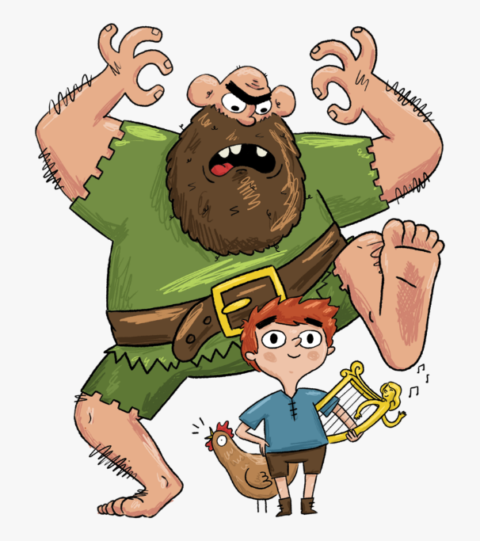
English – Challenge 2/3/4/5
_________________________________________________________________________
_________________________________________________________________________
_________________________________________________________________________
_________________________________________________________________________
The Giant
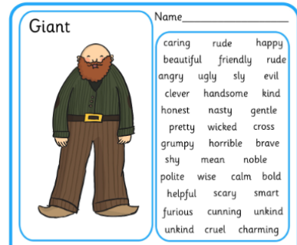

Maths - Challenge 1

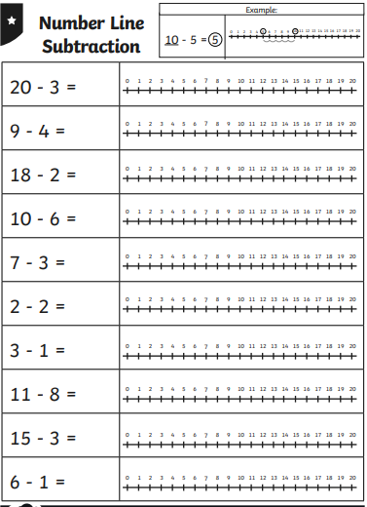
Maths – Challenge 2/3
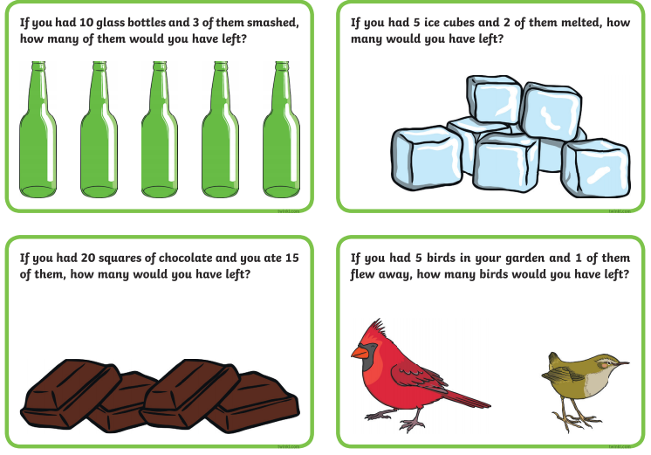

Maths - Challenge 4/5
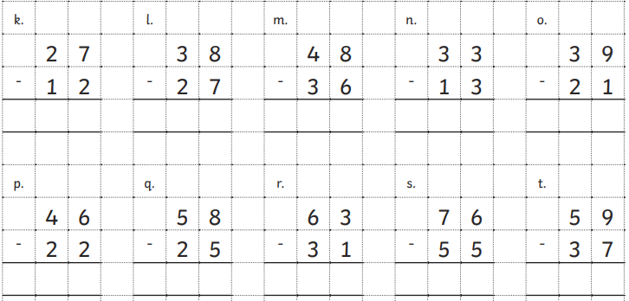

Phonics Challenge 1
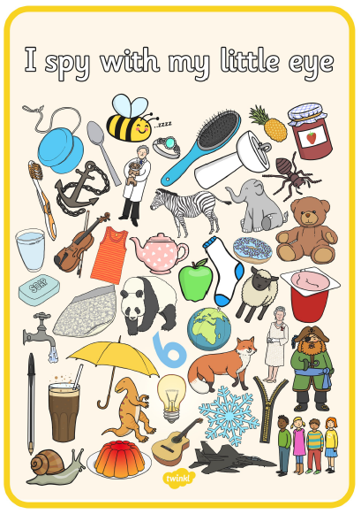

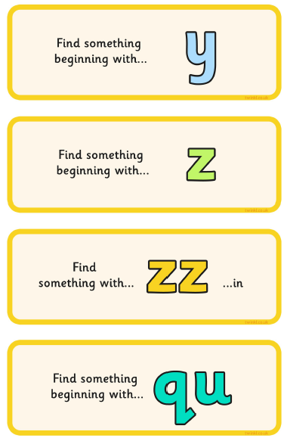

Phonics – Challenge 2
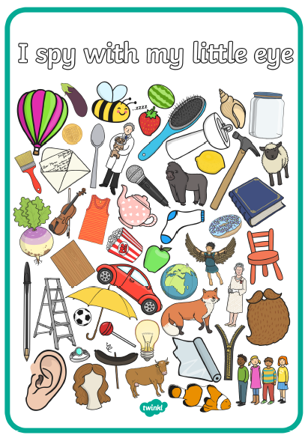

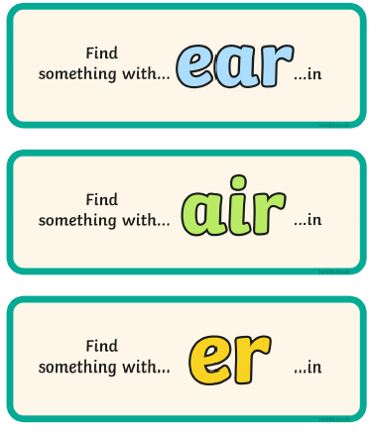

Phonics – Challenge 3
