Please find todays learning tasks below.
The table below explains the tasks and you will find the resources underneath. Your child will know which challenge they usually access in each subject and which task will be appropriate for them. There is a sticker in the front of their Red Home Learning Books if they were able to get one in the last week. If they did not any exercise book or lined paper will be fine.
Year group: 1/2 Date: Tuesday 21st April
 | Challenge 1 | Challenge 2 | Challenge 3 |  | Challenge 4 | Challenge 5
Read and enjoy Make a Face (below)
by Tony Mitton

English | Please see separate e-mail | Look at the poem again and this time find the rhyming words (don’t include face).  If you can print it out you could highlight the words but if not why don’t you write them in a list. | Thinking about the different faces in the poem, see if you can write two more lines in the same style.  Use the sheet to help. |  | Thinking about the different faces in the poem, see if you can write four more lines in the same style.  Use the sheet to help.
Maths | Play the addition game below. You can either print out the game board or make your own. |  |  |  | Log on to Education City and go on ‘Play Live’. Do the addition and subtraction games. E-mail me to tell me your best score.
Reading | https://www.booktrust.org.uk/books-and-reading/have-some-fun/storybooks-and-games/A-hole-in-the-bottom-of-the-sea/  Read along to ‘A Hole in The Bottom of The Sea’ adapted by Jessica Law.
Phonics | Go to Phonics Play and play Dragons Den. Phase 3 the ‘ee’ sound. | Go to Phonics Play and play Dragons Den. Phase 5 the ‘oy’ sound. |  | Go to Phonics Play and play Dragons Den. Phase 5 the ‘ie’ sound. | Suffixes –ful and –less worksheet below.
Other | Today’s learning is The Queen’s birthday!  Queen Elizabeth II is 94 today!  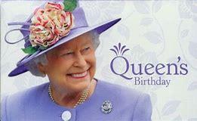  Can you make her a birthday card? What will you write inside?  Send a picture across and we will post some onTwitter!
Unless otherwise specified, please complete the tasks in either your homework book or on a word document.
English – starter task
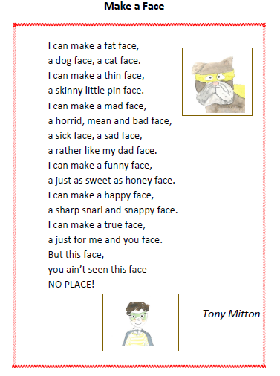

English – Challenge 2
Moody Faces
Let’s really look at this poem
Use coloured pens to highlight all the pairs of rhyming words you can
find in the poem. (Don’t include face!)

I can make a fat face,
a dog face, a cat face.
I can make a thin face,
a skinny little pin face.
I can make a mad face,
a horrid, mean and bad face,
a sick face, a sad face,
a rather like my dad face.
I can make a funny face,
a just as sweet as honey face.
I can make a happy face,
a sharp snarl and snappy face.
I can make a true face,
a just for me and you face.
But this face,
you ain’t seen this face –
NO PLACE!

How many pairs of words did you find?

English – Challenge 3

My Version of Make a Face

I can make a fat face,
a dog face, a cat face
I can make
_____________________________________________
_____________________________________________

I can make
_____________________________________________
_____________________________________________

But this face,
you ain’t seen this face –
NO PLACE!

English – Challenge 4/5

My Version of Make a Face

I can make a fat face,
a dog face, a cat face

I can make
_____________________________________________
_____________________________________________
I can make
_____________________________________________
_____________________________________________
I can make
_____________________________________________
_____________________________________________

I can make
_____________________________________________
_____________________________________________
But this face,
you ain’t seen this face –
NO PLACE!

Maths - Challenge 1/2/3
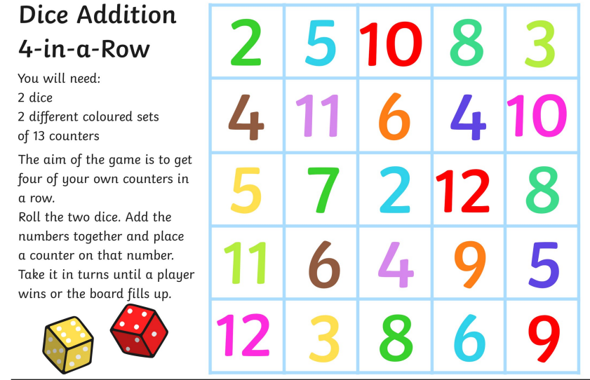

Phonics Challenge 4/5
