Please find todays learning tasks below.
The table below explains the tasks and you will find the resources underneath. Your child will know which challenge they usually access in each subject and which task will be appropriate for them. There is a sticker in the front of their Red Home Learning Books if they were able to get one in the last week. If they did not any exercise book or lined paper will be fine.
Year group: 1/2 Date: Thursday 30th April
 | Challenge 1 | Challenge 2 | Challenge 3 |  | Challenge 4 | Challenge 5
Retell the story of Jack and The Beanstalk to a grown up.
They can help you if you forget some.
English | Please see separate e-mail | Complete the sequence task (below).  If you cannot print copy the pictures into your book in the right order.  Try to write sentences for each picture, we will complete this story tomorrow so don’t worry about the story ending.  Remember to use capital letters and full stops, 2A and interesting words. |  |  | Today we are going to write the first half of the story, Jack and The Beanstalk. Read the character description you wrote the other day. It might give you ideas to include in your story.  Make sure you include 2A sentences, speech, conjunctions and interesting vocabulary.
Maths | Read the word problems. Write out the number sentence and then solve it. | Go on to Education City. Go on Play Live, subtraction. Let me know what your best score is! |  |  | Go on to Education City. Go on Play Live, subtraction. Let me know what your best score is!
Reading | Go to https://www.roythezebra.com/guided-reading-stories/chapter4.html#/section0  Roy the zebra website tells the story of the worst zoo in the world. You can read or listen to the story, answer questions before and after reading.  Following on from yesterday, read Chapter 4 today, we are going to read the rest during the week.
Phonics | Go to http://www.ictgames.com/phonicsPop/index.html  ICT Games Phonics Pop and select sh, th, ch or wh and then pop the sounds. | Go to http://www.ictgames.com/phonicsPop/index.html  ICT Games Phonics Pop and select any of the sounds. Click go and then pop the sounds. |  | Go to http://www.ictgames.com/phonicsPop/index.html  ICT Games Phonics Pop and select any of the sounds. Click go and then pop the sounds. | Go to  https://www.spellzone.com/word_lists/games-4607.htm  Play ‘Against The Clock’.
Other | Today’s subject focus will be Music  Share the link below:  https://www.bbc.co.uk/teach/school-radio/music-jack-and-the-beanstalk-song1/z7m67nb  Follow the tasks on the screen to learn the song ‘What shall we do?’ – clap the rhythms.
Unless otherwise specified, please complete the tasks in either your homework book or on a word document
English – Challenge 2/3
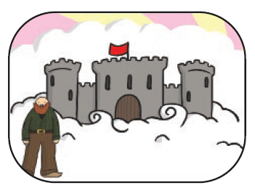
Number the pics or cut and stick if you can. Otherwise tell an adult the order and write your sentence in your book.



