Please find todays learning tasks below.
The table below explains the tasks and you will find the resources underneath. Your child will know which challenge they usually access in each subject and which task will be appropriate for them. There is a sticker in the front of their Red Home Learning Books if they were able to get one in the last week. If they did not any exercise book or lined paper will be fine.
Year group: 1/2 Date: Thursday 23rd April
 | Challenge 1 | Challenge 2 | Challenge 3 |  | Challenge 4 | Challenge 5
Read the two poems, If You Should Meet a Crocodile and The Vulture
What things do the poems have in common?
Which do you like the best? Why is that?
English | Please see separate e-mail | Use a coloured pen to highlight the pairs of rhyming words in The Vulture. If you can’t print it off, tell a grown-up which words rhyme.  Are you sure that you have all pairs listed on Rhymes in The Vulture?  Read the other words in the box below the table.  Copy each into the correct rhyme section.  Challenge 4/5 I also want you to add other rhyming words to the table.
Maths | Solve the addition problems. You can ask someone to help read them to you if you want. | Complete the Tens frames to find the answers. Can you do the extension as well? |  |  | Solve the addition problems below. Remember they are ALL addition problems!
Reading | https://www.booktrust.org.uk/books-and-reading/have-some-fun/storybooks-and-games/the-dragon-machine/  Read along to ‘The Dragon Machine’ by Helen Ward.
Phonics | Search on YouTube for Geraldine the Giraffe. Choose a sound to practice. | Search on YouTube for Geraldine the Giraffe. Choose a sound to practice. |  | Search on YouTube for Geraldine the Giraffe. Choose a sound to practice. | Plurals that end with –es. Choose the correct spelling.  https://www.educationquizzes.com/ks1/english-spelling/year-1-plurals-that-end-in-es/
Other | Today’s learning will be about St George as it is St George’s Day today!  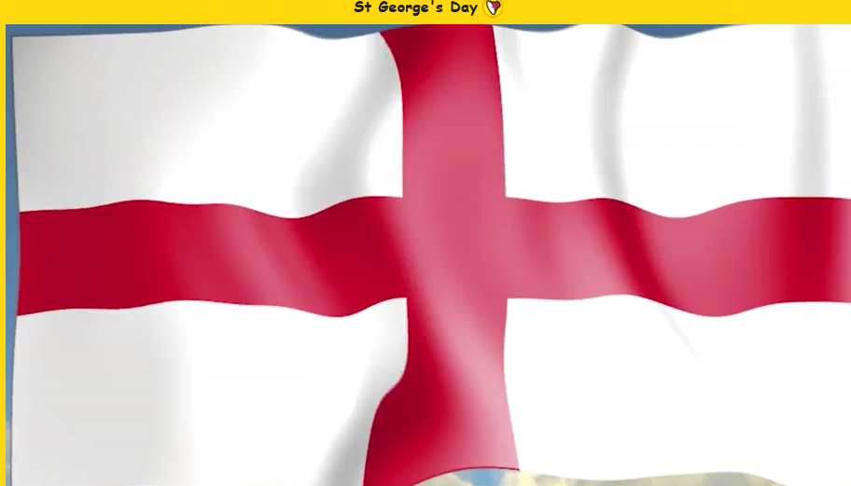  Go to espresso  https://central.espresso.co.uk/espresso/primary_uk/subject/news/video/item788650/grade1/index.html?source=search-all-all-all-all&source-keywords=st%20georges%20day  Espresso.co.uk - Username: student28034 Password: kingsfield  Search for St Georges Day and you will find under KS1 PSHE 1 news 1 this:  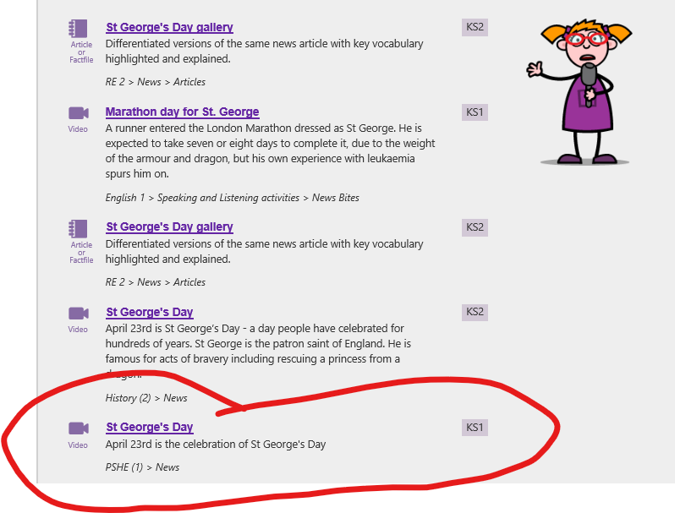 Find out about St George and then can you draw and colour the flag of England?
Unless otherwise specified, please complete the tasks in either your homework book or on a word document.
English – starter task
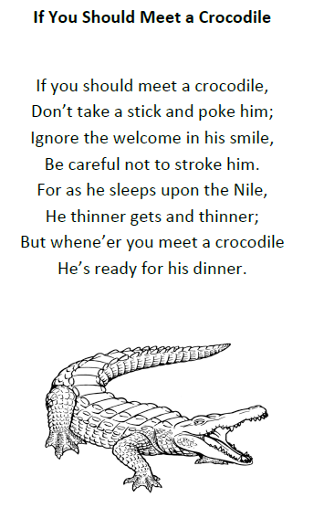
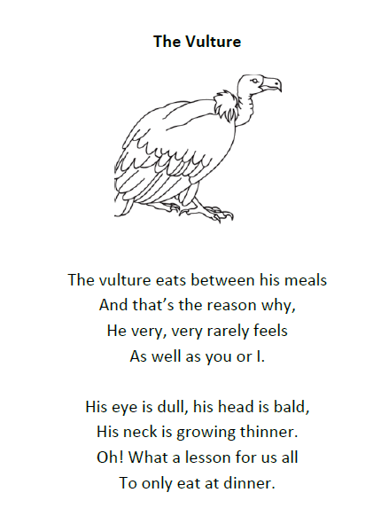

English – Challenge 2/3/4/5
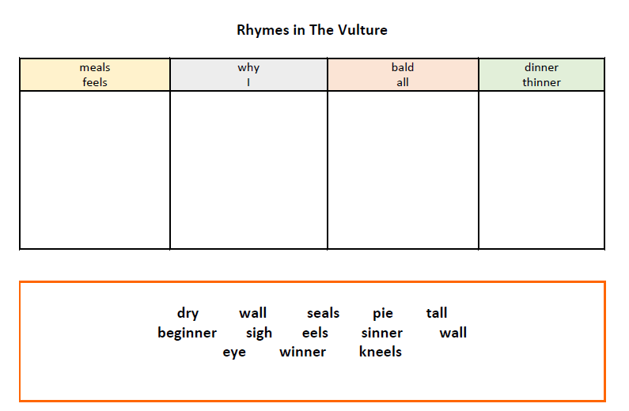

Maths - Challenge 1
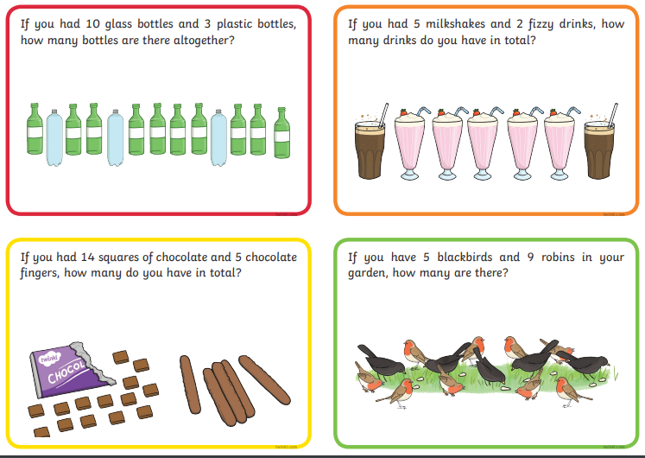
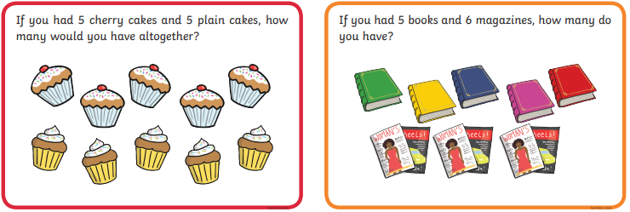

Maths – Challenge 2/3
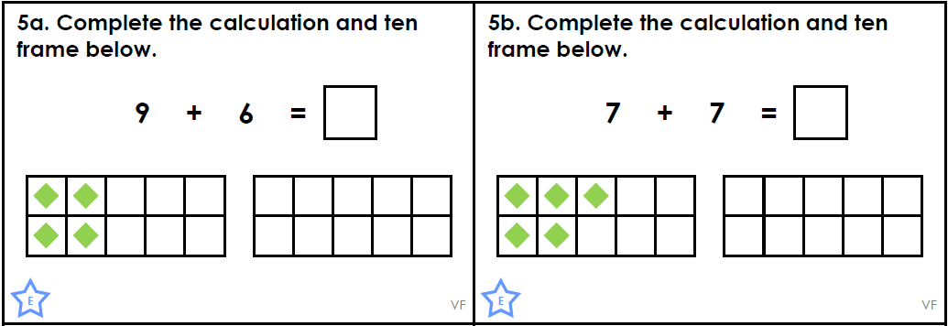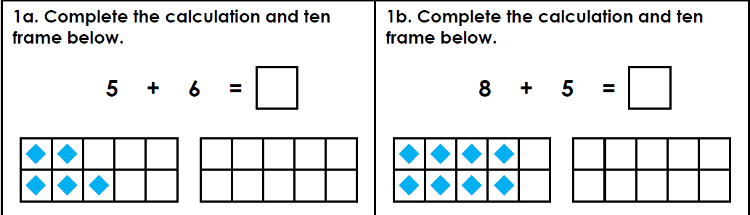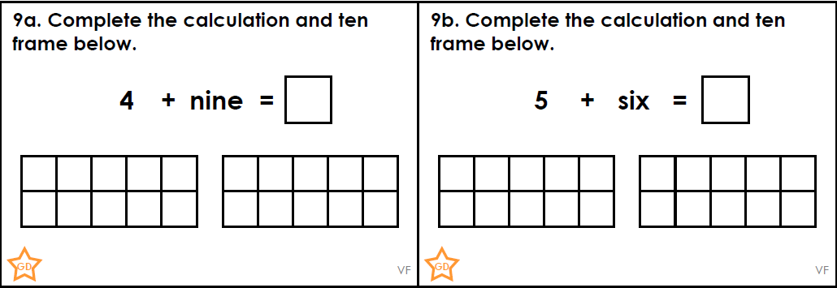
Extension
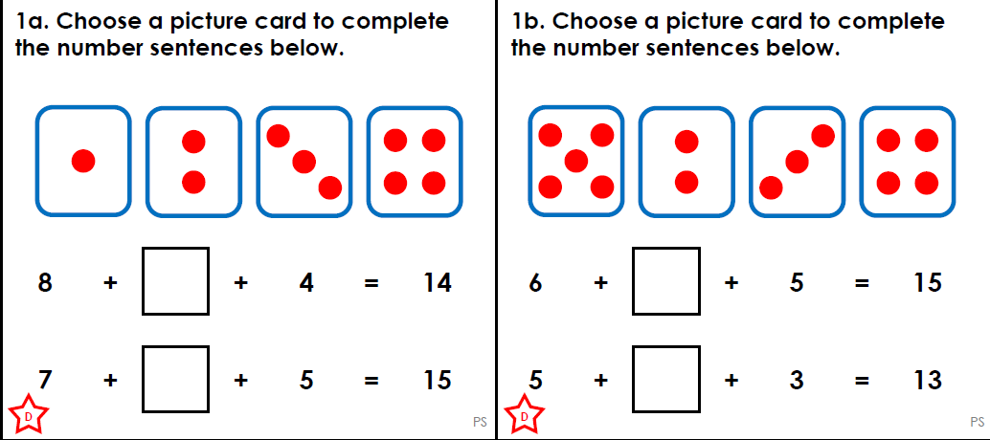
Maths - Challenge 4/5
