Please find todays learning tasks below.
The table below explains the tasks and you will find the resources underneath. Your child will know which challenge they usually access in each subject and which task will be appropriate for them. There is a sticker in the front of their Red Home Learning Books if they were able to get one in the last week. If they did not any exercise book or lined paper will be fine.
Year group: 1/2 Date: Monday 20th April
 | Challenge 1 | Challenge 2 | Challenge 3 |  | Challenge 4 | Challenge 5
Read and enjoy Where Teachers Keep Their Pets by Paul Cookson (below)
The line about the last teacher, Mrs Vickers, doesn’t say where she keeps her pet.
Can you think of a place that rhymes with Vickers!?
English | Please see separate e-mail | Creating rhymes  Read the words on Boxes of Rhymes. How many rhyming words can you  write under each heading? If you get stuck, use rhyming dictionary at  https://www.rhymezone.com.  Form all your letters very carefully. | Creating own rhyme  Read the list of teachers’ names on Whose is it?  Think of a pet for each teacher that rhymes with their name! |  | Creating own rhyme  Read the list of teachers’ names on Whose is it?  Think of a pet for each teacher that rhymes with their name!
Maths | Add the Numicon together to find the answer. Can you write in the question in number form?  ie 6+4=10 | Use addition to find out how many cakes Pudsey made. |  |  | Draw dienes to help you add. I have done the first for you as an example.
Reading | Go to https://www.booktrust.org.uk/books-and-reading/have-some-fun/storybooks-and-games/hairy-maclary/ and read along to  ‘Hairy Maclary From Donaldson’s Dairy’ by Lynley Dodd.
Phonics | Go to YouTube and search for RWI speed sounds set 2. You are looking for an icon that looks like this but with today’s date on it. Watch and join in the sounds today. (If you can’t find today’s date, any previous dates are just as good!)  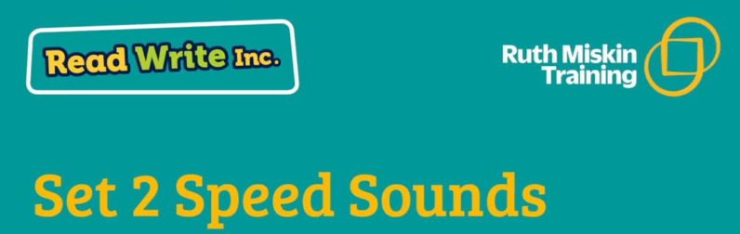 | Go to YouTube and search for RWI speed sounds set 3. You are looking for an icon that looks like this but with today’s date on it. Watch and join in the sounds today. (If you can’t find today’s date, any previous dates are just as good!) |  | Go to YouTube and search for Mr Thorne does phonics - ai ae ay ei eigh a - Phonics Alternative Spellings  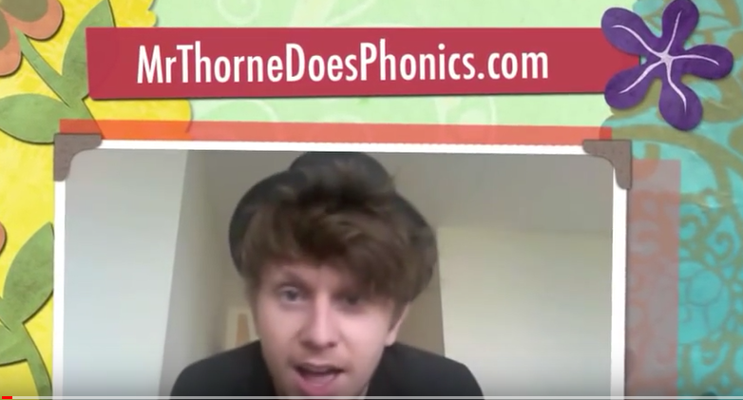 | Play Bouncing Anagram on Spell zone. https://www.spellzone.com/word_lists/games-158181.htm Click on the letters in order to spell the words on the right.
Other | Today’s subject focus will be Science – share the page (below) and look at the pictures about how a fruit plant grows. Think about the sequence of the pictures and draw / stick them on the sequencing sheet.  Extension – Challenge 1 – copy the word underlined in red to match each sequence.  Challenge 2/3 – copy out the correct sentence for each part of the sequence.  Challenge 4/5 – read each sentence – match it up but write your own sentence.
Unless otherwise specified, please complete the tasks in either your homework book or on a word document.
English – starter task
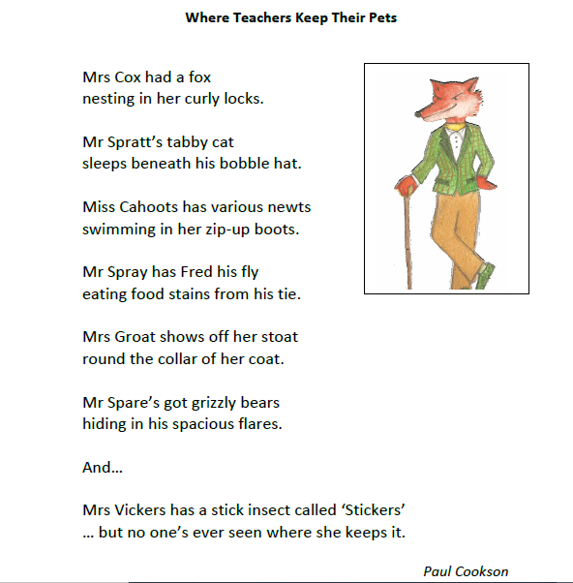

English – Challenge 2
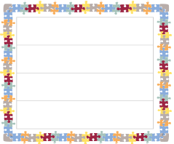
book sea
funny said

English – Challenge 3/4/5
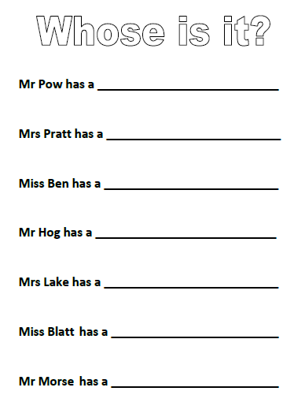

Maths - Challenge 1
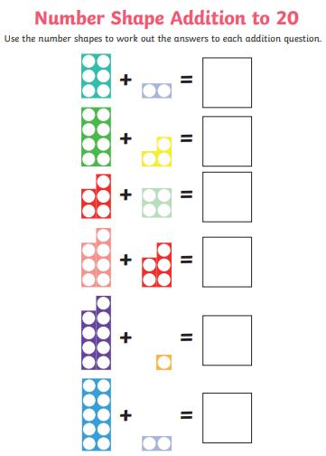

Maths – Challenge 2/3
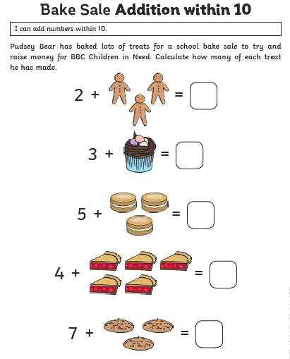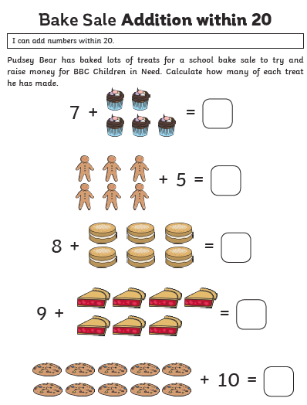

Maths - Challenge 4/5
34 + 27 = 45 + 18 =
T | O
6 | 1
T | O

T | O
T | O
57 + 37 = 49 + 33 =

Extension
67 + 54 = 61 + 29 = 96 + 36 =

Science
