Please find todays learning tasks below.
The table below explains the tasks and you will find the resources underneath. Your child will know which challenge they usually access in each subject and which task will be appropriate for them. There is a sticker in the front of their Red Home Learning Books if they were able to get one in the last week. If they did not any exercise book or lined paper will be fine.
Year group: 1/2 Date: Monday 27th April
 | Challenge 1 | Challenge 2 | Challenge 3 | Challenge 4 | Challenge 5
Share the story (read / listen) by following the link below;
https://learnenglishkids.britishcouncil.org/short-stories/jack-and-the-beanstalk
English | Please see separate e-mail | Act out Jack and The Beanstalk or retell it to your family. You can use your toys as the characters! | Re-read the story and answer the on the sheet. If you can’t print, answer the questions in your home learning book in sentences. | Once you have listened to or read the story – complete the word mat and write some 2A sentences for each picture.
Maths | Subtraction. Cross out the amount you are taking away. | Jump along the number line by the amount you are taking away. | Jump along the number line by the amount you are taking away. | Subtract using a column. Don’t worry there aren’t any exchanging questions.
Reading | Go to https://www.roythezebra.com/guided-reading-stories/chapter1.html#/section0  Roy the zebra website tells the story of the worst zoo in the world. You can read or listen to the story, answer questions before and after reading. Read Chapter 1 today, we are going to read the rest during the week ☺
Phonics | Search on YouTube set 2 speed sounds -watch the Read Write Inc speed sound video from 9.30am or there may be the one on from the day before!  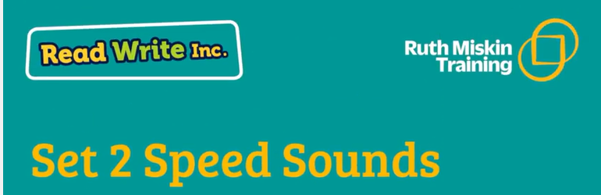  Can your grown up make a list of the words she reads out... then they can read them and you can try to spell them! | Search on YouTube for Mr Thorne does phonics  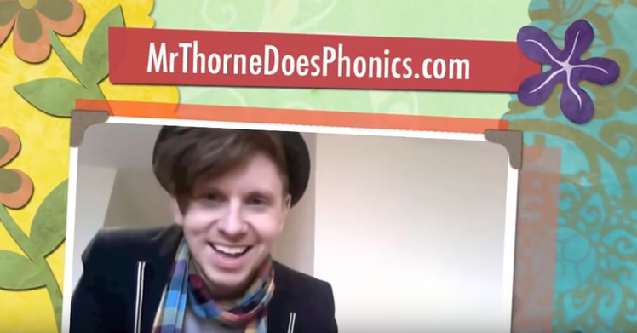  You are looking for oa ow o oe - Alternative Spellings  Remember to play it again with no sound and read the words by yourself. |  | Find the suffix ‘-ful’ words in the wordsearch.
Other | Today’s subject focus will be Science –  Can you make your own Rainbow? Follow the instructions below and see your rainbow grow. You might want to then investigate if it works with different pens or crayons.  I can’t wait to see your results!
Unless otherwise specified, please complete the tasks in either your homework book or on a word document.
English – Challenge 3
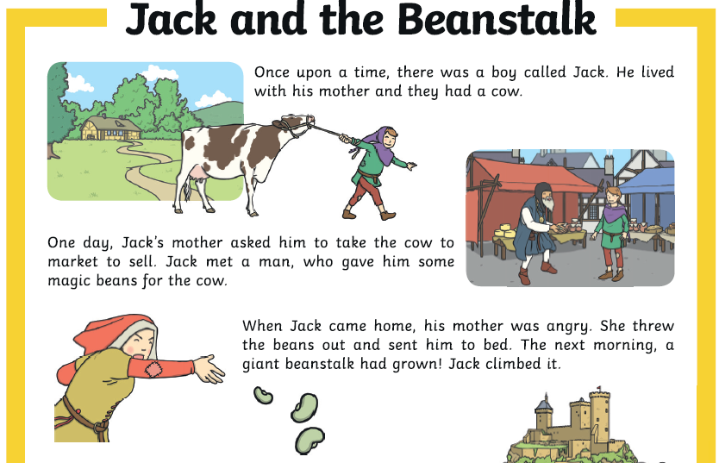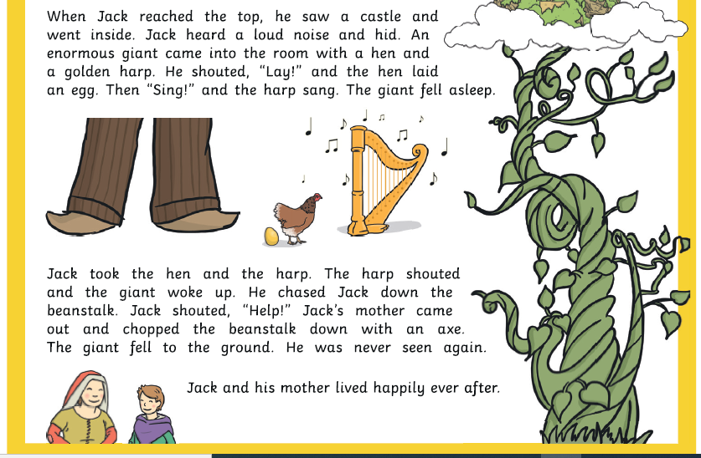
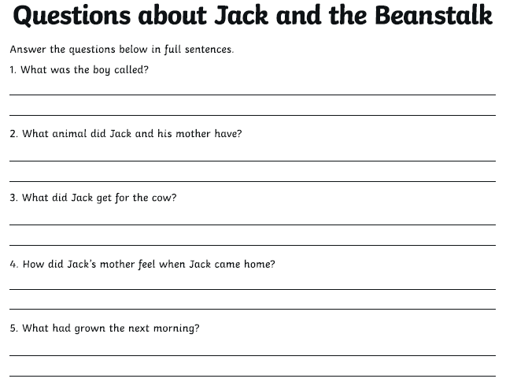

English – Challenge 4/5

Write at least one 2A sentence for each picture.
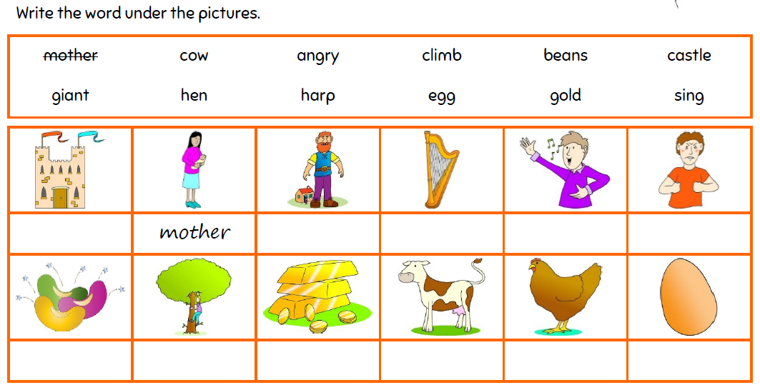

Maths - Challenge 1

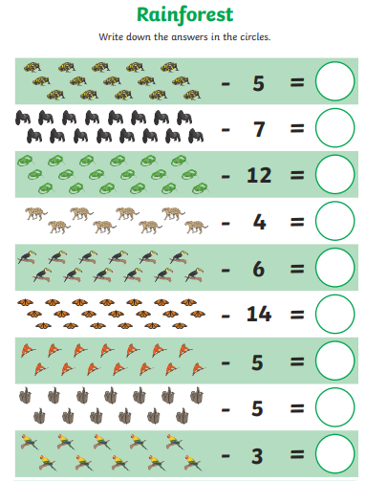
Maths – Challenge 2
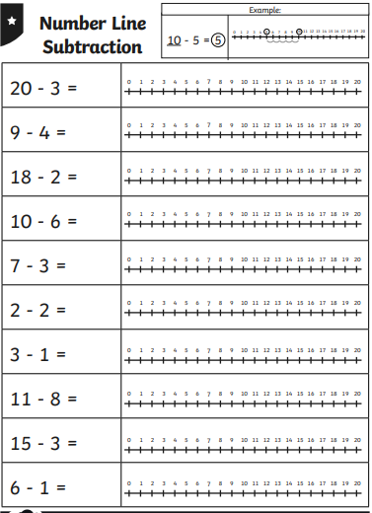

Maths - Challenge 3
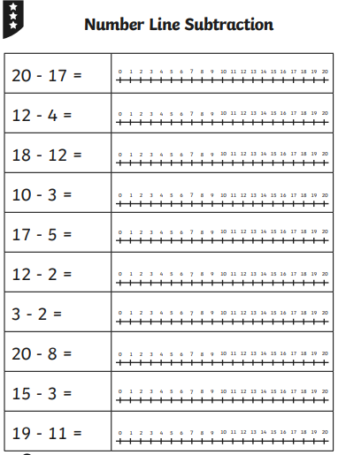

Maths - Challenge 4/5

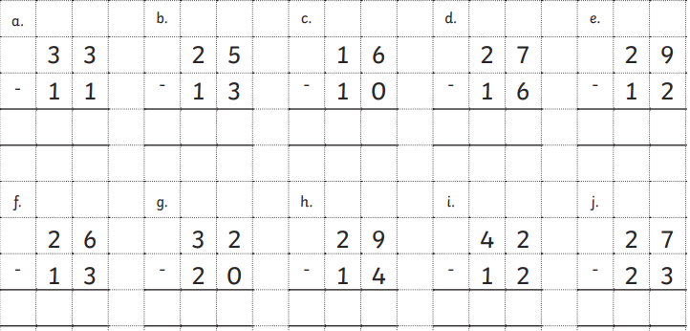
Science

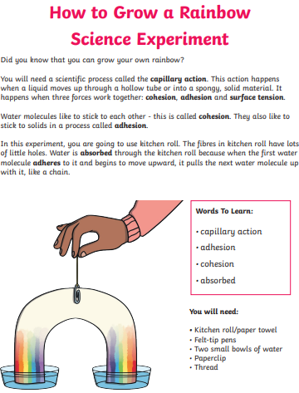

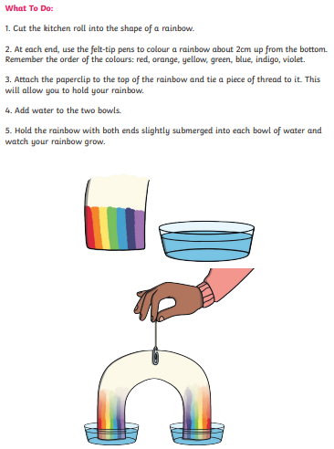

Spelling – Challenge 4/5
