Kingsfield First School Year 1 Home Learning Menu
Please complete a selection of activities each day from the table below
English |  |  | Maths
Challenge 1 | Challenge 2 | Challenge 3 | Challenge 1 | Challenge 2 | Challenge 3
See e-mail | Read, ‘The Three Little Pigs’. Stick the missing pictures onto the story map in the correct order. | Read, ‘The Three Little Pigs’. Draw the missing pictures on the story map. Make sure it is in the correct order. | https://www.ictgames.com /mobilePage/whackAMole/ index.html Change the ‘steps of’ to 5 and play. If you struggle, turn it to steps of 2. | Counting in 5’s. Order the numbers to 50 so they count in jumps of 5. | Counting in 5’s. Order the numbers to 100 so they count in jumps of 5.
See e-mail | Retell the story, ‘The Three Little Pigs’. You can use the story map to help you. Make sure you use 2A sentences. | Retell the story, ‘The Three Little Pigs’. You can use the story map to help you. Make sure you use 2A sentences and different conjunctions (and, but, so). | Use the fingers on the hands to help you count in 5’s. | Counting in 5’s. Complete the number sequences and the 100 square. | Counting in 5’s. Write in the missing numbers and help the children find out how many cakes Grandma has made.
Read ‘Seren’s Seasons’, and answer the questions. There is a set of questions for Challenge 2 and a set for Challenge 3. |  |  | Counting in 5’s.  Add in the missing numbers. | Solve the counting in 5’s reasoning problems. | Solve the counting in 5’s reasoning problems.

Go on Education City and choose some English activities. There are lots of reading and writing ones to choose from. | Go to Education City and choose some Maths activities. Why don’t you have a go on Play Live.
Go to YouTube and search for ‘Twinkl Story Time’. Listen to the story and ask your child some of the questions below. | Go to NumBots and play in either ‘Story’ or ‘Challenge’ mode.
Create an account on Oxford Owls. There are lots of online books and phonics activities to do. | Create a free parents account at https://www.themathsfactor.com/games/ Play a range of maths based games.

There are a range of daily online lessons available on https://www.thenational.academy/online-classroom/year-1#schedule and https://www.bbc.co.uk/bitesize/tags/zjpqqp3/year-1-and-p2-lessons/1 which you may find useful for your child.

Phonics
Challenge 1 | Challenge 2 | Challenge 3
Log on to Phonics Play (Username: march20 Password: home) and play Buried Treasure– Phase 3. | Log on to Phonics Play (Username: march20 Password: home) and play Buried Treasure – Phase 5. | Log on to Phonics Play (Username: march20 Password: home) and play Buried Treasure – Phase 5.
Go to YouTube and search for Geraldine the Giraffe does ‘oo’ Can you write the words? | Go to YouTube and search for Geraldine The Giraffe does ‘o-e’ Can you write the words? | Go to YouTube and search for Geraldine The Giraffe does ‘oa’ Can you write the words?
Write oo words on pieces of paper and draw a picture on another piece to match each word. Then ask someone to play Snap with you. | Write o-e words on pieces of paper and draw a picture on another piece to match each word. Then ask someone to play Snap with you. | Write oa words on pieces of paper and draw a picture on another piece to match each word. Then ask someone to play Snap with you.

Topic
The Three Little Pigs lived in the forest but normally pigs live on a farm. Watch https://www.bbc.co.uk/bitesize/clips/zs97tfr then draw and label different animals that you will find on a farm. Which is your favourite?
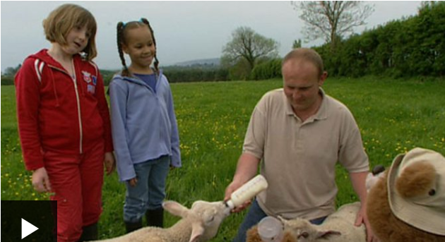
When building their houses, The Three Little Pigs used 3 different materials to build their houses – straw, sticks and bricks. What materials can you find around your house? Write the name of the material, then draw a picture to show a way in which it can be used. For example – glass can be used to make windows. As they are transparent you can see through them.
Time for some Cosmic Yoga! I would like you to do a story one but I will let you pick which. Let me know which one you chose and if you enjoyed it. https://www.cosmickids.com/

Maths – Challenge 1
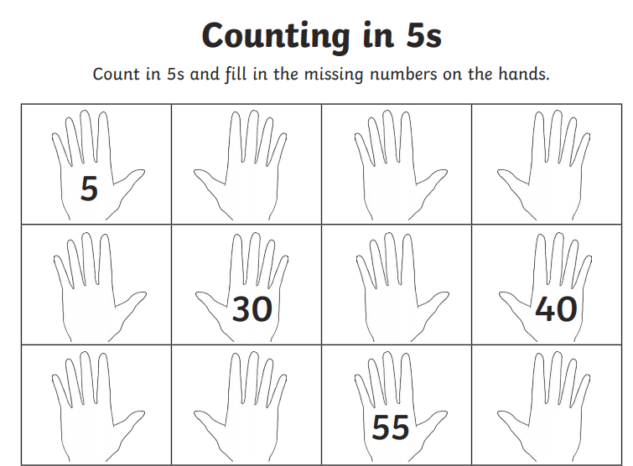

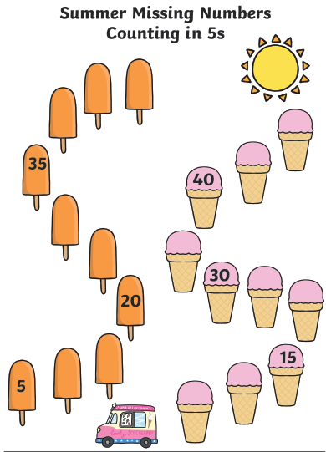

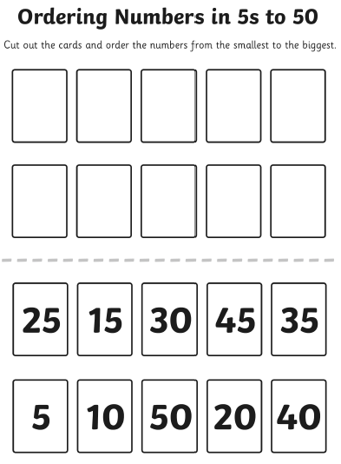
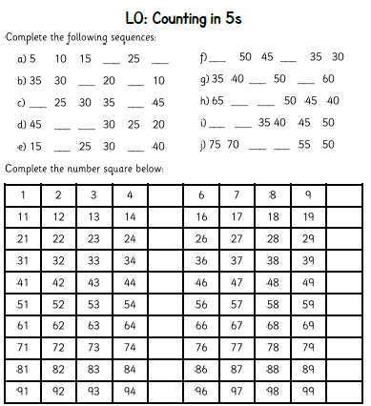

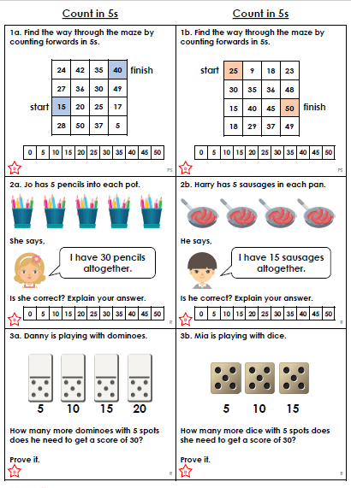

Maths - Challenge 3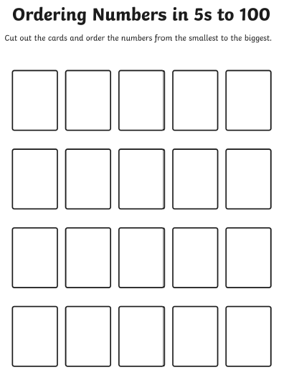 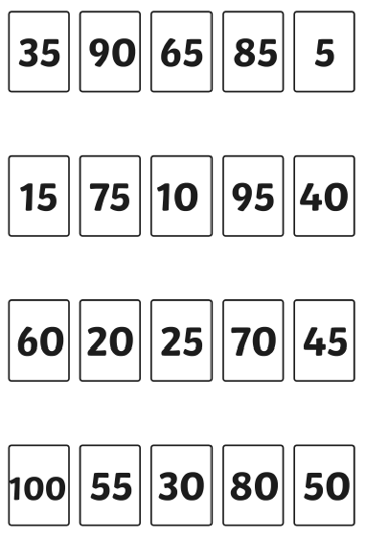
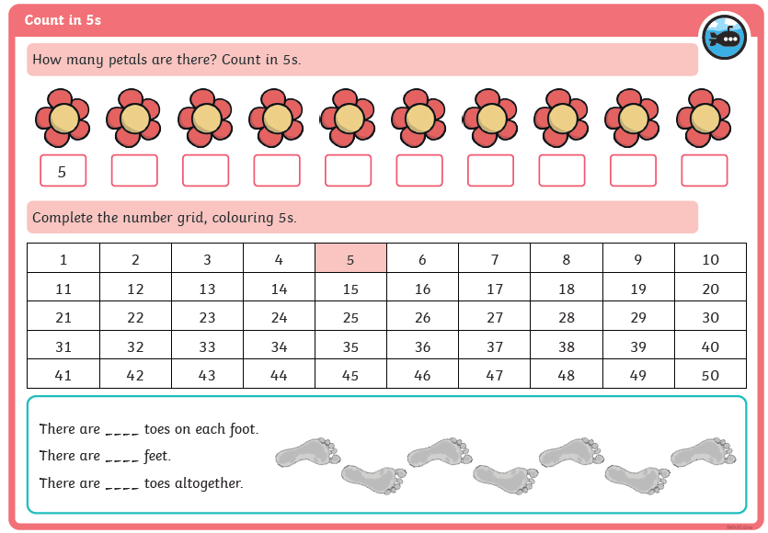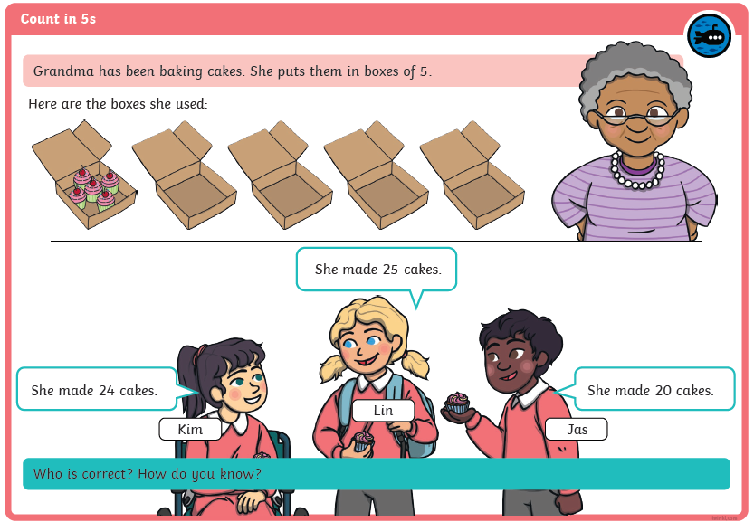

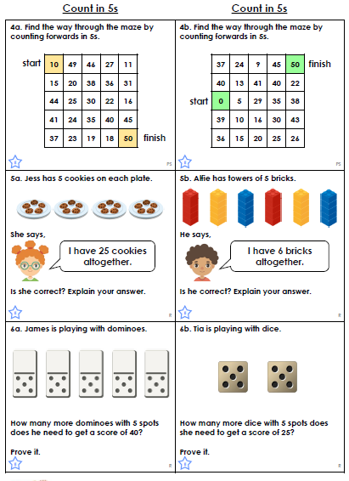
English 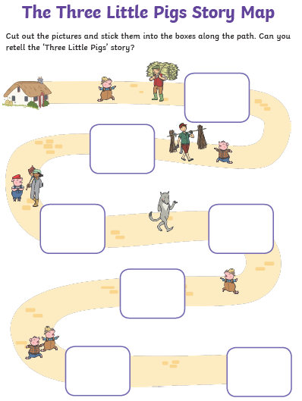 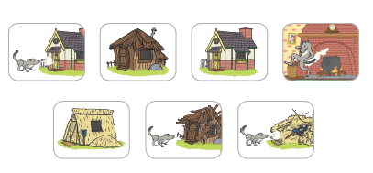

Reading 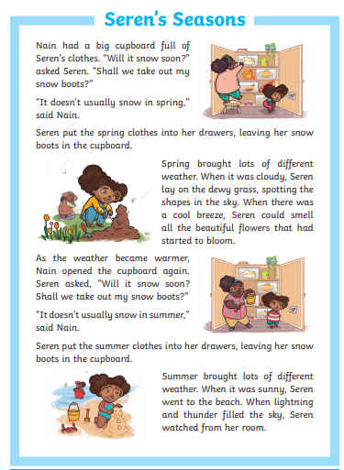 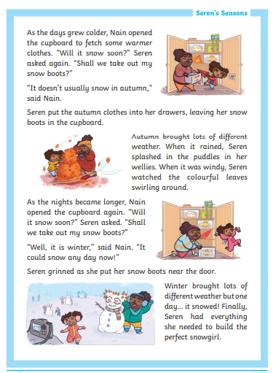

Challenge 2
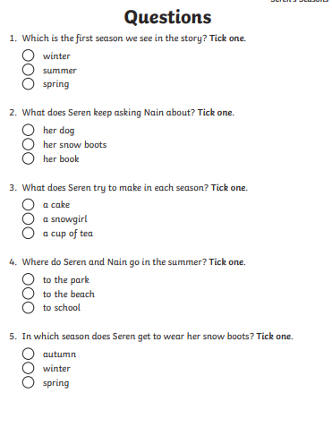

Challenge 3
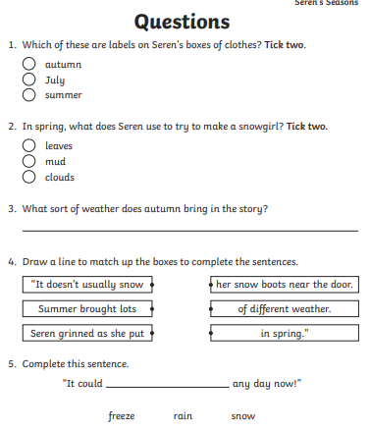

Reading Questions
