Year 2
Please find todays learning tasks below.
The table below explains the tasks and you will find the resources underneath.
Your child will know which challenge they usually access in each subject and which task will be appropriate for them.
Year group: 2 Date: 24.06.20
English | Share the link here and learn all about another famous London landmark  https://www.youtube.com/watch?v=fKmpld1PoPQ&safe=active  Now read a Fact File below and learn more about Big Ben.
 | Challenge 1 | Challenge 2 | Challenge 3
Use the information you have watched and the information on the fact file to complete a page about Big Ben – remember you can use headings and sub-headings on your page.
(see sheet below for layout – or create your own page including Headings / Sub-Headings and Pictures)

Maths | Warm Up – follow this link to complete your maths warm up.  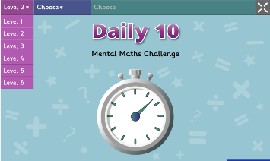  https://www.topmarks.co.uk/maths-games/daily10  Choose Level 2  Complete the Ordering activities.
 | Challenge 1 | Challenge 2 | Challenge 3
 | Share the PPT on the website to complete activities based on measuring in kilograms and then complete the problems and reasoning task sheets below.
Reading  Phonics | Log in to Oxford Owl and continue to read the text ‘Chamber of Treasures’ read / listen to the text from page 10 – 15 (Chapter 3).  Click on the link http://www.ictgames.com/mobilePage/forestPhonics/index.html  Phonics Forest spelling words – choose the o-e activity today.
Other | Today we are going to start to plan some Science  Share the link below to remind you of materials  https://www.youtube.com/watch?v=XnkQcP-RHCw&safe=active  Can you find different objects from around the house made from; Wood – Glass – Paper – Metal – Plastic  Draw a picture of each object and write about why it is a suitable material for the object to be made from  e.g. The jam jar is made from glass. It is a good material because it is strong, you can see through it (transparent) and it can be recycled.

Unless otherwise specified, please complete the tasks in either your home learning book or print out the document below.

English ALL Groups
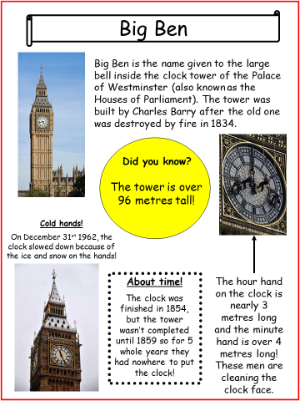

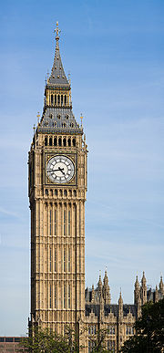
___________________
__________________________________________________________________________________________________________________________________________________________________________________________________________________________________________________________________________________________________________________________________________________________________________________________

Maths Challenge 1

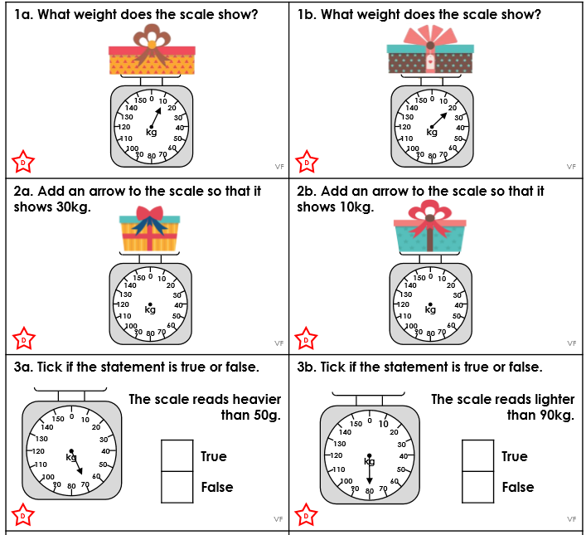

Maths Challenge 2
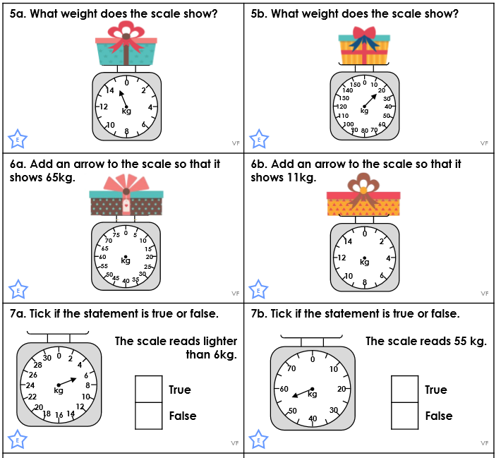

Maths Challenge 3
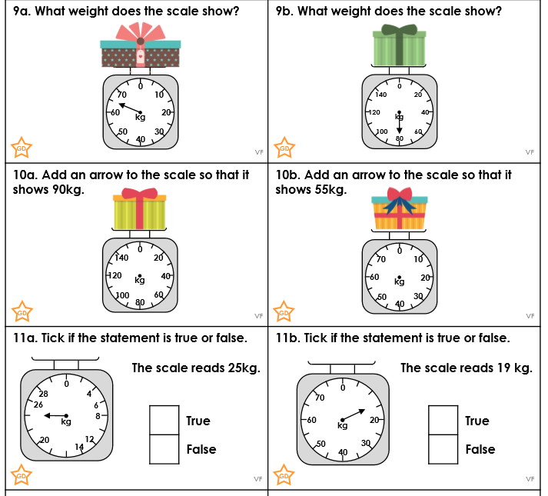

Maths Reasoning ALL Groups

