Year 2
Please find todays learning tasks below.
The table below explains the tasks and you will find the resources underneath.
Your child will know which challenge they usually access in each subject and which task will be appropriate for them.
Year group: 2 Date: 10.06.20
English | 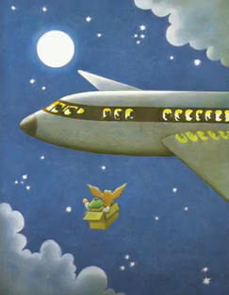  Today we are looking at Whatever Next again so watch it again, but this time focus on the scenes where Baby Bear is on the way to the moon.  Go to https://www.youtube.com/watch?v=Nn73STXrPP0 .  Focus on the scene with the aeroplane and imagine you are one of the passengers on the plane!  You look outside the window and see…!!  What did you think when you saw Baby Bear with his teddy bear and an owl flying through the sky in a cardboard box?
 | Challenge 1 | Challenge 2 | Challenge 3
 | Pretend to be a passenger on the aeroplane and write some sentences about what you saw through the window when Baby Bear flew past.  You could start with I saw…  Or The bear was …  I have done a sentence for you to start you off  Use the word bank below to help you and remember capital letters and full stops.  We are not retelling the story today, just describing what you could see from the aeroplane and what you thought when you saw it! | Pretend to be a passenger on the aeroplane and write about what you saw through the window when Baby Bear flew past.  Use the word bank below to help you and remember capital letters and full stops conjunctions and 2A sentences.  I have started it for you  We are not retelling the story today, just describing what you could see from  the aeroplane and what you thought when you saw it!
Maths | Warm Up – follow this link to complete your maths warm up.  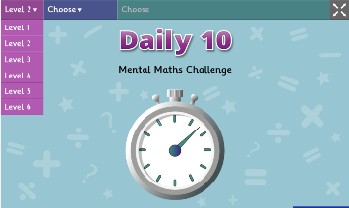  https://www.topmarks.co.uk/maths-games/daily10  Choose Level 2 – Division  Complete the mixed ÷2, ÷5, ÷10 activities.  If you ZOOM through, you can challenge yourselves to the ÷3 task.
 | Challenge 1 | Challenge 2 | Challenge 3
 | Today you are going to be solving some word problems using division.  You can use counters / coins to help you work out or draw counters on your page and group them.  Remember to complete your reasoning / problem solving task. | Today you are going to be solving some word problems using division.  You can use draw counters on your page and group them to help you work out.  Remember to complete your reasoning / problem solving task. | Your challenge today is to apply your knowledge of x and ÷ to help you divide by 3.  Read the activities / questions carefully on the worksheets below.  Remember to complete your reasoning / problem solving task.
Reading  Phonics | Read about the Moon Landing in a newspaper report (see activity sheet below) it should also help you with today’s topic task.  Can you solve these muddled adverbs? Use the clues to help you work them out! (See task below)
Other | Today we are going to start to plan some PSHRE / History  Share the link https://www.ducksters.com/biography/explorers/neil_armstrong.php  Read the facts about Neil Armstrong and complete a fact file about him – you can present it in lots of different ways alternatively you can use the sheet below.

Unless otherwise specified, please complete the tasks in either your home learning book or print out the document below.

English Challenge 1
aeroplane dark
Baby Bear fast
owl looked
flying saw
sky window
stars furry
moon excited

I saw a box and inside there was a bear and an owl. ___________________________________________________________________________________________________________________________________________________________________________________________________________________________________________________________________________________________________________________________________________________________________________
English Challenge 2 and 3
aeroplane whooshing
Baby Bear adventure
owl incredible
flying shouting
window sparkly
furry twinkly
excited cuddly

Suddenly I saw an amazing sight! There was an old cardboard box zooming through the dark, starry sky and in it there was… ___________________________________________________________________________________________________________________________________________________________________________________________________________________________________________________________________________________________________________________________________________________________________________
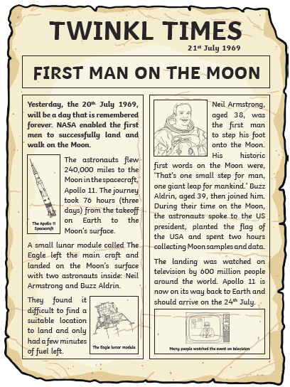
Reading Task

Phonics / Spelling
Can you spell these muddled words? Use the clues to help
wlsyol= ________ (snail) dkilyn = __________ (sharing)
lykicuq = ___________ (cheetah) dlyas = ___________ (tears)
ouldly= ____________ (roar!) rcsosly= ___________ (shouting)
dmayl = _________ (in love) luflyreac = __________ (tip-toe)

Choose 2 of the adverbs (ly) words and write sentences.
Maths Challenge 1
Use counters / coins to help share
you work these number sentences out if it helps
alternatively, you can draw counters and group them to show your working.

Kian has 10 football stickers. He shares them between his 2 friends. How many stickers do they get each?

Lottie has 15 sweets. She shares them between 5 children. How many sweets does each child get?

Katie has 12 dolls. She shares them between 2 of her friends. How many dolls do they have each?

There are 20 books in total and they are packed in boxes of 10. How many boxes are there?

8 flowers are shared between 2 vases. How many flowers go in each vase?

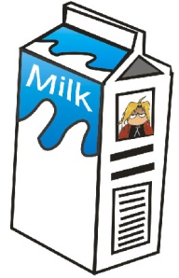
The milkman has 15 bottles of milk, if he delivers 5 bottles to each house, how many houses will he deliver to?
Problem Solving Challenge 1
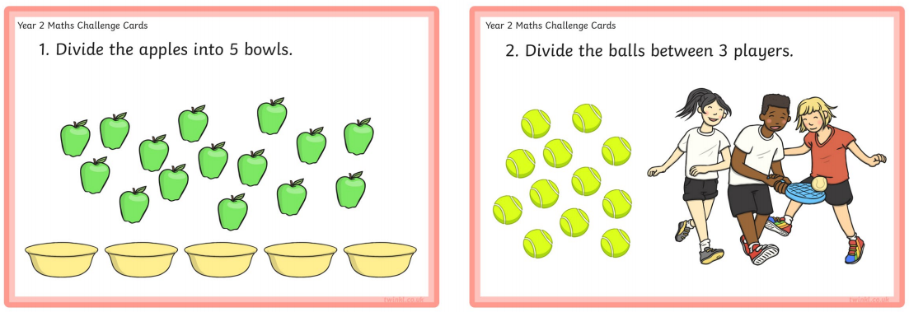

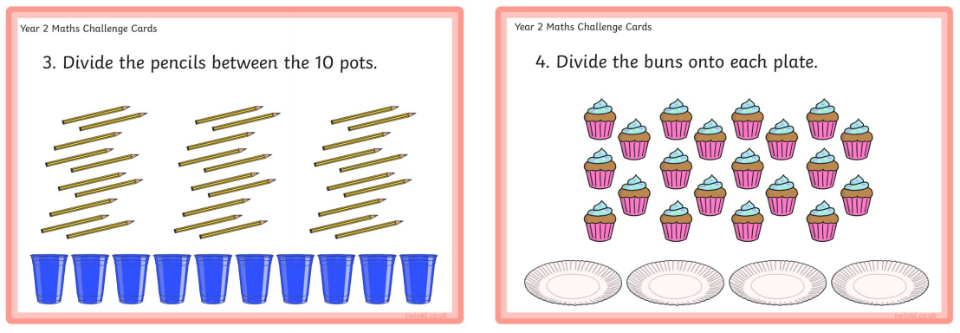

Maths Challenge 2
Show you working by drawing counters to help you!

Kian has 18 football stickers. He shares them between his 2 friends. How many stickers do they get each?

Lottie has 25 sweets. She shares them between 5 children. How many sweets does each child get?

Katie has 20 dolls. She shares them between 5 of her friends. How many dolls do they have each?

There are 50 books in total and they are packed in boxes of 10. How many boxes are there?

15 flowers are shared between 3 vases.
How many flowers go in each vase?

The milkman has 30 bottles of milk, if he delivers 5 bottles to each house, how many houses will he deliver to?

Maths Problems Challenge 2
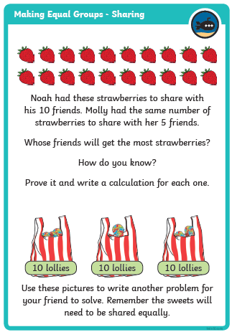
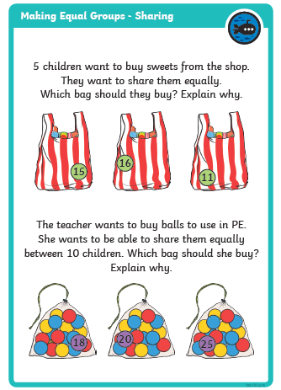

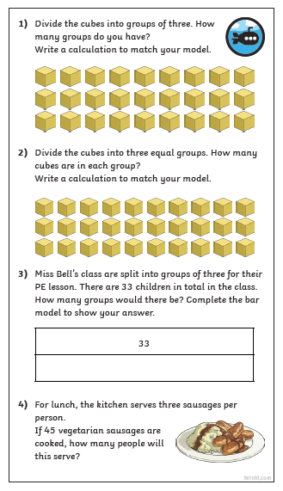
Maths Challenge 3

Challenge 3 Cont’d Reasoning / Problem Solving Task
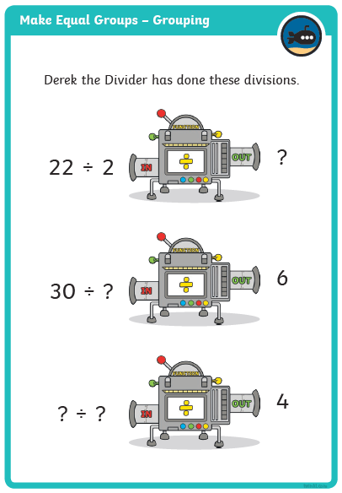
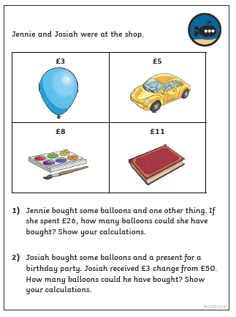

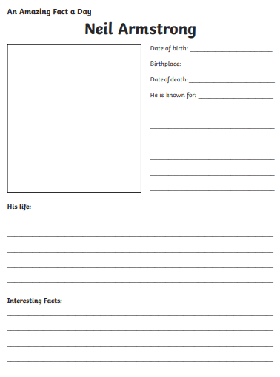
Topic Task

