Year 2
Please find todays learning tasks below.
The table below explains the tasks and you will find the resources underneath.
Your child will know which challenge they usually access in each subject and which task will be appropriate for them.
Year group: 2 Date: 23.06.20
English | Today you are going to be reading some information about The Tower of London (see sheet below)
 | Challenge 1 | Challenge 2 | Challenge 3
Read all about the Tower of London and use this information to draw your own picture of the Tower of London and write a paragraph to explain all about the tower to somebody who perhaps doesn’t know very much.
Think about how to start your sentences – try to make it exciting!

Maths | 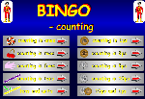  Click on the link http://www.wldps.com/gordons/Bingo_-_counting_v4.swf  Complete the Bingo activities of your choice – see if you can play with someone from your family.
 | Challenge 1 | Challenge 2 | Challenge 3
Today you will be continuing to learn about mass.
Choose 5 different items from the kitchen cupboard and then put them in order from lightest to heaviest, by picking them up and comparing the weight. We call this estimation / comparison.

If you have some scales in your kitchen (either electronic or mechanical), can you weigh the items and read the scales to check if you had put the items in the right order?

Now complete the problems and reasoning tasks below.
Reading  Phonics | Log in to Oxford Owl and search for the text ‘Chamber of Treasures’ read / listen to the text up to Page 10 (end of chapter 2).  Click on the link https://www.ictgames.com/littleBirdSpelling/  Choose the darker green bird box and practise spelling the words such as thought and caught using au/ou.
Other | Today we are going to do some Art.  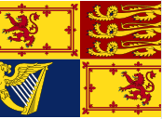  The Royal Standard represents the Sovereign and the United Kingdom. The Royal Standard is flown when The Queen is in residence in one of the Royal Palaces, on The Queen's car on official journeys and on aircraft (when on the ground). It may also be flown on any building, official or private, during a visit by The Queen, if the owner so requests.  You can do any of the following;  - Draw your own version of the Royal Standard  - Colour the Royal Standard Activity sheet below using crayons, pastels, chalks, paint etc.  - Choose one part of the flag and reproduce it in which every way you want!

Unless otherwise specified, please complete the tasks in either your home learning book or print out the document below.

Maths Challenge 1
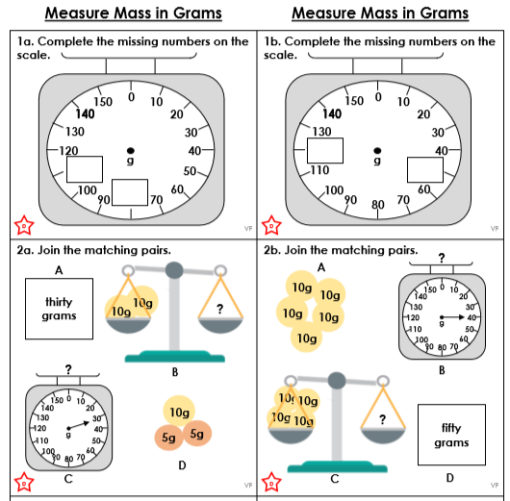

Maths Challenge 2
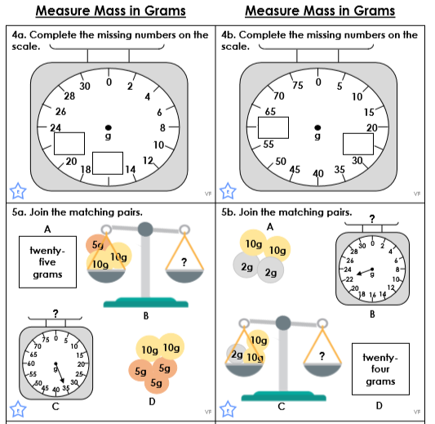

Maths Challenge 3
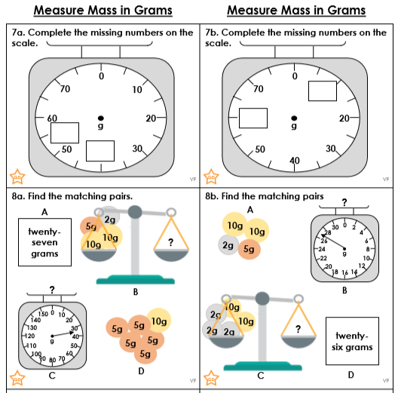

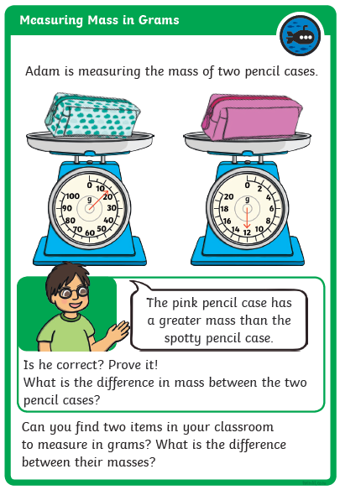
Reasoning Task ALL groups

English ALL groups
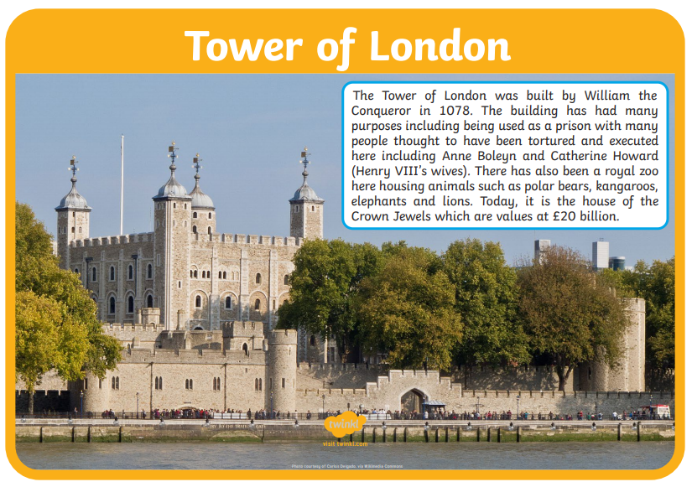

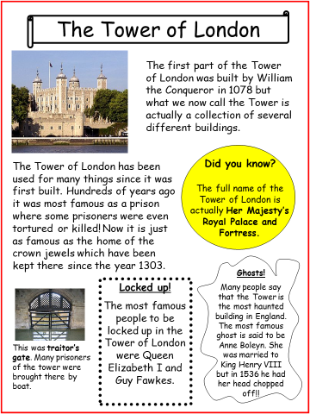

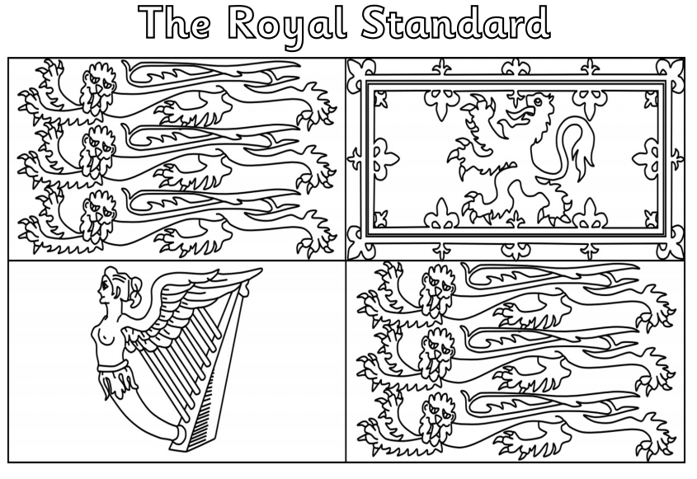
Art Task

