Year 2
Please find todays learning tasks below.
The table below explains the tasks and you will find the resources underneath.
Your child will know which challenge they usually access in each subject and which task will be appropriate for them.
Year group: 2 Date: 09.06.20
English | Today we are continuing to look at Whatever Next by Jill Murphy so if you like you could watch it again on  You tube using https://www.youtube.com/watch?v=Nn73STXrPP0 or read it using then PPT instead.  Think about the journey to the moon…It starts on page 6 when it says ‘WHOOSH! Out into the night’.  Look at this again and imagine what it would be like in Baby Bear’s rocket.  Imagine you are Baby Bear!  Think about words to describe the sky and journey to the moon.  What does it look like/ feel like? What can you see? How do you feel?
 | Challenge 1 | Challenge 2 | Challenge 3
 | Can you describe what it is like in Baby Bear’s rocket as it travels through the sky?  Add some adjectives around the picture which you think describe it the best and remember to include some 2A phrases.  Think of another word instead of whoosh – what other word might the rocket make as it goes into space?  Next, using the words you have written around the rocket, write two sentences to describe what it is like, what you can see, how you feel. Which is your best sentence?  Remember to use capital letters, full stops, 2A and beautiful handwriting! | Can you describe what it is like in Baby Bear’s rocket as it travels through the sky?  Add some adjectives around the picture which you think describe it the best and remember to include some 2A phrases.  Think of another word instead of whoosh – what other word might the rocket make as it goes into space?  Next, using the words you have written around the rocket, write at least 6 sentences to describe what it is like, what you can see, how you feel. Which is your best sentence?  Remember to use capital letters, full stops, 2A and beautiful handwriting!
Maths | 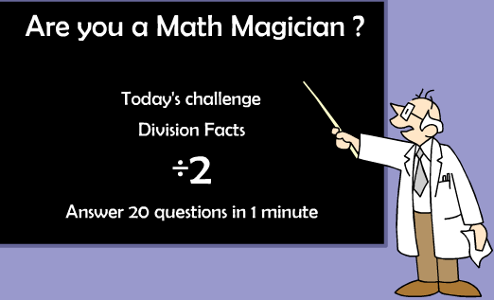  Click on this link here:  https://coolsciencelab.com/math_magician_division.html  Choose the following activities;  ÷ 2  ÷ 5  ÷ 10  Remember knowing your tables will help you!
 | Challenge 1 | Challenge 2 | Challenge 3
 | Keep working on your 2x tables and complete the activity sheet below.  Next log in to TT Rock stars and complete your x2, x5 and x10 times tables. | First log into TT Rock Stars and complete the x2, x5 and x10 activities – then challenge yourself to x3.  Next play the game below with a member of your family – you don’t need to print it out.  How to play  Roll the dice – choose a calculation from the row – work it out if you are right win a counter / record in your book.  First to complete 5 correctly is the winner.
Reading  Phonics | Complete the reading task sheet below answering the questions about the poem.  Click on the link https://www.oxfordowl.co.uk/for-school/online-learning/read-write-inc-spelling (log in) search for Playing with plurals and complete the activities. Once completed, complete the activity sheet below.
Other | 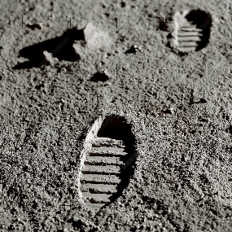  Today we are going to do some Art.  Click on the link here: https://www.youtube.com/watch?v=cwZb2mqId0A&safe=active  Watch the clips of Neil Armstrong landing on the moon.  When Neil Armstrong landed on the moon – he left footprints, they will still be there as there is no wind for them to be blown away!  Choose to create some footprints for your art task – you could do lots of things such as –  - Make footprints using paint – you could add glitter etc to make them sparkle!  - Print out the footprints from the activity sheet below and get creative!  - Draw around your feet and colour / decorate it.  - Use chalk outside in the garden and draw around your feet  Be as creative as you can! Looking forward to seeing your pictures!

Unless otherwise specified, please complete the tasks in either your home learning book or print out the document below.

English – Challenge 1
___________________________________________________________
Can you describe the sky and Baby Bear’s
journey?

_________________________________________________________________
WHOOSH!!!!
___________________________________________________________________
_______________________________________________________________________________________________________________________________________

_______________________________________________________________________________________________________________________________________

_______________________________________________________________________________________________________________________________________

_________________________________________________________________

English Challenge 2 and 3

__________________________________________________________________________________________________________________________________________________________________________________________________________________________________________________________________________________________________________________________________________________________________________________________________________________________________________________________________________________________________________________________________________________________________________________________
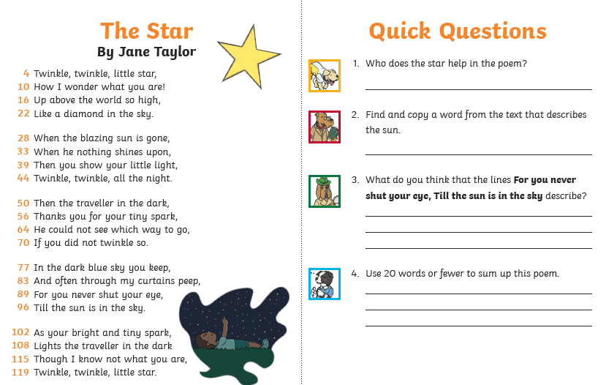
Reading Task
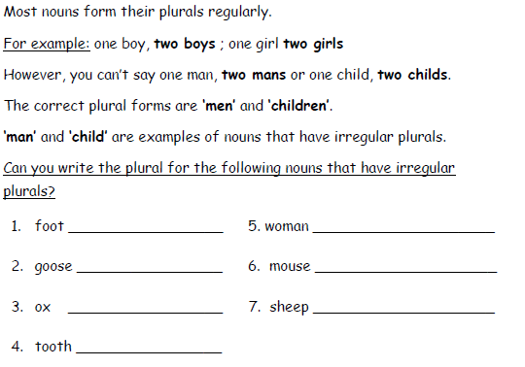
Phonics Task

Complete these noun sentneces.
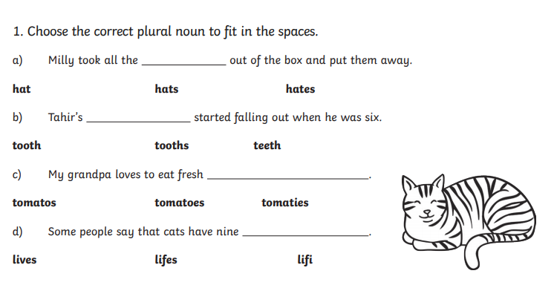

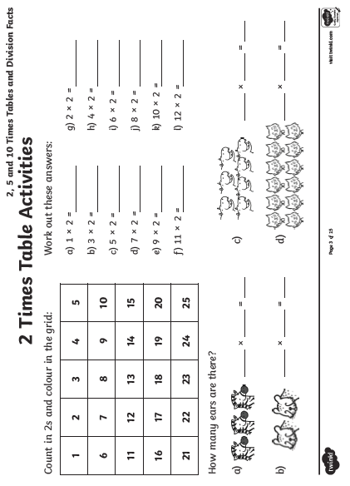
Maths Challenge 1

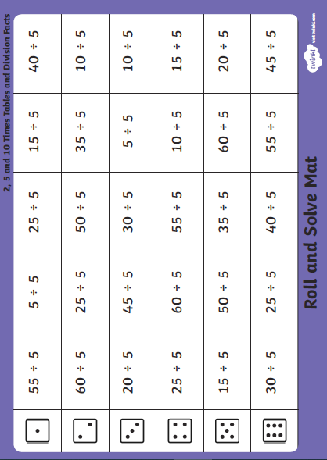
Maths Challenge 2 and 3

Topic Task

