Year 2
Please find todays learning tasks below.
The table below explains the tasks and you will find the resources underneath.
Your child will know which challenge they usually access in each subject and which task will be appropriate for them.
Year group: 2 Date: 18.06.20
English | Today you are going to be planning ideas to complete an acrostic poem for the word SPACE.  Look at my WAGOLL (What a good one looks like) can you see I have included lots of interesting word types in my poem such as nouns, verbs, adjectives, adverbs and prepositions.
 | Challenge 1 | Challenge 2 | Challenge 3
 | Complete the planning task (see activity sheet below) and plan the different words that you could use to write your own poem. Think about words you have read in the poems completed this week already, think about exciting words too!
Maths | 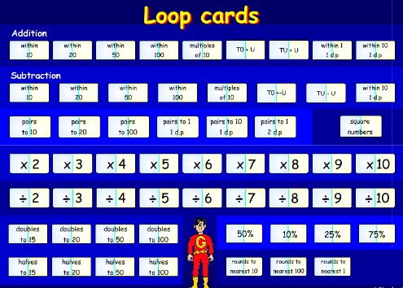  Follow this link and complete the activity Loop Cards http://www.wldps.com/gordons/Loop_cards.swf  Choose adding multiples of 10 loop card activities.  Followed by the adding within 100 activities.
 | Challenge 1 | Challenge 2 | Challenge 3
Today we are going to be using Block Graphs.
Click on the link here to find out more:
https://www.bbc.co.uk/bitesize/clips/zkf34wx

Complete the tally chart, block graph and answer the questions about the birthday data you have been given.
Don’t forget to solve your word problems too!

Reading  Phonics | 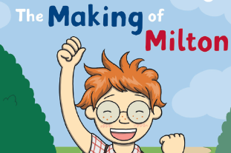  Read the PDF version of this book – I have included it in the resources on the website.  Click on the link here: https://www.bbc.co.uk/games/embed/karate-cats?exitGameUrl=http%3A%2F%2Fbbc.com%2Fbitesize%2Farticles%2Fzdp4pg8  Complete the spelling and sentence activities on the game Karate Cat.
Other | Today we are going to complete some History  Share the PPT (PDF version on website) and learn about Sir Isaac Newton and how he discovered Gravity.  Click on the link here to start to learn about Gravity - https://www.bbc.co.uk/bitesize/topics/zf66fg8/articles/zqbm3k7  Complete the question and answer activity sheet – showing what you have learnt about him.

Unless otherwise specified, please complete the tasks in either your home learning book or print out the document below.

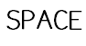
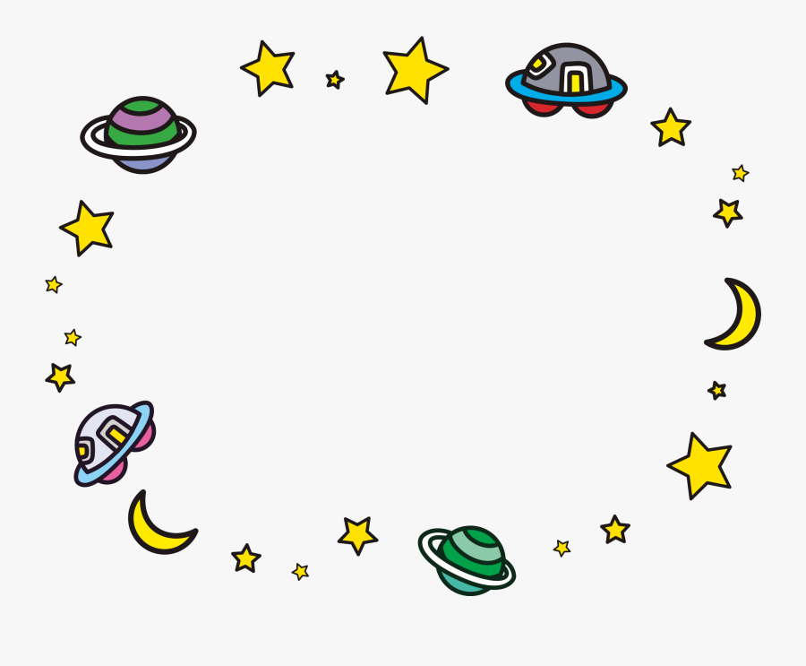
Nouns are names of words like the word planet.
Verbs are doing words like the word flying.
Adverbs are words often ending in ‘ly’ like quickly.
Adjectives are describing words like round / red.
Prepositions tell you where it is, words like next, beyond etc.

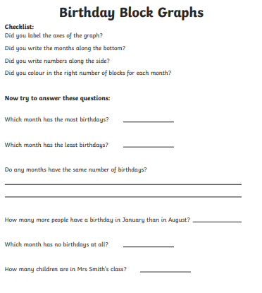
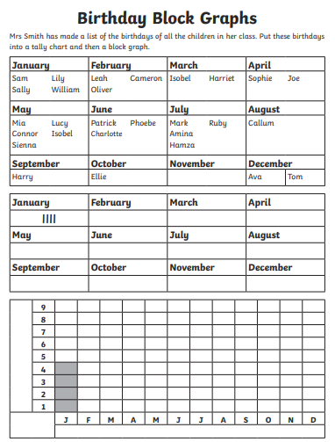
Maths Task 4 ALL Groups

Reasoning Task ALL Groups

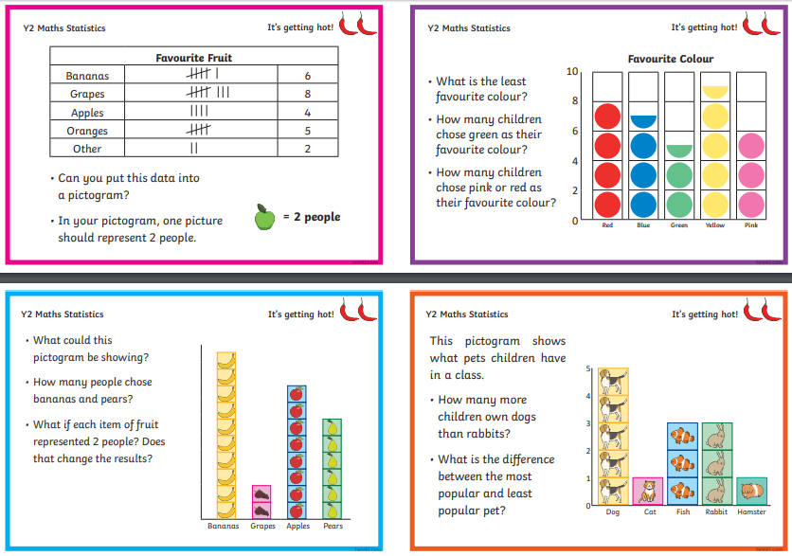

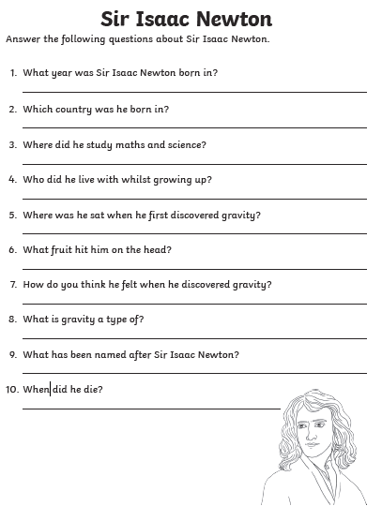
Topic Task

