Year 2
Please find todays learning tasks below.
The table below explains the tasks and you will find the resources underneath.
Your child will know which challenge they usually access in each subject and which task will be appropriate for them.
Year group: 2 Date: 11.06.20
English | 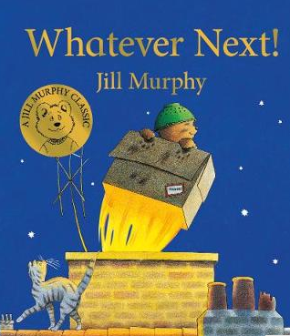  Go to https://www.youtube.com/watch?v=Nn73STXrPP0  and  watch and listen to the story of Whatever Next by Jill Murphy.
 | Challenge 1 | Challenge 2 | Challenge 3
Today we are learning about writing a diary.

Watch the Power point on Diary entries (on website) and then think about what it was like to be Baby Bear.

Read the example of a diary entry from an astronaut (see below)

You now need to write about the pictures below as if you are Baby Bear and retell what happened so far.

Remember to use ‘I’ not Baby Bear and also write in the past tense so you may need to use _ed.

Try and make your diary entry as interesting as you can by adding adjectives too.

We will complete this tomorrow so there is no need to finish to the end of the story, just up to where the pictures end!

Maths | 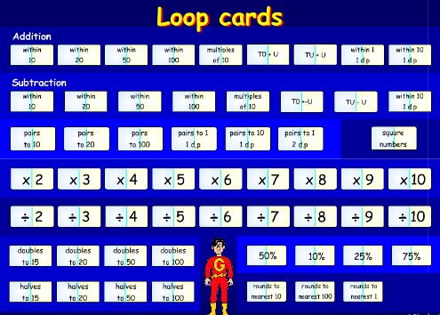  Follow this link and complete the activity Loop Cards http://www.wldps.com/gordons/Loop_cards.swf  Choose ÷2 then ÷5 and ÷10 loop card activities.  Challenge 3 children could also complete the ÷ 3 activity.
 | Challenge 1 | Challenge 2 | Challenge 3
 | Complete the grouping tasks on the activity sheet below – grouping to divide. | Complete the grouping tasks on the activity sheet below – grouping to divide. | Complete the grouping tasks on the activity sheets below – grouping to divide.
Reading  Phonics | Read a book from home / school today. Remember to record in your blue books!  Click on this link http://www.ictgames.com/mobilePage/lcwc/index.html (Google Chrome works best)  Choose Y2 and Tricky Words – Choose Tricky 4 read the word and them type it out.
Other | Today we are going to complete some D&T (Food Technology)  Below I have included 2 recipes for Star Biscuits and Rock Cakes you might like to make – the recipes are quite simple so hopefully you will have the ingredients and equipment in you will need.  Alternatively, you could have fun decorating some cakes / biscuits to create the moon / stars / planets even aliens!  Would be lovely to see some photos of your creations!

Unless otherwise specified, please complete the tasks in either your home learning book or print out the document below.

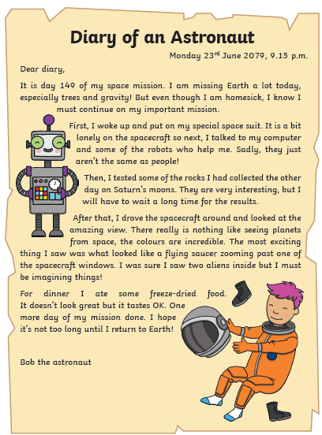
Example of a Diary Entry

English Challenge ALL groups

First Next Then After Soon asked
flew whooshed darkest twinkly suddenly blasted
looked wanted excited scared cardboard box
Dear Diary
_________________________________________________________________________________________________________________________________________________________________________________________________________________________________________________________________________________________________________________________________________________________________________________________________________________________________________________________________________________________________________________________________________________________________________________

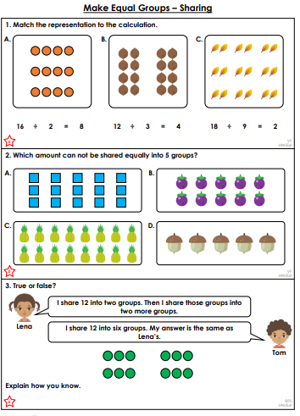
Maths Challenge 1
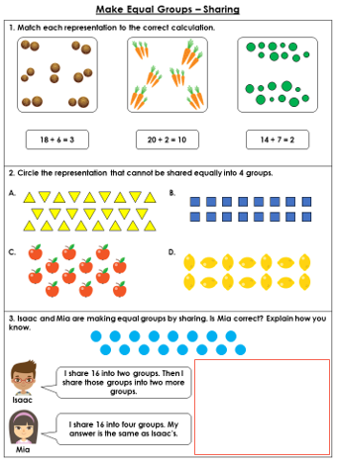
Maths Challenge 2
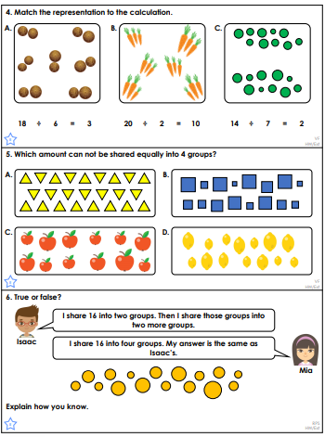
Maths Challenge 3

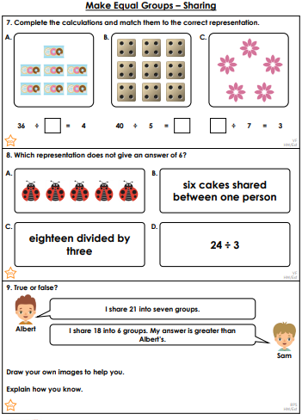
Challenge 3 Maths Cont’d

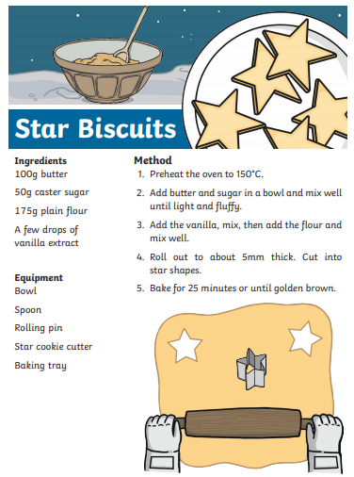
Topic Task
