Year 2
Please find todays learning tasks below.
The table below explains the tasks and you will find the resources underneath.
Your child will know which challenge they usually access in each subject and which task will be appropriate for them.
Year group: 2 Date: 02.07.20
English | 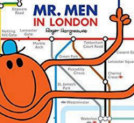  Reread the story of the Mr Men in London.
 | Challenge 1 | Challenge 2 | Challenge 3
Reread the story you wrote yesterday to remind you about where you are up to.
Today you are going to be retelling the next parts of the story in your own words – look at the pictures on the activity sheet (below) and think about what happens in the story from each picture.

Retell the story and try and think about some of these to include as you write.
- Capital letters, finger spaces and full stops throughout.
- Speech “ “ if characters are speaking.
- Start your sentences in different ways you could use time connectives, exciting words etc.
- Remember to use capital letters for character names and places too!
- Reread your writing to make sure it makes sense

Maths | Warm Up – follow this link to complete your maths warm up.  https://www.topmarks.co.uk/maths-games/hit-the-button  Complete the Double and Halves activities.
 | Challenge 1 | Challenge 2 | Challenge 3
Put your hands out in front of you on the table – you will notice that your left hand creates a letter L between your first finger and your thumb, this is your left hand – have a go at learning your left and right by asking your adult to test you e.g. pick up your pencil with your left hand, click your fingers on your right hand etc.

Today you will need to be following instructions to move around a map.

Look carefully at the instructions on the map sheet and complete.

Remember to complete your Reasoning Task.

Reading  Phonics | Log in again to Oxford Owl and continue to read / listen to ‘The Dinosaur Hunters’ reading pages 17 – end.  Click on the link here: https://www.ictgames.com/littleBirdSpelling/  Complete the 4th bird box tasks – spelling common exception words.
Other | Today we are going to continue with our History  Share the PowerPoint on the school website ‘Samuel Pepys’ and learn about the important role he played in us being able to learn about the Great Fire of London.  Once you have shared the information, complete a diary as though you were Samuel Pepys.

Unless otherwise specified, please complete the tasks in either your home learning book or print out the document below.

English ALL challenges

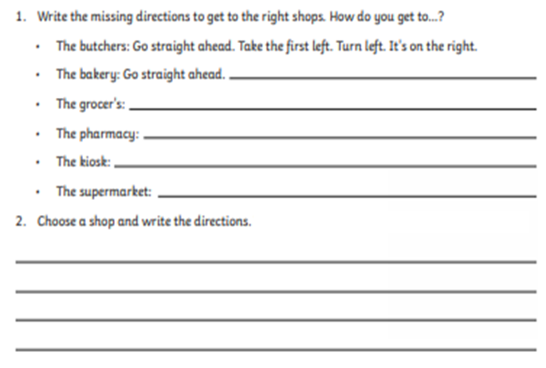
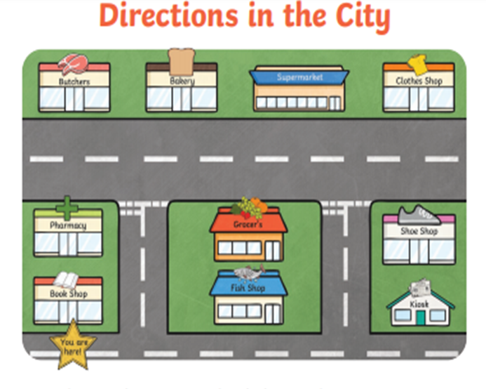
Maths ALL challenges
Reasoning / Problem Solving ALL Groups
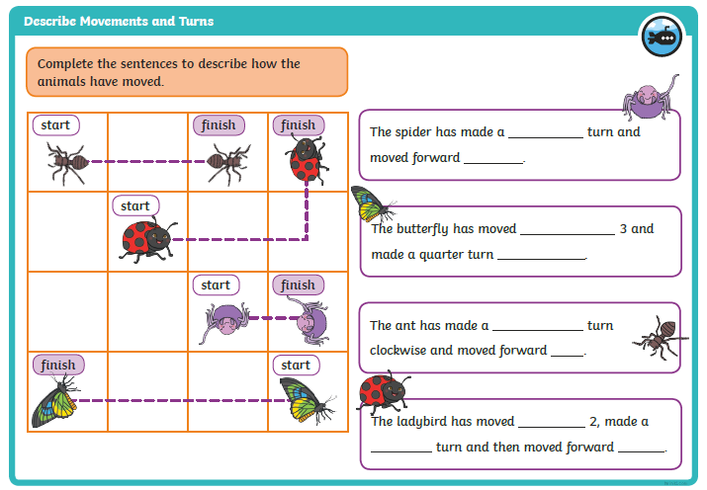

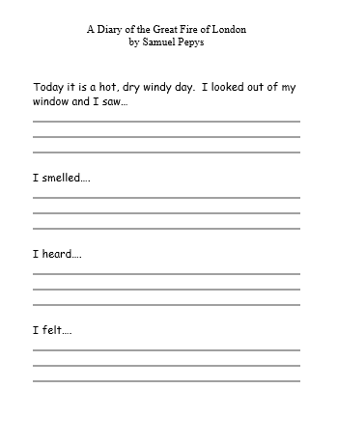
Topic Task

