Year 2
Please find todays learning tasks below.
The table below explains the tasks and you will find the resources underneath. Your child will know which challenge they usually access in each subject and which task will be appropriate for them.
Year group: 2 Date: 22.06.20
English | Today we are going to change our topic and learn all about LONDON.  Share the link: https://www.youtube.com/watch?v=MuDAUa0XSHI&safe=active  Learn all about what it would be like to go to visit London.  As you watch the clip – make some notes as you watch, to name some of the different places that you see as you watch.
 | Challenge 1 | Challenge 2 | Challenge 3
Now you have watched the clip all about London complete some super sentences using different time connectives to start your sentences, all about the places the visited.
e.g. First they went to Buckingham Palace to see where the Queen lives.
Then…
Next…
After…
Later…
Finally…

Challenge 3 Extension – complete an extended sentence
e.g. First they went to Buckingham Palace to see where the Queen lives, it is an enormous palace and has over 600 rooms.
Maths | Log in to TT Rock Stars to complete your x tables challenges  (your login is in your Blue Home School Book)
 | Challenge 1 | Challenge 2 | Challenge 3
 | Today you will be learning about mass.  Look at the PowerPoint about mass on the website.  Then, complete the reasoning problems below about comparing mass. | Today you will be learning about mass.  Look at the PowerPoint about mass on the website.  Then, complete the reasoning problems below about comparing mass. | Today you will be learning about mass.  Look at the PowerPoint about mass on the website.  Then, complete the reasoning problems below about comparing mass.
Reading  Phonics | Complete the Reading Comprehension Task (See sheets below)  Complete the spelling activity sheet below – making nouns.
Other | Today we are going to do some Music  Share the link: https://www.bbc.co.uk/teach/school-radio/nursery-rhymes-london-bridge-is-falling-down/zhy6jhv and learn and sing along with the song London Bridge is Falling Down.

Unless otherwise specified, please complete the tasks in either your home learning book or print out the document below.

Maths Challenge 1
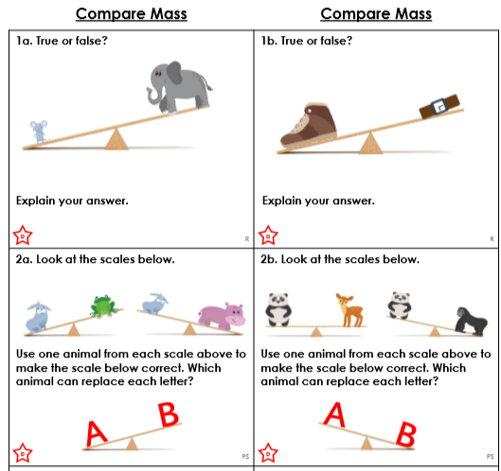

Maths Challenge 2

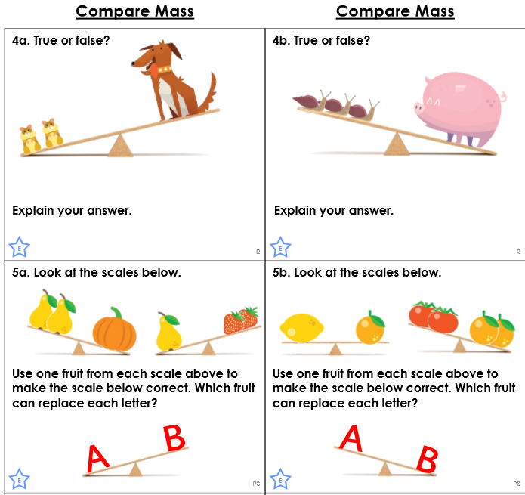

Maths Challenge 3

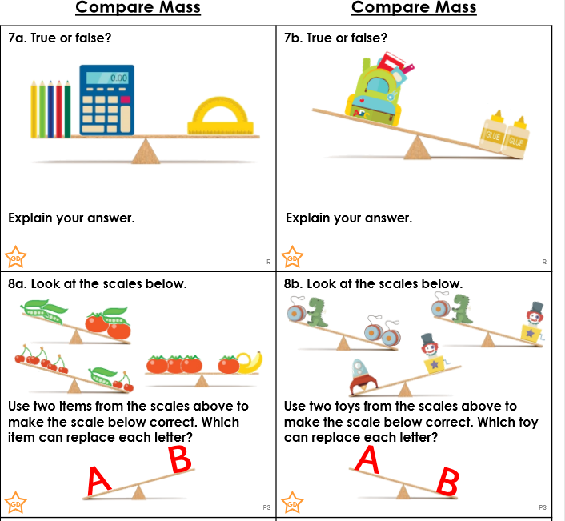

Reasoning ALL Groups
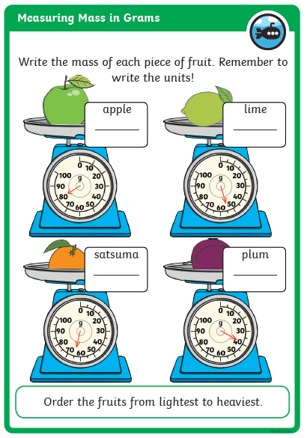

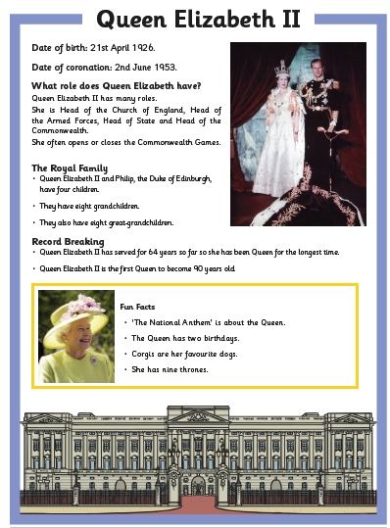
Reading Comprehension ALL Groups

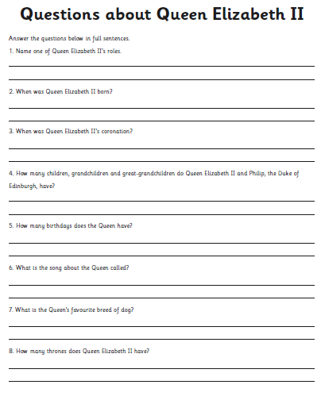

Phonics Activity

