Year 2
Please find todays learning tasks below.
The table below explains the tasks and you will find the resources underneath.
Your child will know which challenge they usually access in each subject and which task will be appropriate for them.
Year group: 2 Date: 26.06.20
English | Today you are going to continue learning about London.  Start by sharing the link: https://www.youtube.com/watch?v=MHxSq4c_E6g&safe=active
 | Challenge 1 | Challenge 2 | Challenge 3
Today you need to read the information below about the London Eye and then answer the questions about the page.
Remember to answer the sentences using full sentences.

Maths | 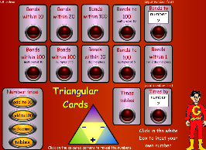  Complete the interactive ‘Number bonds within 100’ activity on the following link:  http://www.wldps.com/gordons/Triangular_cards.swf
 | Challenge 1 | Challenge 2 | Challenge 3
Today you will be continuing to learn about temperature.
Complete the sheets below.

Reading  Phonics | Log in to Oxford Owl and complete the reading of ‘Chamber of Treasures’ reading / listening to pages 19 – end.  Complete the misspelt words task below.
Other | Today we are going to complete PE  Click on the Link Here: https://www.youtube.com/watch?v=9vDjXxRjkXk&safe=active and join in with the Cosmic Yoga Session all about visiting London and helping a little pigeon called Nelson settle in to his new home.  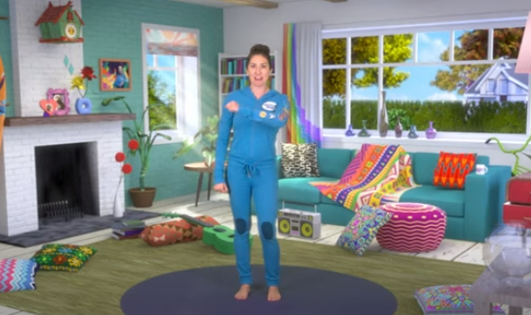 Session lasts about 30 minutes.

Unless otherwise specified, please complete the tasks in either your home learning book or print out the document below.

English All challenges
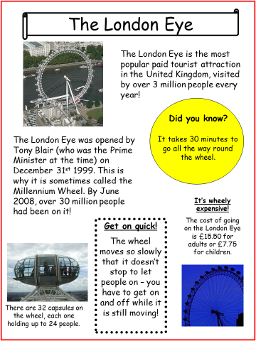

English ALL Groups
Answer these questions about the information you have read about
The London Eye.
- How many people visit the attraction each year? ________________________________________________________
- When was the London Eye opened? ________________________________________________________
- How many capsules are there on the wheel? ________________________________________________________
- How long would it take to travel all the way around the wheel? ________________________________________________________
- Why is the wheel sometimes called the ‘Millennium Wheel’? ________________________________________________________
- True / False?
The wheel was opened by Tony Brian. True False
Each capsule holds up to 24 people. True False
The wheel is the same shape as a Rugby ball. True False
The London Eye is on the bank of
the River Thames. True False

Maths Task ALL Groups
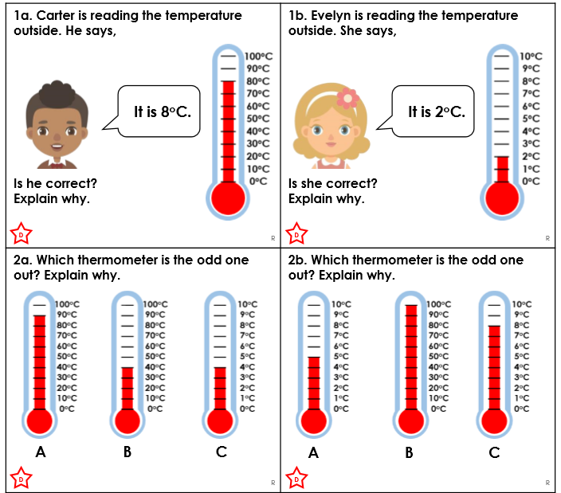

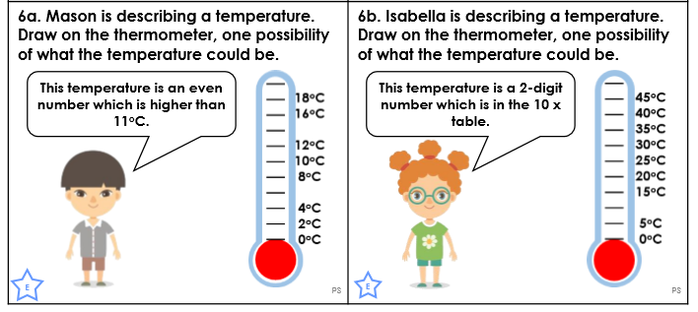
Reasoning / Problem Solving ALL Groups
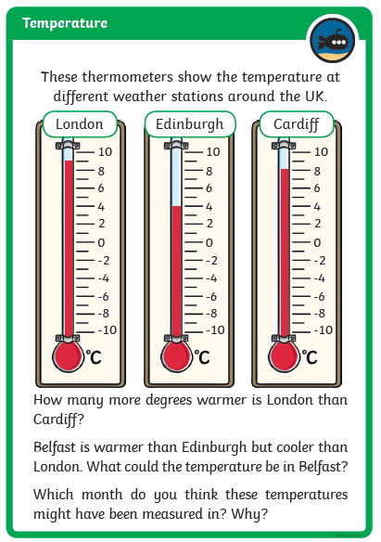

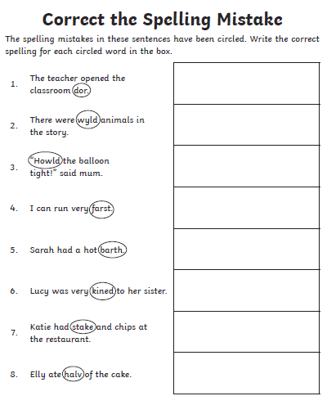
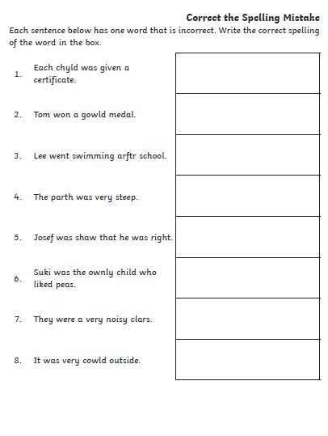
Spelling Task

