Year 2
Please find todays learning tasks below.
The table below explains the tasks and you will find the resources underneath.
Your child will know which challenge they usually access in each subject and which task will be appropriate for them.
Year group: 2 Date: 12.06.20
English | 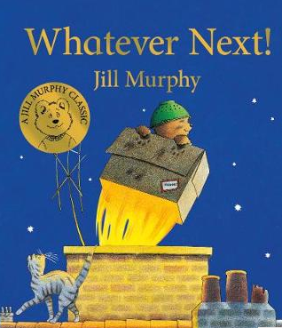  Go to https://www.youtube.com/watch?v=Nn73STXrPP0  and watch and listen again to the story of Whatever Next by Jill Murphy.
 | Challenge 1 | Challenge 2 | Challenge 3
 | Today we are completing the sequencing of the pictures and retelling the story of Whatever Next.  Look at the pictures below and either cut and reorder then stick the pictures correctly or show an adult which order they need to be.  Next match the sentences to say what is happening in the pictures. The last picture does not have a sentence – can you write what happens at the end? | Today we are continuing to write Baby Bear’s diary.  You now need to write about the pictures below as if you are Baby Bear and retell what happened in the middle and ending of the story.  Remember to use ‘I’ not Baby Bear and also write in the past tense, so you may need to use _ed words. Try and make your diary entry as interesting as you can by adding adjectives too.
Maths | 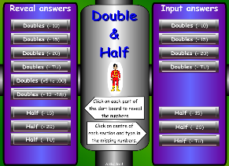  Complete the interactive doubles / halves activities on the following link  http://www.wldps.com/gordons/Dart_Board_-_doubles_and_halves.swf
 | Challenge 1 | Challenge 2 | Challenge 3
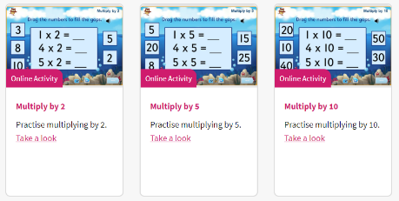
https://home.oxfordowl.co.uk/kids-activities/fun-maths-games-and-activities/
Log into Oxford Owl – there are some lovely online activities the children can complete to reinforce their times tables.
Then log in to TT Rock Stars and complete some of the activities there

Reading  Phonics | 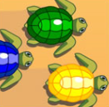  Complete the reading task below. (see activity sheet)  Click on to the link https://www.arcademics.com/games/turtle-dash  and choose the vowels that spell the words on the game Turtle Dash
Other | Today we are going to complete PE – Cosmic Yoga Style (activity lasts about 30 minutes)  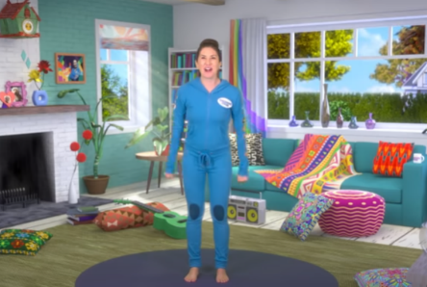  Click on the link below and complete the  Cosmic Yoga Task Mike the Cosmic Space Monkey  https://www.youtube.com/watch?v=VuOsMsH0FQQ

Unless otherwise specified, please complete the tasks in either your home learning book or print out the document below.

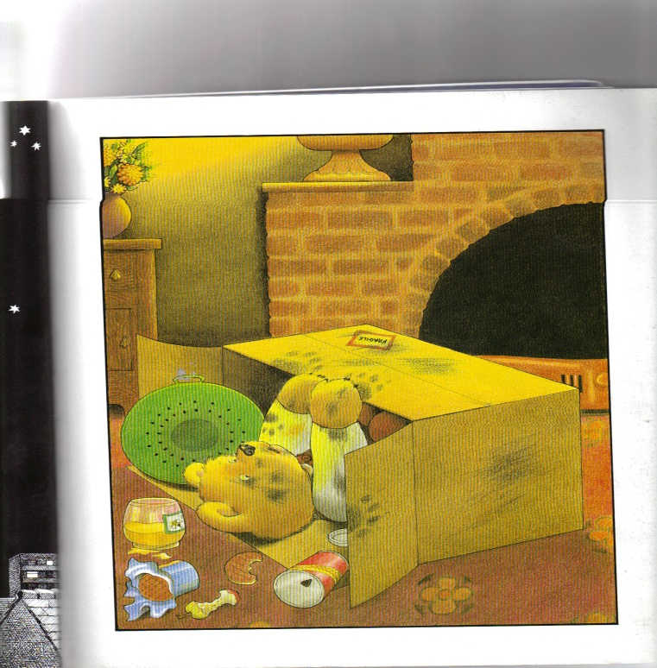
English All challenges
Next Then After Soon Finally ate waved
flew whooshed darkest twinkly suddenly landed
cardboard box crashed chimney washed goodbye

Dear Diary
____________________________________________________________________________________________________________________________________________________________________________________________________________________________________________________________________________________________________________________________________________________________________________________________________________
Reading Task
